

**数据库系统原理实践报告**

|  |  |
| --- | --- |
| 项目名称： |  |
|  |  |
| 姓 名： | 黄俊淇 |
| 专 业： | 计算机科学与技术 |
| 班 级： | CS1804 |
| 学 号： | U201814604 |
| 指导教师： | 袁平鹏 |

|  |  |
| --- | --- |
| 分数 |  |
| 教师签名 |  |

2020年5月20日

**教师评分页**

|  |  |
| --- | --- |
| 子目标 | 子目标评分 |
| 1 |  |
| 2 |  |
| 3 |  |
| 4 |  |
| 5 |  |
| 6 |  |
|  |  |

目 录

1课程任务概述 1

2软件功能学习 2

2.1 任务要求 2

2.2 完成过程 2

2.3任务总结 4

3 SQL练习 5

3.1 任务要求 5

3.2 完成过程 5

3.3任务总结 23

4 应用系统设计 24

4.1系统设计目标 24

4.2 需求分析 25

4.3 总体设计 26

4.4 数据库设计 27

4.5 详细设计与实现 30

4.6 系统测试 33

4.7 系统设计与实现总结 47

5课程总结 48

附录：实验源代码 50

参考文献 161

# 1课程任务概述

**实验一 软件功能学习**

1.使用Navicat Premium平台进行实验

2.练习数据导入、数据导出、数据备份、新增用户（包含分配权限）

**实验二 Sql练习**

1.建表

2.数据更新

3.数据查询

4.了解系统的查询性能分析功能（选做）

5. DBMS函数及存储过程和事务（选做）

**实验三**

自行选择所擅长的DBMS软件以及数据库应用系统（客户端程序或者网站）的程序开发工具，参考后面的题目例子，拟定一个自己感兴趣的数据库应用系统题目，完成该小型数据库应用系统的设计与实现工作。主要内容包括：需求调研与分析、总体设计、数据库设计、详细设计与实现、测试等环节的工作。

# 2软件功能学习

## 2.1 任务要求

完成下列1~2题，并在实践报告中叙述过程，可适当辅以插图（控制在A4三页篇幅以内）

1）练习SQL Server或其他某个主流关系数据库管理系统软件的备份方式：数据和日志文件的脱机备份、系统的备份功能。

2）练习在新增的数据库上增加用户并配置权限的操作，通过用创建的用户登录数据库并且执行未经授权的SQL语句验证自己的权限配置是否成功。

## 2.2 完成过程

实验环境如下：

操作系统:macOS Big Sur

数据库:MySQL

交互图形界面:Navicat Premium

### 2.2.1 数据库备份

热备：直接使用navicat自带的备份功能即可，如下图所示。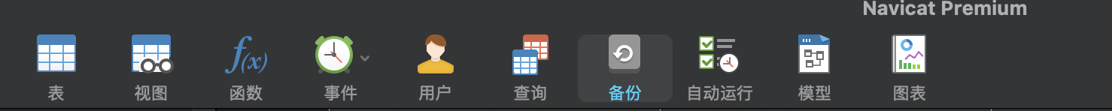

点击备份即可，备份成功如下图所示

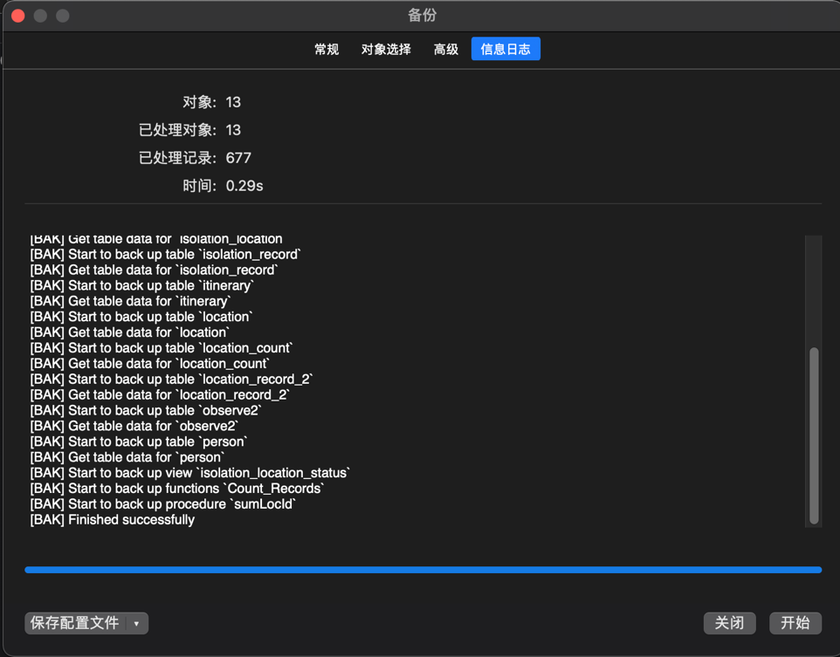

备份完成。

冷备：不用登陆mysql，直接找到mysql相应的文件夹，物理备份即可。

### 2.2.2 配置权限

同样在navicat中集成了相应的创建用户和配置权限的功能，如下图所示



进入创建用户界面，如下图所示

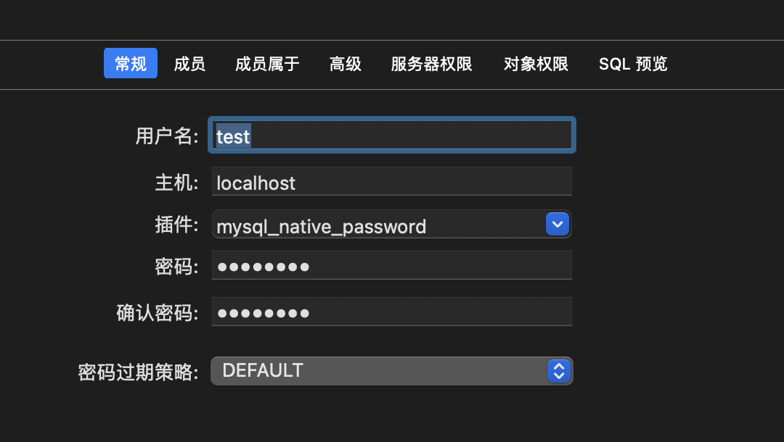

在这个界面中还可以直接配置权限，如下图所示

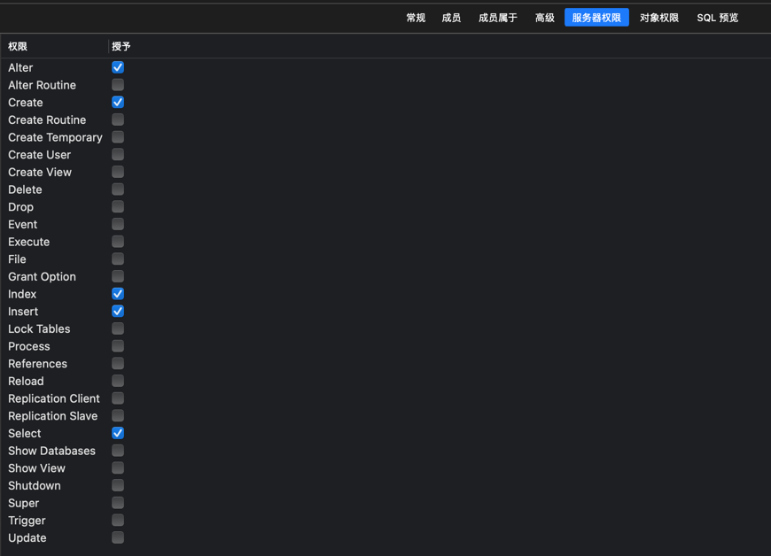

在这里我给了修改，创建，索引，查询，插入的权限，而没有给其他权限，用select和update进行测试，sql语句如下图所示

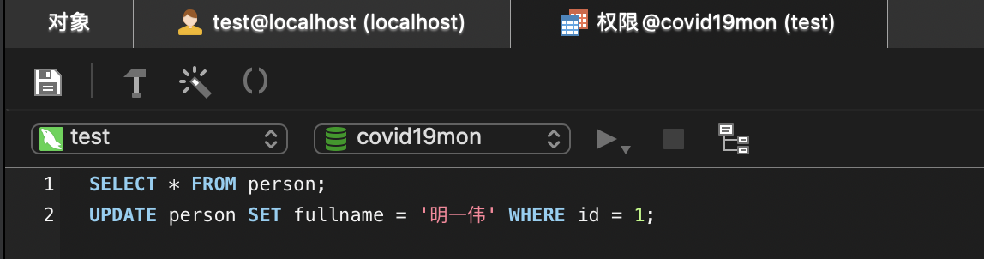

测试结果如下图所示

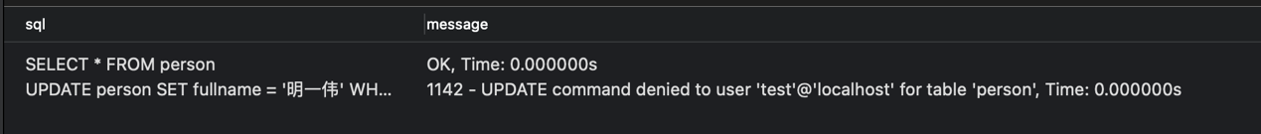

可以看到select执行成功，但update因为没有权限失败。

## 2.3任务总结

本次实验使用了集成度非常高的navicat软件，使得备份和用户功能变得极为简单，不需要自己写sql语句，省去了大量时间。

# 3 SQL练习

## 3.1 任务要求

假设在某个区域内的所有地点都存储在地点表中。该地区中的所有人员信息存储在人员表中。根据收集到的人员行程建立了疫情期间某个地区的人员行程表。

该地区的部分人员进行了核酸检测，检测结果保存在诊断表中。根据诊断表中的检测结果，对新冠确诊和无症状感染者的密切接触者进行隔离，密切接触者的信息存储到密切接触表中，隔离信息存储到隔离表中。隔离地点共设置了4个，并且每个隔离地点都有容量限制，隔离点的信息存储在隔离地点表中。

完成下列任务：

1. 建表
2. 数据更新
3. 数据查询
4. 了解系统的查询优化功能
5. DBMS函数以及存储过程

## 3.2 完成过程

### 3.2.1 建表

（1）根据每个表对应的要求建立相应基本表，sql语句见附录，如图3.1所示

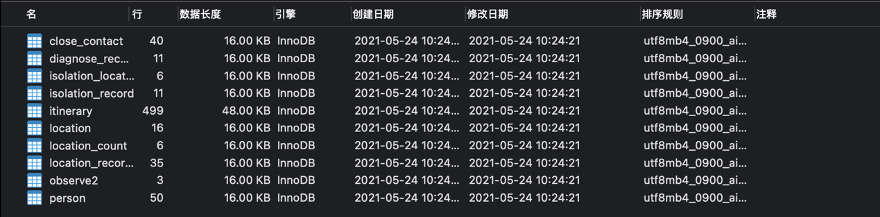

图3.1 建表

（2）观察性实验：验证在设置外码时是否一定要参考被参照关系的主码，并在实验报告中简述过程和结果。

person中fullname不是主码，因此使用fullname作为外码建表尝试，结果如图3.2所示



图3.2 观察性实验1

可以看到建表失败，因为fullname不是主码。

（3）数据准备

使用老师给的sql文件，运行即可。

### 3.2.2 数据更新

1. **分别用一条sql语句完成对人员表基本的增、删、改的操作；**

使用头歌平台完成该任务，结果如图3.3所示

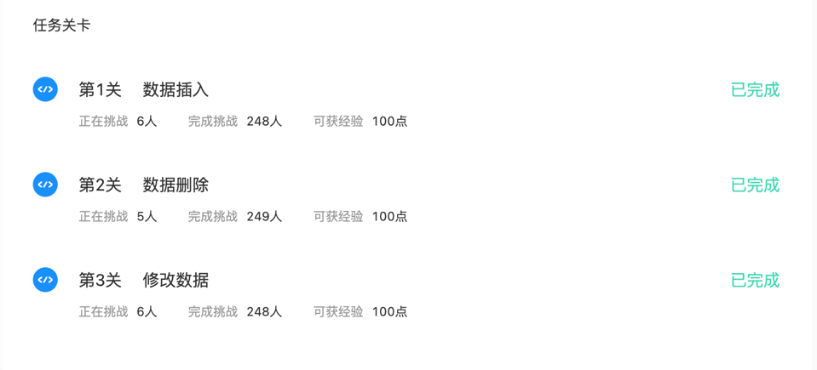

图3.3 数据增删改

1. **批处理操作**

将行程表中所有到达地点2的记录插入到新表location_record_2中。

使用下列sql语句即可

CREATE TABLE location_record_2 AS(

SELECT * FROM itinerary

WHERE loc_id = 2

);

结果如图3.4所示

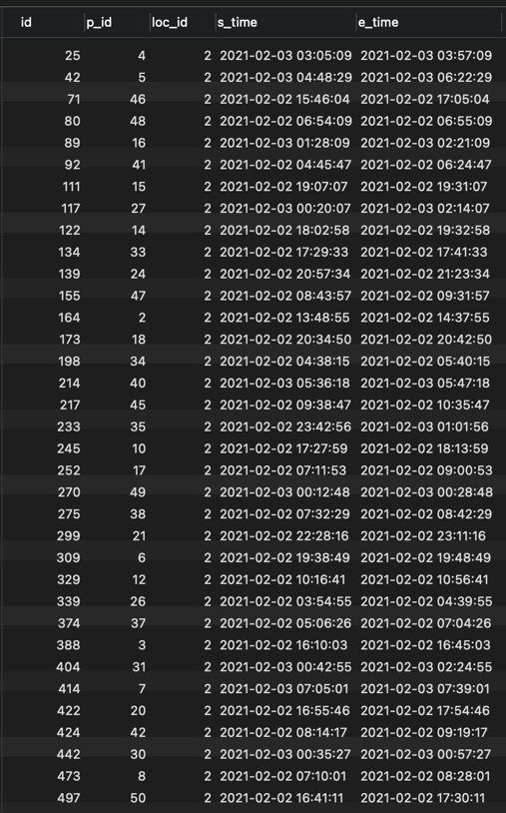

图3.4 批处理

1. **数据导入导出**

使用navicat集成的导入导出功能即可，导出结果如图3.5所示

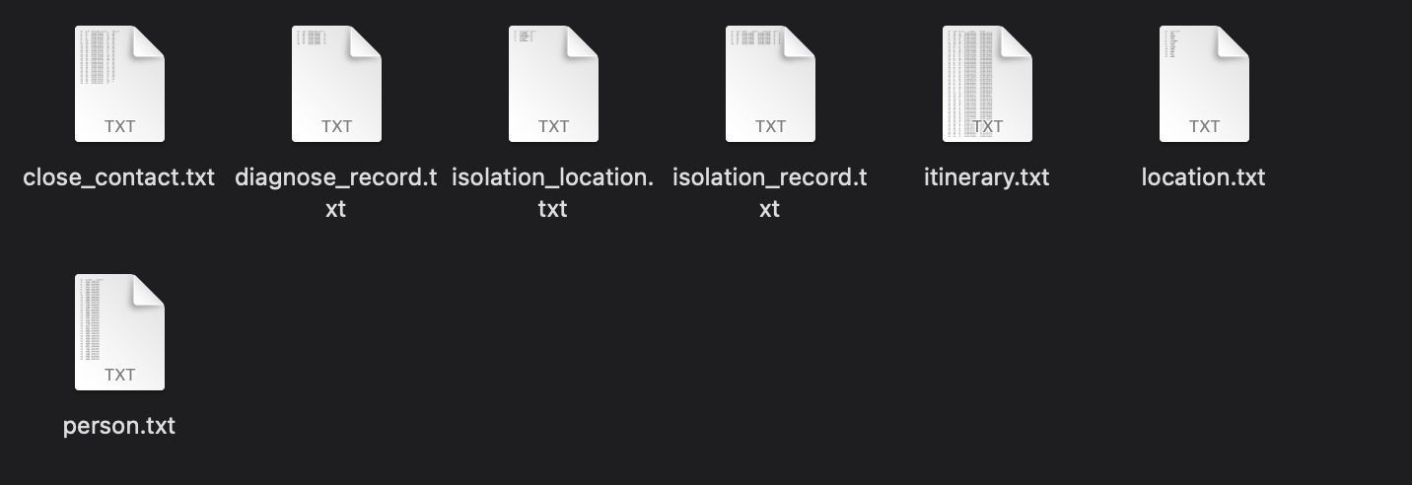

图3.5 导出结果

1. **观察性实验**

如果不设置主码，可插入重复元组。sql语句见附录，如图3.6所示。

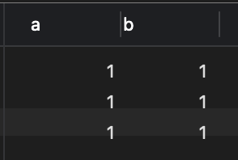

图3.6 观察性实验2

1. **触发器实验**

在diagnose_record表上设置触发器，触发时机为AFTER update和insert，对每一行设置行触发器，更新isolation_record中的字段即可。使用头歌平台测试，结果如图3.7所示

delimiter ;;

DROP TRIGGER IF EXISTS mytrigger1;

CREATE TRIGGER mytrigger1

AFTER UPDATE ON diagnose_record

FOR EACH ROW

BEGIN

UPDATE isolation_record SET state = 3 WHERE(p_id = new.p_id AND new.result = 1);

END;;

delimiter ;;

DROP TRIGGER IF EXISTS mytrigger2;

CREATE TRIGGER mytrigger2

AFTER INSERT ON diagnose_record

FOR EACH ROW

BEGIN

IF(new.result = 1)

THEN

BEGIN

INSERT INTO isolation_record VALUES(new.id,new.p_id,NULL,NULL,3,3);

END;

ELSE INSERT INTO isolation_record VALUES(new.id,new.p_id,NULL,NULL,3,1);

END IF;

END;;

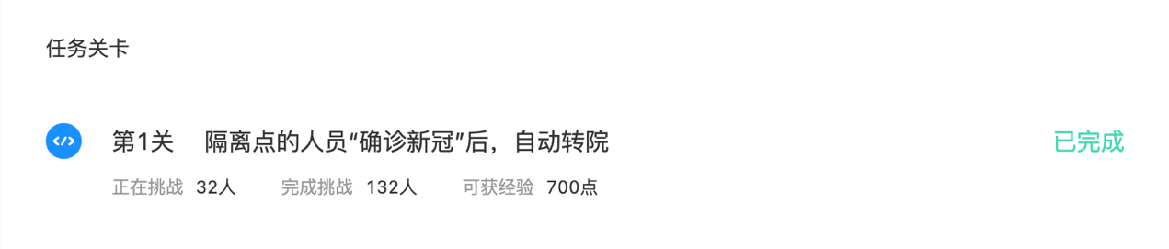

图3.7 触发器

### 3.2.3 数据查询

查询测试统一使用头歌平台进行测试，sql语句统一见附录。

1. 查询截至目前的人流量大于30的地点，并按照从高到低排序

使用group by和having可以统计满足条件的分组，使用order by进行排序，嵌套查询即可，结果如图3.8所示

select location_name,count(loc_id) as visitors

from location,itinerary

where location.id = itinerary.loc_id

group by location.id

having count(loc_id)>30

order by visitors desc,location_name;

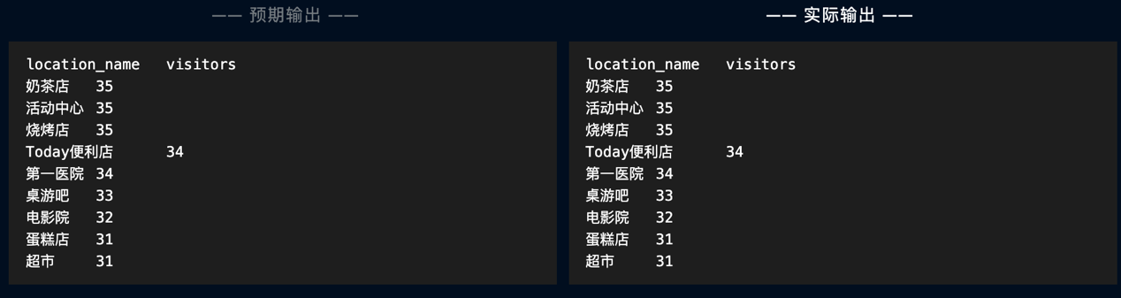

图3.8 查询人流量大于30的地点

1. 查询出每个隔离地中正在进行隔离的人数，并按数量由多到少排序

使用派生表以及嵌套查询即可，统计人数使用聚集函数count，结果如图3.9所示

select location_name,count(p_id) as number

from isolation_record,isolation_location

where isolation_location.id = isolation_record.isol_loc_id

and state = 1

group by isolation_location.id

order by number desc,location_name;

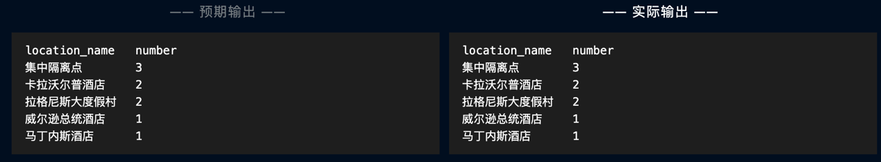

图3.9 每个隔离地中正在进行隔离的人数

1. 查询行程表中连续行程中的一对行程地点（例如，方斯雪，在2021-02-02 03:02:12至2021-02-02 03:51:12 在博物馆中，2021-02-02 03:51:12 至 2021-02-02 04:23:12出现超市中，输出【姓名，重合时间，起始地点id，起始地点，结束地点id，结束地点】，查询结果如下图所示）



自身链接查询，使用表别名进行区分，结果图3.10所示

select person.id,

person.fullname,

person.telephone,

t1.e_time as reclosing_time,

t1.loc_id as loc1,

l1.location_name as address1,

t2.loc_id as loc2,

l2.location_name as address2

from person,

location l1,

location l2,

itinerary t1,

itinerary t2

where person.id > 30

and person.id = t1.p_id

and l1.id = t1.loc_id

and l2.id = t2.loc_id

and t1.p_id = t2.p_id

and t1.e_time = t2.s_time

order by person.id, reclosing_time;

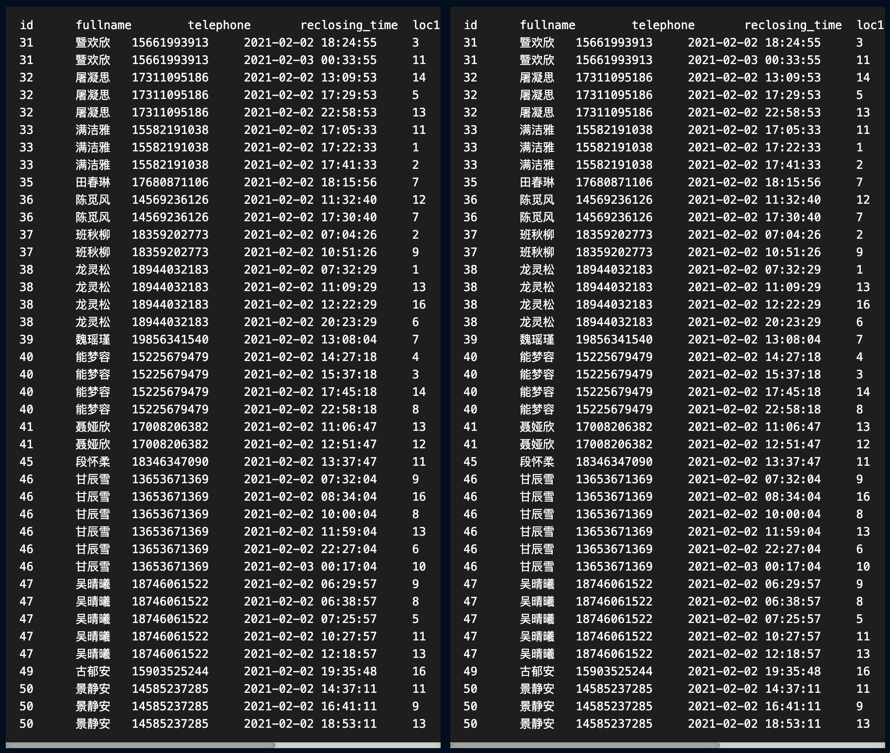

图3.10 接续行程

1. 查询贾涵山的行程情况

因为头歌平台与实验任务书中有区别，结果如图3.11所示

select a.fullname, a.telephone, tmp.location_name, tmp.s_time, tmp.e_time

from person a left join (

select b.fullname, location_name, s_time, e_time

from person b,

location,

itinerary

where b.id = itinerary.p_id

and itinerary.loc_id = location.id

) tmp on a.fullname = tmp.fullname

where a.fullname = "贾涵山"

order by a.id desc;

注意left join联合on使用。

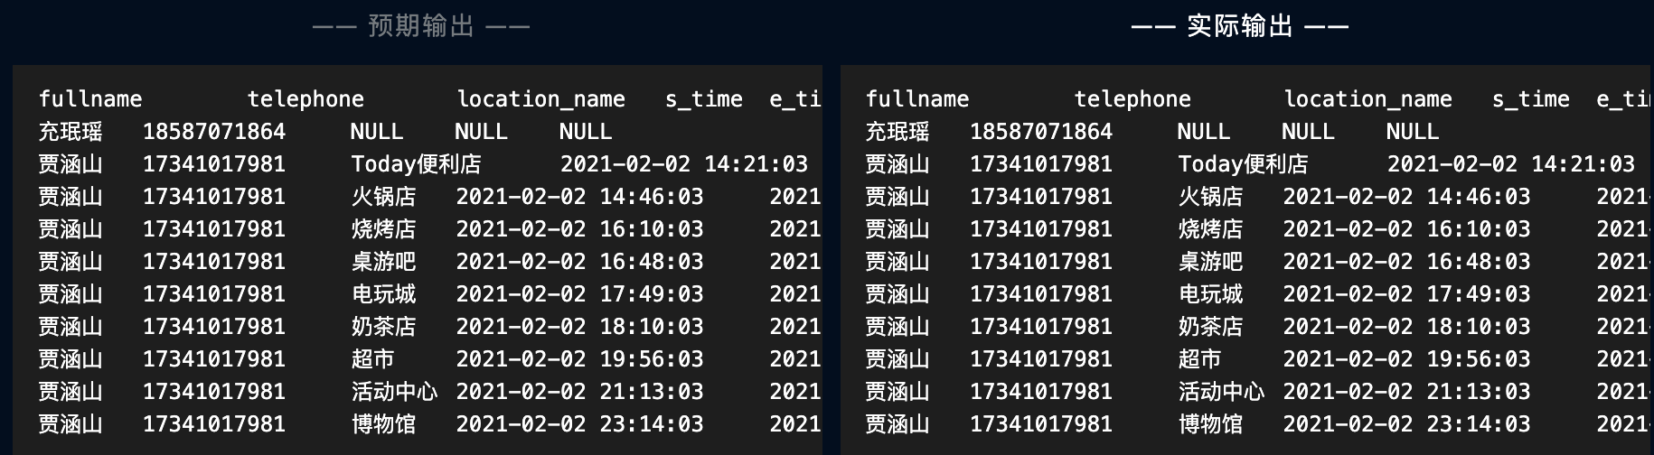

图3.11贾涵山的行程情况

1. 查询地名中带有‘店’字的地点名称

select id, location_name

from location

where location_name like "%店%"

order by id;

使用like即可，结果如图3.12所示

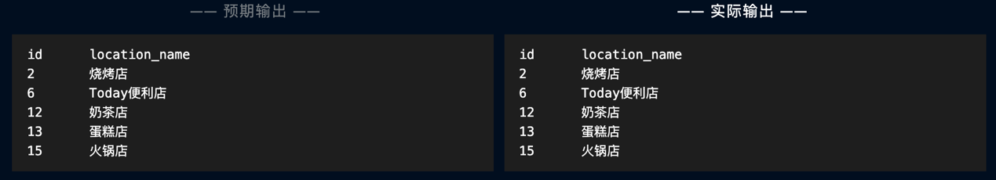

图3.12 地名中带有‘店’字的地点名称

1. 新发现一位确诊者，已知他在2021.2.2日20:05:40到21:25:40之间在“活动中心”，查询他接触到的人员的名字

select fullname, telephone

from person,

itinerary,

location

where person.id = itinerary.p_id

and itinerary.loc_id = location.id

and location_name = "活动中心"

and (itinerary.s_time between "2021-02-02 20:05:40" and "2021-02-02 21:25:40"

or itinerary.e_time between "2021-02-02 20:05:40" and "2021-02-02 21:25:40"

)

order by fullname;

使用between and语句，结果如图3.13所示。

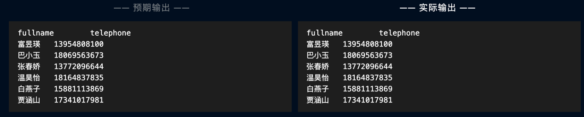

图3.13 确诊者的接触者

1. 查询正在使用的隔离区名（使用DISTINCT关键字）

select location_name

from isolation_location

where exists(

select *

from isolation_record

where isolation_location.id = isolation_record.isol_loc_id

and state = 1

)

order by id;

使用exists关键字，结果如图3.14所示

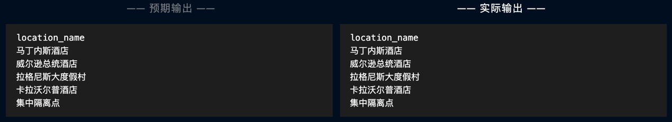

图3.14 正在使用的隔离点

1. 查询有出行记录的人员（使用EXISTS关键字）

结果如图3.15所示

select fullname, telephone

from person

where exists(

select *

from itinerary

where person.id = itinerary.p_id

)

order by person.id

limit 30

;

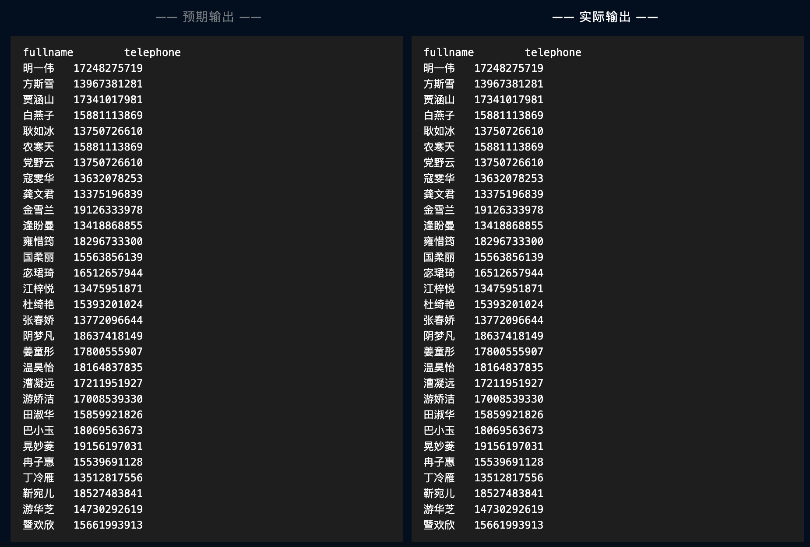

图3.15 有出行记录的人员

1. 查询没有达到地点“Today便利店”的人数（使用NOT EXISTS 关键字），结果如图3.16所示

select count(person.id) as number

from person

where not exists(

select *

from itinerary,

location

where person.id = itinerary.p_id

and itinerary.loc_id = location.id

and location.location_name = "Today便利店"

);

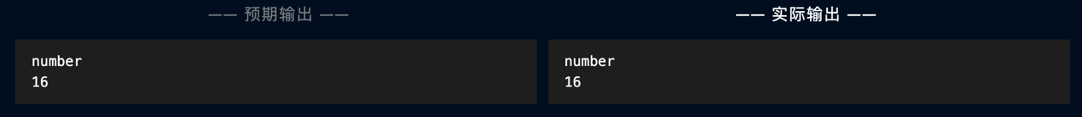

图3.16没有达到地点“Today便利店”的人数

1. 查询去过所有地点的人员

全称量词使用双重否定表示肯定，结果如图3.17所示

select fullname

from person

where not exists(

select *

from location

where location.id not in (

select itinerary.loc_id

from itinerary

where itinerary.loc_id = location.id

and person.id = itinerary.p_id

)

)

order by fullname;

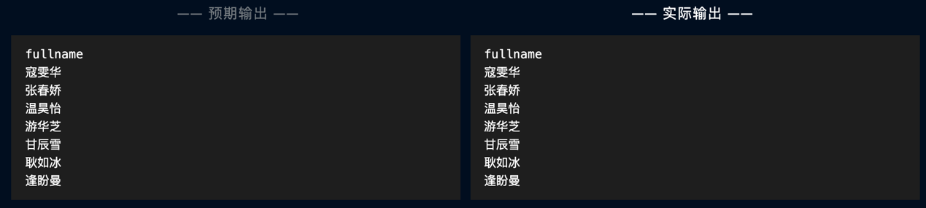

图3.17 去过所有地点的人员

1. 新建一个视图，里面有每个隔离点的id,名称，已用房间，容量

结果如图3.18所示

create view isolation_location_status as

select l.id, l.location_name, l.capacity, ifnull(tmp.cut, 0) as occupied

from isolation_location l left join (

select r.isol_loc_id, count(r.isol_loc_id) as cut

from isolation_record r

where r.state = 1

group by r.isol_loc_id

) tmp

on l.id = tmp.isol_loc_id;

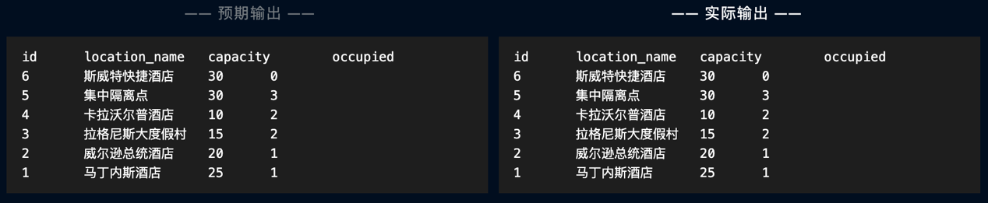

图3.18 隔离点的现状视图

1. 从视图中查询还有空房间的隔离点的剩余房间数目

使用表达式作为查询结果，结果如图3.19所示

select location_name, capacity - occupied as available_rooms

from isolation_location_status

order by id;

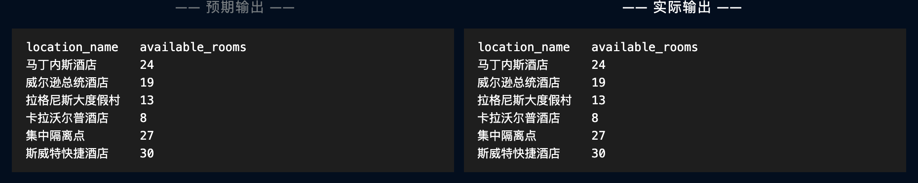

图3.19 各隔离点的剩余房间数

1. 查询靳宛儿传染的人有哪些

结果如图3.20所示

select fullname, telephone

from person,

itinerary,

(

select i.loc_id, i.s_time, i.e_time

from person p,

itinerary i

where p.id = i.p_id

and p.fullname = "靳宛儿"

) tmp

where person.fullname <> "靳宛儿"

and person.id = itinerary.p_id

and itinerary.loc_id = tmp.loc_id

and (

itinerary.s_time between tmp.s_time and tmp.e_time

or itinerary.e_time between tmp.s_time and tmp.e_time

or tmp.s_time between itinerary.s_time and itinerary.e_time

or tmp.e_time between itinerary.s_time and itinerary.e_time

)

order by fullname;

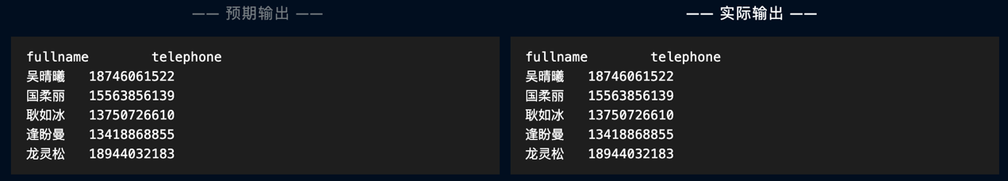

图3.20 靳宛儿传染的人

1. 查询每个地点的密切接触者的数量

结果如图3.21所示

select location_name, count(loc_id) as close_contact_number

from location,

close_contact

where location.id = close_contact.loc_id

group by close_contact.loc_id

order by close_contact_number desc, location_name;

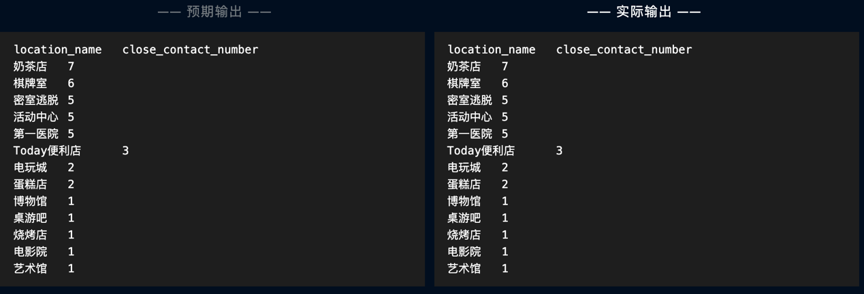

图3.21 每个地点的密切接触者的数量

1. 查询感染人数最多的用户的名字和感染人数

使用limit关键字，结果如图3.22所示

select case_p_id, fullname, count(case_p_id) as infected_number

from close_contact,

person

where person.id = close_contact.case_p_id

group by case_p_id

order by infected_number desc

limit 1;

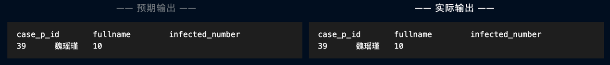

图3.22 感染人数最多的用户

1. 查询2021-02-02 10:00:00到14:00:00，行程记录最频繁的五个人及行程记录数目

因头歌平台与实验任务书有所区别，sql语句如下，结果如图3.23所示

select *

from (

select fullname, count(p_id) as record_number

from person,

itinerary

where person.id = itinerary.p_id

and (itinerary.s_time between "2021-02-02 10:00:00" and "2021-02-02 14:00:00"

or itinerary.e_time between "2021-02-02 10:00:00" and "2021-02-02 14:00:00"

or "2021-02-02 10:00:00" between itinerary.s_time and itinerary.e_time)

group by itinerary.p_id) tmp

order by record_number desc, fullname

limit 5;

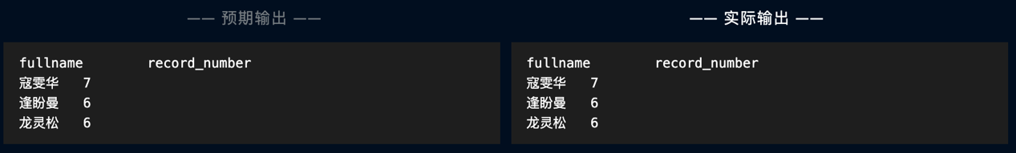

图3.23 行程记录最频繁的五个人

### 3.2.4 了解系统的查询优化功能

使用EXPLAIN关键字可以看到某个查询的查询过程，sql语句见附录，结果如图3.24所示，其中对应列的取值意义如下：

**一、 id**

SELECT识别符。这是SELECT的查询序列号

我的理解是SQL执行的顺序的标识，SQL从大到小的执行

1. id相同时，执行顺序由上至下

2. 如果是子查询，id的序号会递增，id值越大优先级越高，越先被执行

3. id如果相同，可以认为是一组，从上往下顺序执行；在所有组中，id值越大，优先级越高，越先执行

**二、select_type**

示查询中每个select子句的类型

(1) SIMPLE(简单SELECT，不使用UNION或子查询等)

(2) PRIMARY(子查询中最外层查询，查询中若包含任何复杂的子部分，最外层的select被标记为PRIMARY)

(3) UNION(UNION中的第二个或后面的SELECT语句)

(4) DEPENDENT UNION(UNION中的第二个或后面的SELECT语句，取决于外面的查询)

(5) UNION RESULT(UNION的结果，union语句中第二个select开始后面所有select)

(6) SUBQUERY(子查询中的第一个SELECT，结果不依赖于外部查询)

(7) DEPENDENT SUBQUERY(子查询中的第一个SELECT，依赖于外部查询)

(8) DERIVED(派生表的SELECT, FROM子句的子查询)

(9) UNCACHEABLE SUBQUERY(一个子查询的结果不能被缓存，必须重新评估外链接的第一行)

**三、table**

显示这一步所访问数据库中表名称（显示这一行的数据是关于哪张表的），有时不是真实的表名字，可能是简称，例如上面的e，d，也可能是第几步执行的结果的简称

**四、type**

对表访问方式，表示MySQL在表中找到所需行的方式，又称“访问类型”。

常用的类型有： ALL、index、range、 ref、eq_ref、const、system、NULL（从左到右，性能从差到好）

ALL：Full Table Scan， MySQL将遍历全表以找到匹配的行

index: Full Index Scan，index与ALL区别为index类型只遍历索引树

range:只检索给定范围的行，使用一个索引来选择行

ref: 表示上述表的连接匹配条件，即哪些列或常量被用于查找索引列上的值

eq_ref: 类似ref，区别就在使用的索引是唯一索引，对于每个索引键值，表中只有一条记录匹配，简单来说，就是多表连接中使用primary key或者 unique key作为关联条件

const、system: 当MySQL对查询某部分进行优化，并转换为一个常量时，使用这些类型访问。如将主键置于where列表中，MySQL就能将该查询转换为一个常量，system是const类型的特例，当查询的表只有一行的情况下，使用system

NULL: MySQL在优化过程中分解语句，执行时甚至不用访问表或索引，例如从一个索引列里选取最小值可以通过单独索引查找完成。

**五、possible_keys**

指出MySQL能使用哪个索引在表中找到记录，查询涉及到的字段上若存在索引，则该索引将被列出，但不一定被查询使用（该查询可以利用的索引，如果没有任何索引显示 null）

**六、Key**

key列显示MySQL实际决定使用的键（索引），必然包含在possible_keys中

**七、key_len**

表示索引中使用的字节数，可通过该列计算查询中使用的索引的长度（key_len显示的值为索引字段的最大可能长度，并非实际使用长度，即key_len是根据表定义计算而得，不是通过表内检索出的）

**八、ref**

列与索引的比较，表示上述表的连接匹配条件，即哪些列或常量被用于查找索引列上的值

**九、rows**

估算出结果集行数，表示MySQL根据表统计信息及索引选用情况，估算的找到所需的记录所需要读取的行数

**十、Extra**

该列包含MySQL解决查询的详细信息,有以下几种情况：

Using where:不用读取表中所有信息，仅通过索引就可以获取所需数据，这发生在对表的全部的请求列都是同一个索引的部分的时候，表示mysql服务器将在存储引擎检索行后再进行过滤

Using temporary：表示MySQL需要使用临时表来存储结果集，常见于排序和分组查询，常见 group by ; order by

Using filesort：当Query中包含 order by 操作，而且无法利用索引完成的排序操作称为“文件排序”

Using join buffer：改值强调了在获取连接条件时没有使用索引，并且需要连接缓冲区来存储中间结果。如果出现了这个值，那应该注意，根据查询的具体情况可能需要添加索引来改进能。

Impossible where：这个值强调了where语句会导致没有符合条件的行（通过收集统计信息不可能存在结果）。

Select tables optimized away：这个值意味着仅通过使用索引，优化器可能仅从聚合函数结果中返回一行

No tables used：Query语句中使用from dual 或不含任何from子句

using index ：使用覆盖索引的时候就会出现



图3.24 性能分析

### 3.2.5 DBMS函数以及存储过程

1) 编写一个依据人员编号计算其达到所有地点的次数的自定义函数，并利用其查询至少到达过3个地点的人员。

输入为某个id，返回为该人员到达所有地点的次数。函数如下所示。

DROP FUNCTION IF EXISTS Count_Records;

DELIMITER ;;

CREATE FUNCTION Count_Records(a int)

RETURNS INT

READS SQL DATA

DETERMINISTIC

BEGIN

DECLARE c INT;

SELECT count(*) INTO c FROM itinerary WHERE p_id = a;

RETURN c;

END;;

DELIMITER ;

(2) 利用创建的函数，仅用一条SQL语句查询在行程表中至少有3条行程记录的人员信息，查询结果依人员编号排序。

SELECT * FROM person WHERE Count_Records(id)>=3;

结果如图3.25所示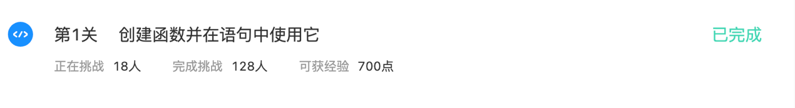

图3.25 DBMS函数

2) 尝试编写DBMS的存储过程，建立每个隔离点的人数统计表，并通过存储过程更新该表。sql语句如下：

DROP TABLE IF EXISTS location_count;

CREATE TABLE location_count(

loc_id INT PRIMARY KEY NOT NULL,

times INT NOT NULL,

FOREIGN KEY(loc_id) REFERENCES isolation_location(id)

);

DROP PROCEDURE IF EXISTS sumLocId;

DELIMITER ;;

CREATE PROCEDURE sumLocId()

BEGIN

INSERT INTO location_count SELECT isol_loc_id,COUNT(*) FROM isolation_record GROUP BY isolation_record.isol_loc_id;

END;;

CALL sumLocId();

测试结果如图3.26所示

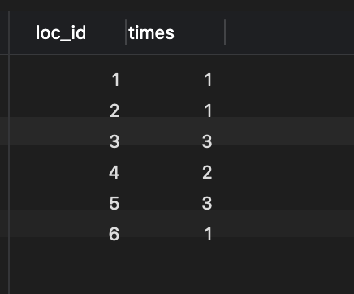

图3.26 DBMS存储过程

## 3.3任务总结

本次实验难点在查询，如何使用select进行对应的查询是非常难的，比如全称量词需要双重否定，又比如要统计某个分组需要使用having而不是where。

此外，可以发现sql也可以有类似函数的功能，可以在函数里实现循环或者判断，减去了重复sql语句带来的冗余，可以更加方便操作数据库。

# 4 应用系统设计

## 4.1系统设计目标

### 4.1.1 系统应用背景

数据库是数据管理的有效技术，是计算机科学的重要分支。今天，信息资源 已成为各个部门的重要财富和资源，建立一个满足各级部门的信息处理要求的行 之有效的信息系统也成为一个企业或组织生存和发展的重要条件。因此，作为信 息处理系统核心和基础的数据库技术得到越来越广泛的应用。从小型单项事务处 理系统到大型信息系统，从联机事务处理到联机分析处理，从一般企业管理到计 算机辅助设计与制造，计算机集成制造系统、电子政务、电子商务、地理信息系 统等，越来越多的应用领域采用数据库技术来存储和处理信息资源。特别是随着互联网的发展，广大用户可以之间访问并使用数据库，例如通过网上订购图书，日用品，机票，火车票。通过网上银行存款取款、检索和管理账户，等等，数据库已经成为每个人生活中不可缺少的部分。

而现在出行驾车是短途路程的优选，其次有驾照的人很多，而买车的人少，因此出现了很多租车公司为相当一部分人群提供服务。因此，本次选题汽车租赁信息系统，采用C/S模式实现。

### 4.1.2 总体目标

采用B/S或C/S模式实现一个汽车租借信息系统。完成用户、车辆、租借情况、交通违规罚款等信息的管理。

要求：

1. 实现不同权限的浏览和更新。
2. 能够根据车辆使用情况计算押金退还金额。
3. 能查询客户的租借历史记录，并进行信誉度评价，进行会员制和非会员制的客户管理。
4. 能够管理车辆信息；
5. 能够查询最近7天，最近一个月，最近一年的收支记录，并且能够生成公司年度财务报表。
6. 系统需包含事务（包含commit，rollback），存储过程/触发器，视图，函数。

7）需要在程序中体现SQL和编程语言的结合。

### 4.1.3 具体目标

对于用户：

1. 可以登陆软件
2. 可以租车
3. 可以查看过往租车记录
4. 可以还车，修改车辆使用情况
5. 可以退出登录

对于公司：

1. 可以登陆软件
2. 可以管理用户，注册，修改，删除用户信息
3. 可以管理车辆，增加，修改，删除车辆信息
4. 可以查询正在租赁车辆相关信息
5. 可以查询收支记录，可以根据选定时间段查询
6. 可以生成公司年度财务报表
7. 可以退出登录

## 4.2 需求分析

租车公司，需求分析如图4.1所示

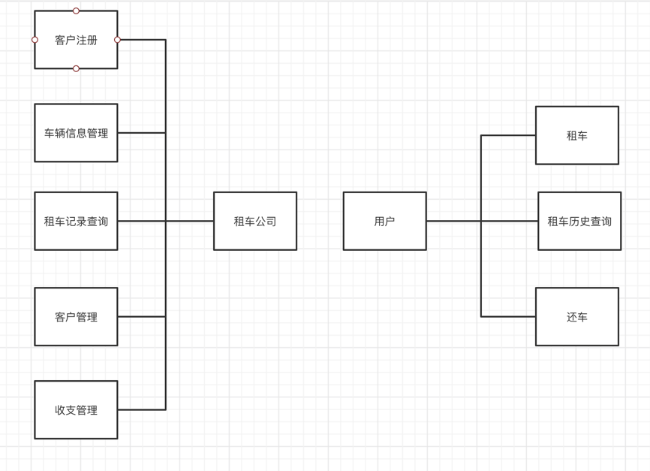

图4.1 需求分析

### 4.2.1 车辆收入计算

客户等级=（租车次数-超时次数）/100，

车辆使用情况分为“良好”，“未加满油”，“交通违规”，

若为良好，收支明细=租车价格*天数/客户等级，退还所有押金

若为未加满油，收支明细=租车价格*天数/客户等级+100，即押金中扣除100

若为交通违规，收支明细=租车价格*天数/客户等级+押金

### 4.2.2 数据流图

数据流图底层如图4.2所示

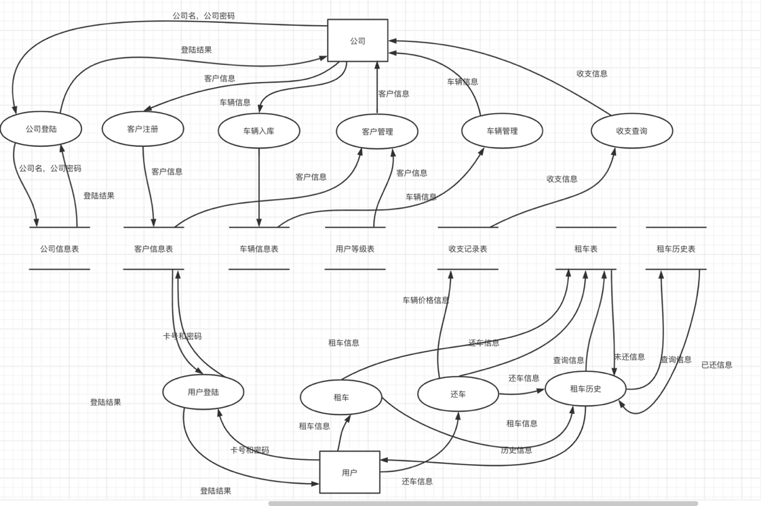

图4.3 底层数据流

## 4.3 总体设计

登陆界面有两个输入框，分别输入用户ID/公司名和密码，还有两个选项选择进入用户/公司界面。

### 4.3.1 用户功能设计

用户功能流程图如图4.2所示。

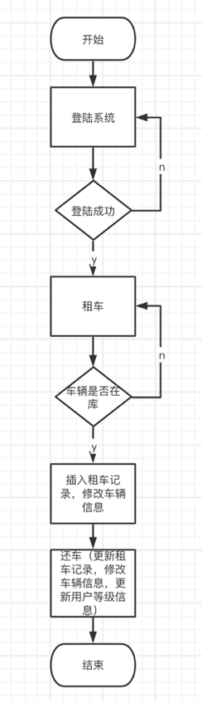

图4.3 用户功能流程图设计

用户登陆后有两个按钮：租车和还车，并且还车界面显示该用户的租车记录。租车时应插入对应租车记录，还车时应计算收支，并删除租车记录。

### 4.3.2 租车公司功能设计

租车公司功能设计流程图如图4.4所示

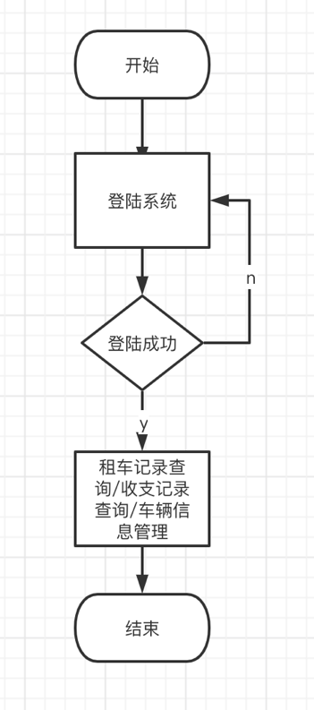

图4.4 租车公司功能设计

公司登陆成功后，有三个按钮对应用户查询，租车记录查询，收支记录查询，车辆信息管理，其中，用户查询有两个按钮可以添加和删除用户；车辆信息管理有两个按钮可以用来添加和删除对应车辆信息。

## 4.4 数据库设计

### 4.4.1 ER图设计

本系统ER图如图4.5所示。

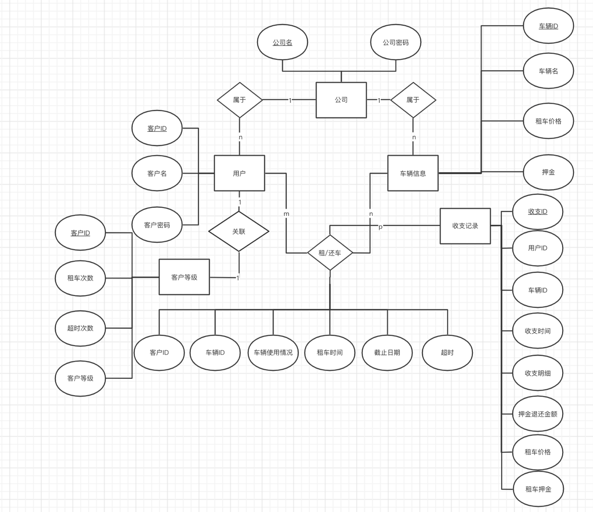

图4.5 E-R图

### 4.4.2 关系模式

由需求分析可以得知需要以下几个关系模式：

1. 租车公司（公司名，公司密码）
2. 车辆信息（车辆ID，车辆名，租车价格（按天算），租车押金，公司名）
3. 租车记录（客户ID，车辆ID，车辆使用情况，租车日期，截止日期，超时）
4. 用户信息（客户ID，客户名，客户密码，租车次数，超时次数，客户等级,公司名）
5. 收入记录（收支ID，用户ID，车辆ID，收支时间，收支明细，押金退还金额，租车价格，租车押金）

### 4.4.3 数据库表设计

1.租车公司表

|  |  |  |  |  |
| --- | --- | --- | --- | --- |
| 字段名 | 中文说明 | 字段类型 | 完整性约束 | 备注 |
| cName | 公司名 | VARCHAR（20） | 主码 | not null |
| cPassword | 公司密码 | VARCHAR（20） |  | not null |

2.客户等级表

|  |  |  |  |  |
| --- | --- | --- | --- | --- |
| 字段名 | 中文说明 | 字段类型 | 完整性约束 | 备注 |
| userID | 客户ID | VARCHAR（20） | 外码 | not null |
| borrowTimes | 租车次数 | INT |  | default=0 |
| overTimes | 超时次数 | INT |  | default=0 |
| userLevel | 客户等级 | INT |  | default=1 |

3.车辆信息表

|  |  |  |  |  |
| --- | --- | --- | --- | --- |
| 字段名 | 中文说明 | 字段类型 | 完整性约束 | 备注 |
| carID | 车辆ID | VARCHAR（20） | 主码 | not null |
| carName | 车辆名 | VARCHAR（20） |  | not null |
| carPrice | 租车价格 | VARCHAR（20） |  | not null |
| borrowPrice | 押金 | VARCHAR（20） |  | not null |

4.租车记录表

|  |  |  |  |  |
| --- | --- | --- | --- | --- |
| 字段名 | 中文说明 | 字段类型 | 完整性约束 | 备注 |
| userID | 客户ID | VARCHAR（20） | 外码 | not null |
| carID | 车辆ID | VARCHAR（20） | 外码 | not null |
| condition | 车辆使用情况 | VARCHAR（20） |  | not null |
| borrowTime | 租车时间 | date |  |  |
| dueTime | 截止日期 | date |  |  |
| overTime | 超时 | VARCHAR（20） |  | default=否 |

5.租车历史表

|  |  |  |  |  |
| --- | --- | --- | --- | --- |
| 字段名 | 中文说明 | 字段类型 | 完整性约束 | 备注 |
| userID | 客户ID | VARCHAR（20） | 外码 | not null |
| carID | 车辆ID | VARCHAR（20） | 外码 | not null |
| condition | 车辆使用情况 | VARCHAR（20） |  | not null |
| borrowTime | 租车时间 | date |  |  |
| dueTime | 截止日期 | date |  |  |
| overTime | 超时 | VARCHAR（20） |  | default=否 |

6.用户信息表

|  |  |  |  |  |
| --- | --- | --- | --- | --- |
| 字段名 | 中文说明 | 字段类型 | 完整性约束 | 备注 |
| userID | 客户ID | VARCHAR（20） | 主码 | not null |
| username | 客户名 | VARCHAR（20） |  | not null |
| userPassword | 客户密码 | VARCHAR（20） |  | not null |

7.收入记录表

|  |  |  |  |  |
| --- | --- | --- | --- | --- |
| 字段名 | 中文说明 | 字段类型 | 完整性约束 | 备注 |
| moneyID | 收支ID | VARCHAR（20） | 主码 | not null |
| userID | 用户ID | VARCHAR（20） |  |  |
| carID | 车辆ID | VARCHAR（20） |  |  |
| moneyTime | 收支时间 | date |  |  |
| moneyDetail | 收支明细 | VARCHAR（20） |  | not null |
| moneyback | 押金退还金额 | VARCHAR（20） |  | not null |
| price | 租车价格 | VARCHAR（20） |  |  |
| back | 押金 | VARCHAR（20） |  |  |

## 4.5 详细设计与实现

使用Java swing实现交互界面，使用mysql数据库存储数据，使用JDBC操作数据库。

### 4.5.1 用户功能设计

（1）用户登陆功能：通过UI界面输入的用户卡号在数据库搜索对应的密码，再与UI中输入的密码进行比对，如果正确则能跳转到用户功能界面，否则弹出登陆失败。

（2）用户租车功能：通过select *将所有车辆展示在用户界面，并检索在租车表的车辆，如果在租车表中则显示在借，否则显示在库，允许用户租用该车辆。

（3）用户查询租车历史：将正在租借的记录和已经还车的记录分别存储在两个表中，通过用户ID搜索这两个表，如果正在租借则显示未还，如果在历史表中则显示已还。

（4）用户还车记录：将租车记录从表示正在租借的表中移除，并加入历史表。

### 4.5.2 租车公司功能设计

（1）用户注册功能：向用户信息表中添加相应信息，因为新用户的租车信息为空，等级也应该为初始等级，因此将用户信息区分成用户基本信息表，用来实现用户登陆功能，以及用户等级表，记录用户等级信息。注册用户时，通过触发器自动完成将等级信息插入用户等级表。

（2）车辆入库功能：将相应车辆信息加入车辆信息表。

（3）客户管理功能：通过多表查询完成用户等级信息和用户基本信息的查询并展示。并且提供更新和删除按钮，更改指定用户的信息。

（4）车辆管理功能：提供更改和删除按钮更改指定用户信息。

（5）租赁管理：通过输入对应客户的卡号在正在租车表中搜索指定客户正在租借的记录。

（6）收支查询：当用户还车后，通过触发器自动将借车信息以及4.2.1所示的收入计算公式插入对应收支记录，并在UI中展示出来。通过对日期的划分展示出不同时间段的收支记录。并使用JFreeChart框架生成年份报表。

### 4.5.3 触发器设置

（1）当用户注册后，应对应生成用户的等级信息表,即用户注册后，系统会在用户信息表中插入一条记录，而此时也应向等级信息表中插入该用户的等级信息。

DROP TRIGGER IF EXISTS customer_trigger;

delimiter ;;

CREATE TRIGGER customer_trigger

AFTER INSERT ON customer

FOR EACH ROW

BEGIN

INSERT INTO customer_level VALUES(new.userID,DEFAULT,DEFAULT,DEFAULT);

END;;

delimiter ;

（2）当用户还车后，应更新用户等级表以及在收支表中插入对应收支记录。用户还车后，系统会从borrow表中删除对应的租车记录，此时应该将等级信息表中的用户租车次数加一，并根据日期修改超时次数，最后更新用户等级；并根据对应的租车记录，计算租车的价格，并计算应退回的押金数额。

DROP TRIGGER IF EXISTS borrow_trigger;

delimiter ;;

CREATE TRIGGER borrow_trigger

BEFORE DELETE ON borrow

FOR EACH ROW

BEGIN

CALL Update_Level(old.userID,old.dueTime);

INSERT INTO borrowed VALUES(old.userID,old.carID,old.carCondition,old.borrowTime,old.dueTime,old.overTime);

IF(old.carCondition = '良好')

THEN

BEGIN

DECLARE price1 VARCHAR(20);

DECLARE back1 VARCHAR(20);

DECLARE level1 INT;

SET price1 = (SELECT borrowPrice FROM car WHERE carID = old.carID);

SET back1 = (SELECT carPrice FROM car WHERE carID = old.carID);

SET level1 = (SELECT userLevel FROM customer_level WHERE userID = old.userID);

INSERT INTO money(userID,carID,moneyTime,moneyDetail,moneyback,price,back) VALUES(old.userID,old.carID,CURRENT_DATE()

,CONCAT('+',CONVERT(CONVERT(TO_DAYS(CURRENT_DATE())-TO_DAYS(old.borrowTime),UNSIGNED)*CONVERT(price1,UNSIGNED)/level1,CHAR(20)))

,back1,price1,back1) ;

END;

END IF;

IF(old.carCondition = '未加满油')

THEN

BEGIN

DECLARE price1 VARCHAR(20);

DECLARE back1 VARCHAR(20);

DECLARE level1 INT;

SET price1 = (SELECT borrowPrice FROM car WHERE carID = old.carID);

SET back1 = (SELECT carPrice FROM car WHERE carID = old.carID);

SET level1 = (SELECT userLevel FROM customer_level WHERE userID = old.userID);

INSERT INTO money(userID,carID,moneyTime,moneyDetail,moneyback,price,back) VALUES(old.userID,old.carID,CURRENT_DATE()

,CONCAT('+',CONVERT(CONVERT(TO_DAYS(CURRENT_DATE())-TO_DAYS(old.borrowTime),UNSIGNED)*CONVERT(price1,UNSIGNED)/level1+100,CHAR(20)))

,CONVERT(CONVERT(back1,UNSIGNED)-100,char(20)),price1,back1) ;

END;

END IF;

IF(old.carCondition = '交通违规')

THEN

BEGIN

DECLARE price1 VARCHAR(20);

DECLARE back1 VARCHAR(20);

DECLARE level1 INT;

SET price1 = (SELECT borrowPrice FROM car WHERE carID = old.carID);

SET back1 = (SELECT carPrice FROM car WHERE carID = old.carID);

SET level1 = (SELECT userLevel FROM customer_level WHERE userID = old.userID);

INSERT INTO money(userID,carID,moneyTime,moneyDetail,moneyback,price,back) VALUES(old.userID,old.carID,CURRENT_DATE()

,CONCAT('+',CONVERT(CONVERT(TO_DAYS(CURRENT_DATE())-TO_DAYS(old.borrowTime),UNSIGNED)*CONVERT(price1,UNSIGNED)/level1+CONVERT(back1,UNSIGNED),CHAR(20)))

,'0',price1,back1) ;

END;

END IF;

END;;

### 4.5.4 存储过程

在触发器中使用了存储过程Update_Level，该存储过程有两个参数，一个是删除记录的userID和dueTime，通过这两个参数更新用户等级。存储过程如下：

DROP PROCEDURE IF EXISTS Update_Level;

DELIMITER ;;

CREATE PROCEDURE Update_Level(in oldID INT,in oldTime DATE)

READS SQL DATA

DETERMINISTIC

BEGIN

UPDATE customer_level SET borrowTimes = borrowTimes + 1 WHERE userID = oldID;

UPDATE customer_level SET overTimes = overTimes + 1 WHERE userID = oldID AND CURRENT_DATE() > oldTime;

UPDATE customer_level SET userLevel = userLevel+((borrowTimes - overTimes)/100) WHERE userID = oldID;

END;;

DELIMITER ;

## 4.6 系统测试

### 4.6.1 用户功能测试

（1）登陆功能，用于前台工作人员根据客户帮助客户租车，还车。如图4.6，4.7所示

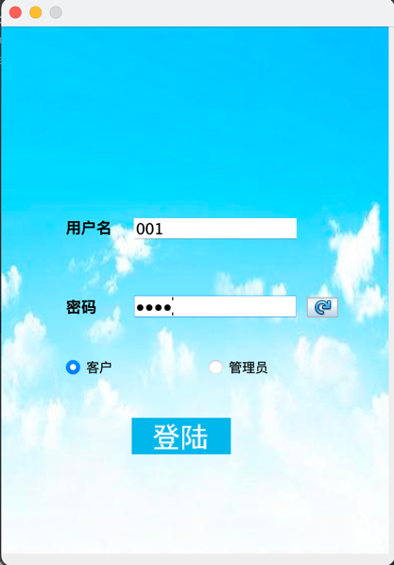

图4.6 登陆成功

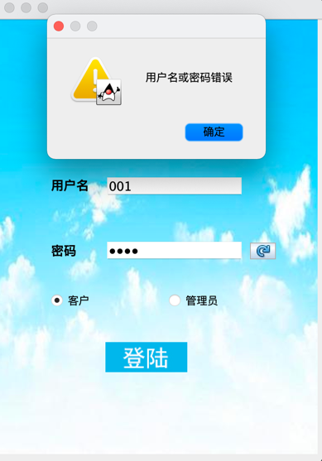

图4.7 登陆失败

（2）用户界面，如图4.8所示

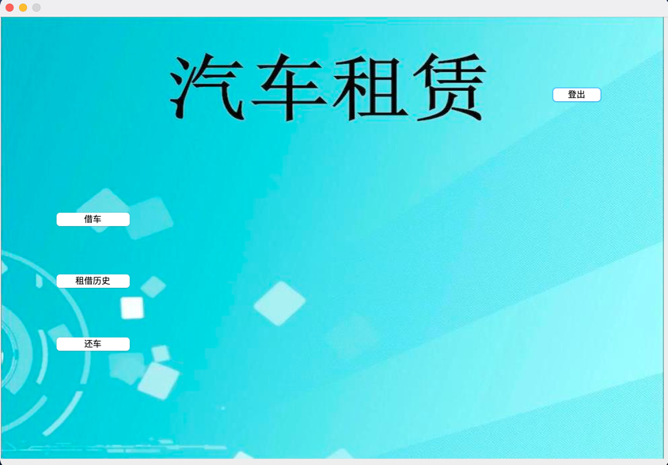

图4.8 用户界面

（3）借车界面，如图4.9所示

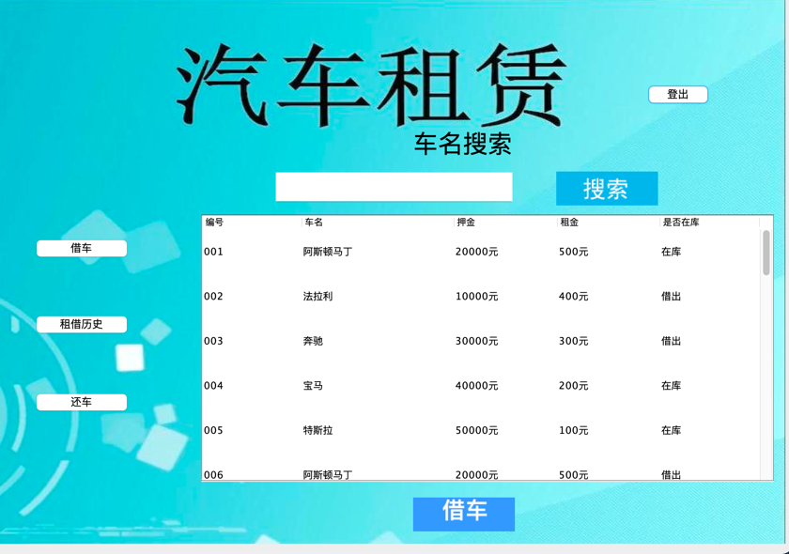

图4.9借车界面

搜索功能，如图4.10，4.11所示

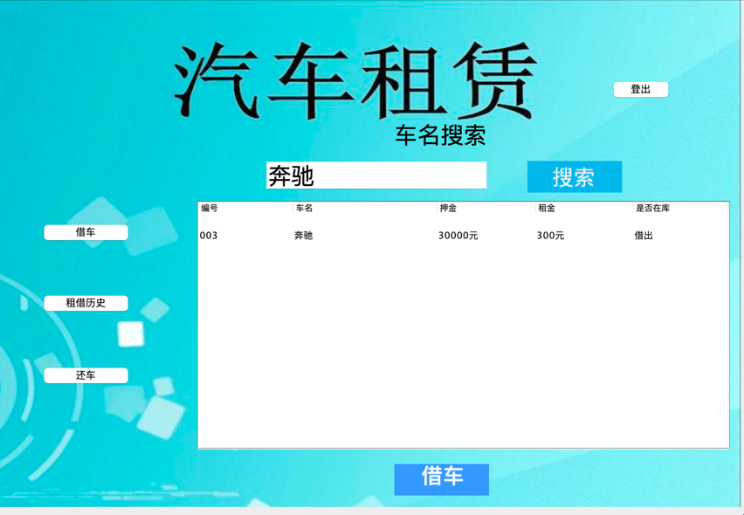

图4.10 借车搜索成功

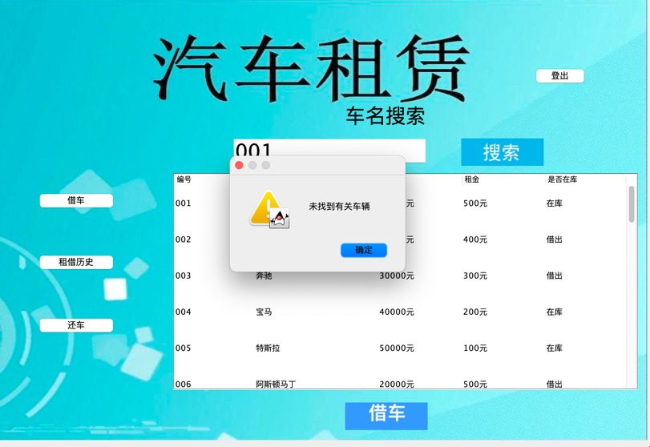

图4.11 搜索失败

借车成功，如图4.12所示

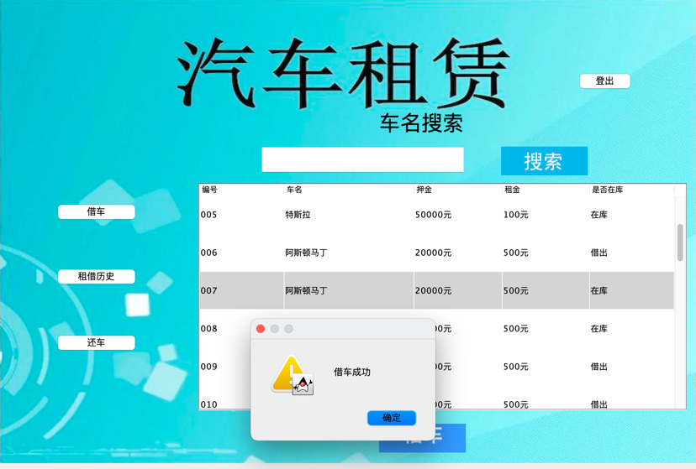

图4.12 借车成功

借车失败，如图4.13所示

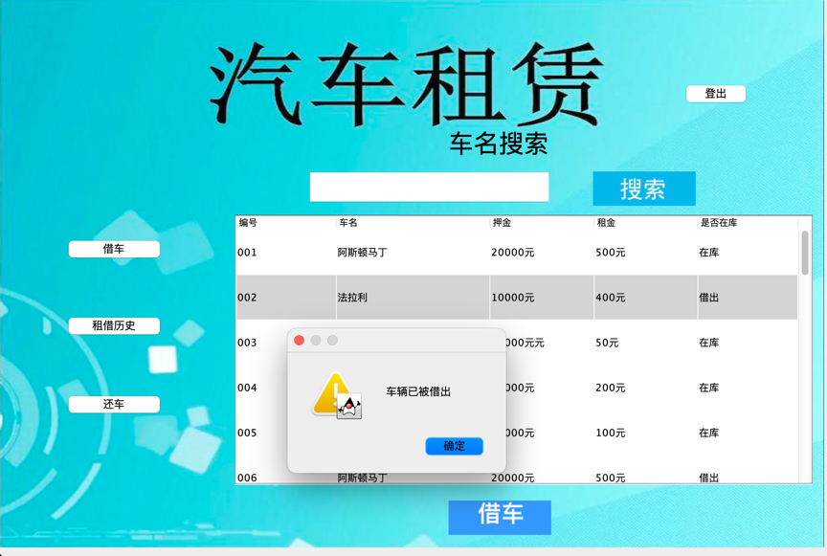

图4.13 借车失败

（4）租借历史，如图4.14所示

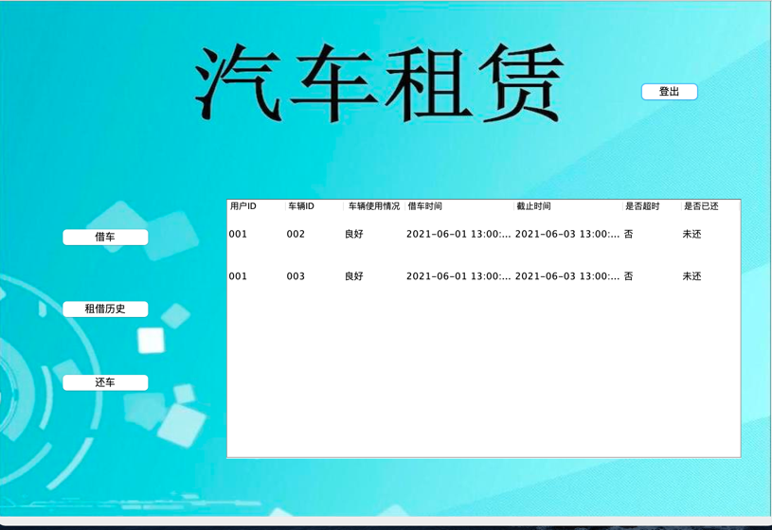

图4.14 租借历史

（5）还车界面，前台人员根据车辆使用情况帮助客户还车，如图4.15所示

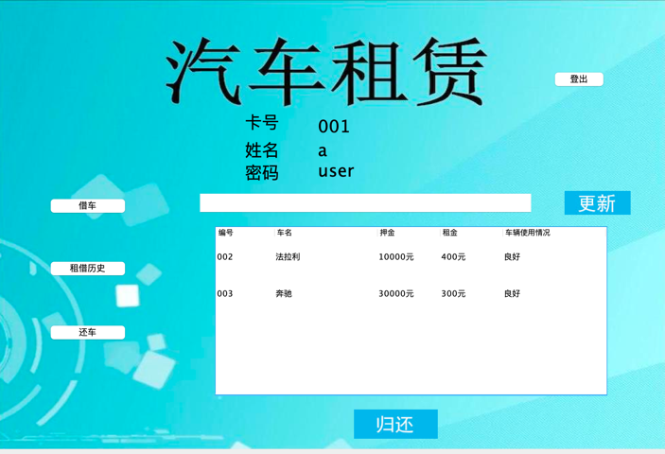

图4.15 还车界面

还车更新车辆情况，未选中车辆如图4.16所示

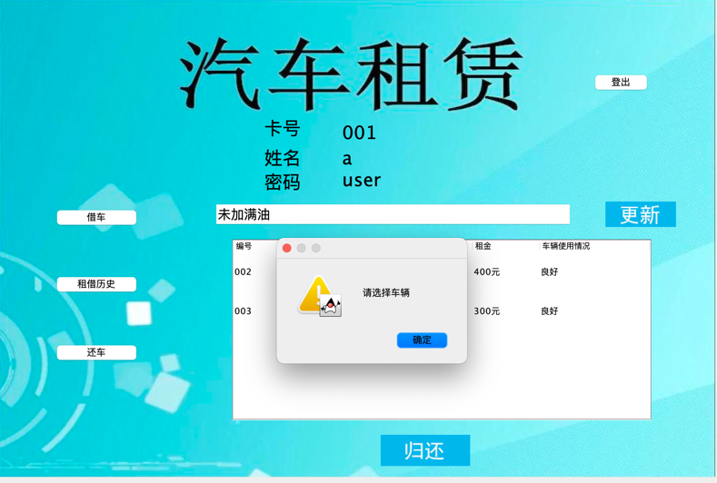

图4.16 未选中车辆

更新成功如图4.17所示

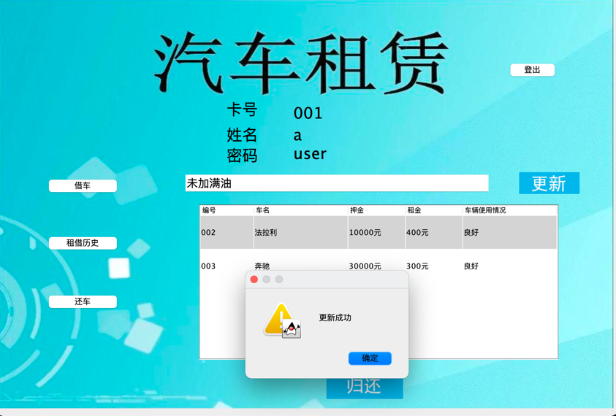

图4.17 更新成功

更新成功后再搜索，如图4.18所示

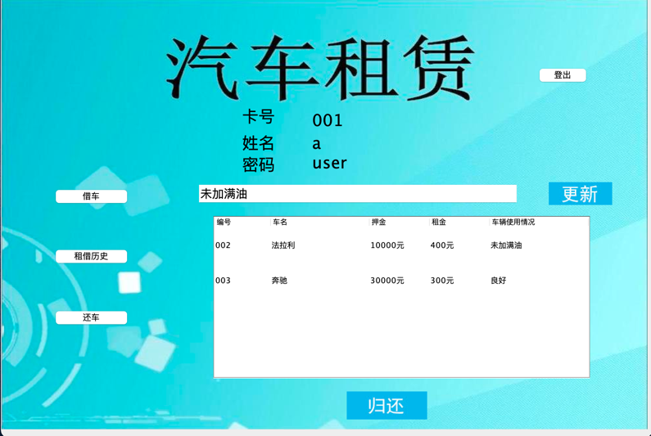

图4.18 更新成功

还车成功，如图4.19所示

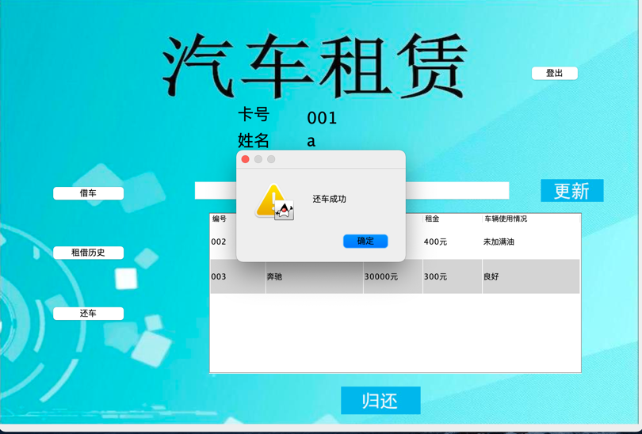

图4.19 还车成功

### 4.6.2 租车公司功能测试

（1）登陆界面，如图4.20所示

（2）租车公司功能界面，如图4.21所示

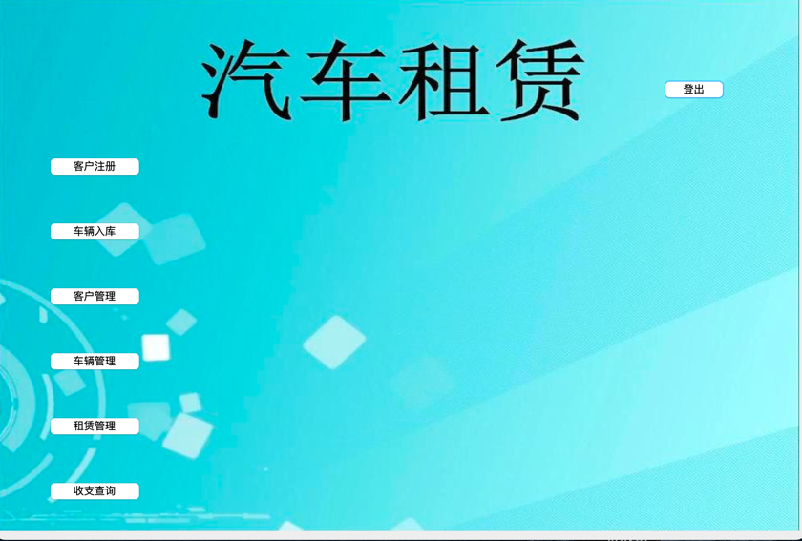

图4.21 租车公司界面

（3）客户注册功能，后台工作人员根据客户信息帮助客户完成注册。如图4.22所示

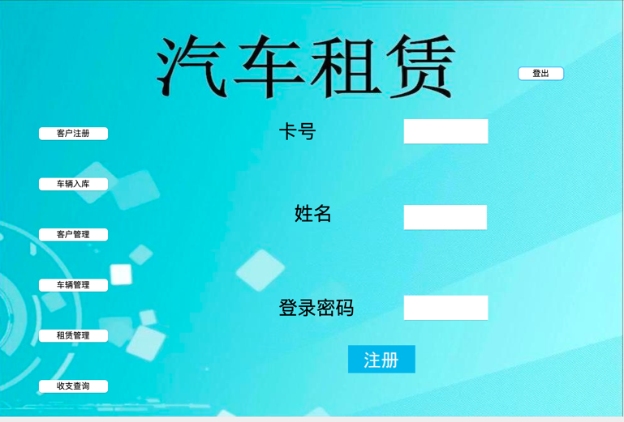

图4.22 客户注册功能

客户未输入完整资料，如图4.23所示

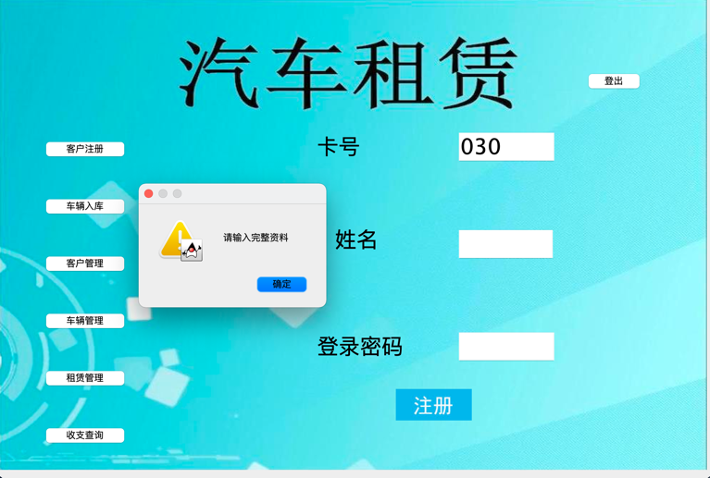

图4.23 客户注册未输入完整资料

重复注册，如图4.24所示

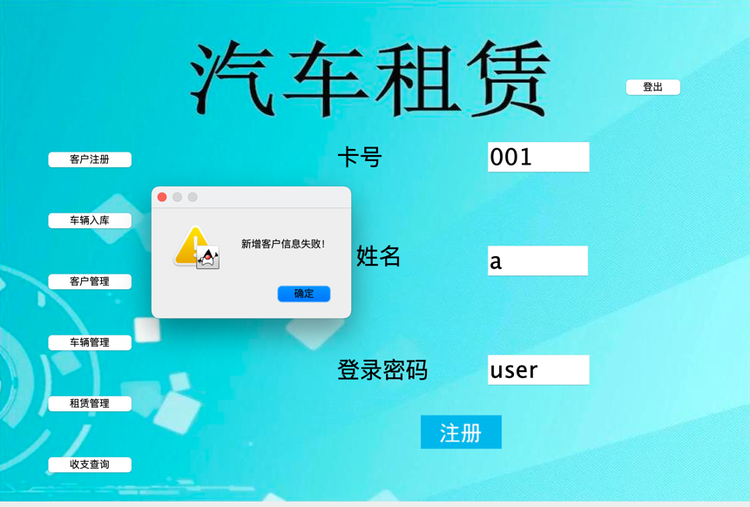

图4.24 重复注册

注册成功，如图4.25所示

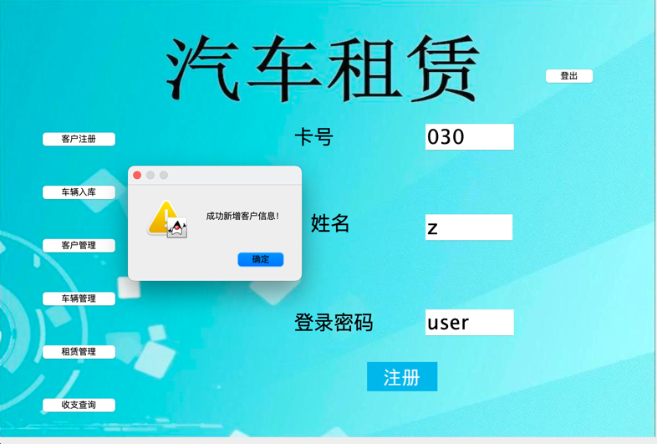

图4.25 注册成功

（4）车辆入库功能，如图4.26所示

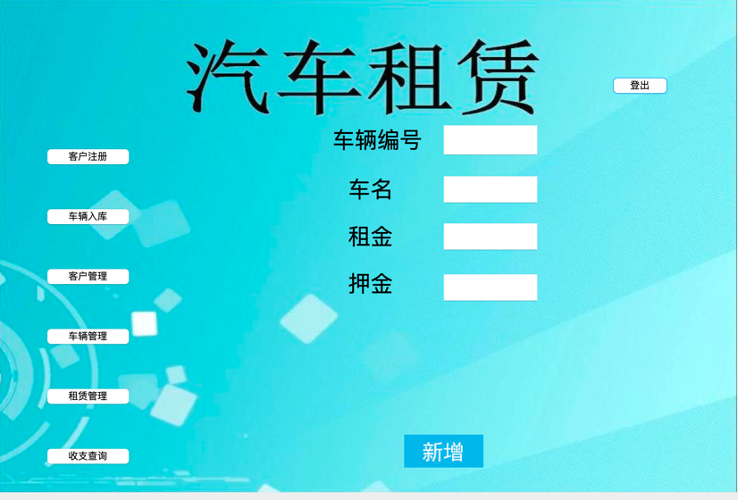

图4.26 车辆入库

车辆入库未输入完整资料，如图4.27所示

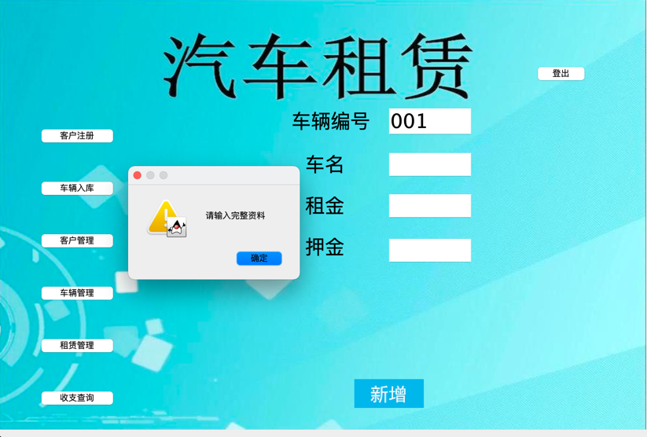

图4.27 车辆入库未输入完整资料

新增重复车辆编号，如图4.28所示

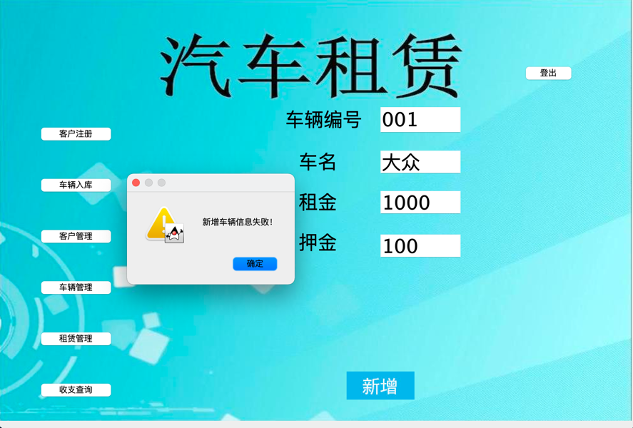

图4.28 重复入库

成功入库，如图4.29所示

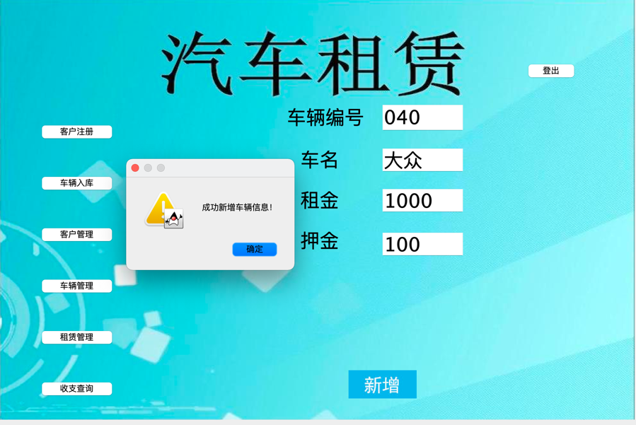

图4.29 成功入库

（5）客户管理功能，如图4.30所示

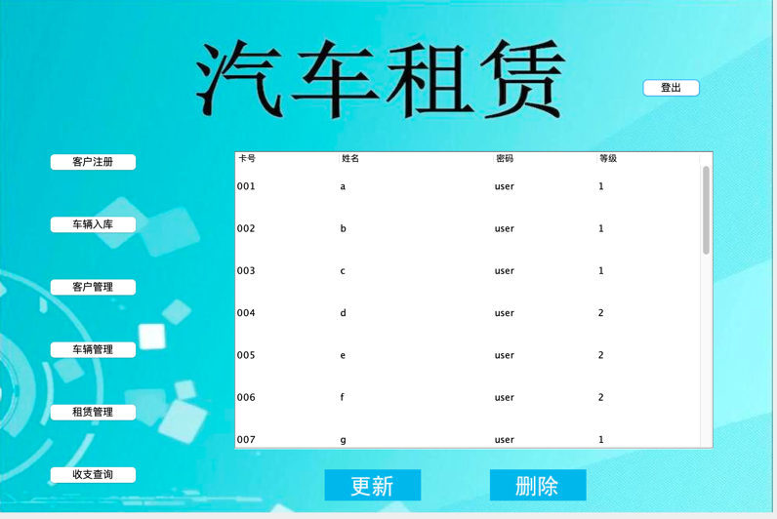

图4.30 客户管理

客户管理，更新如图4.31所示

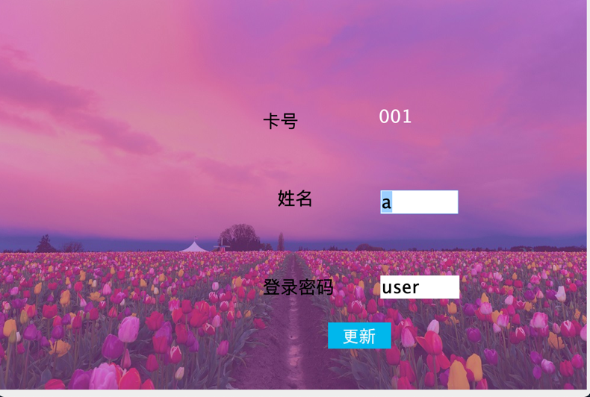

图4.31 客户更新

客户更新资料失败，如图4.32所示

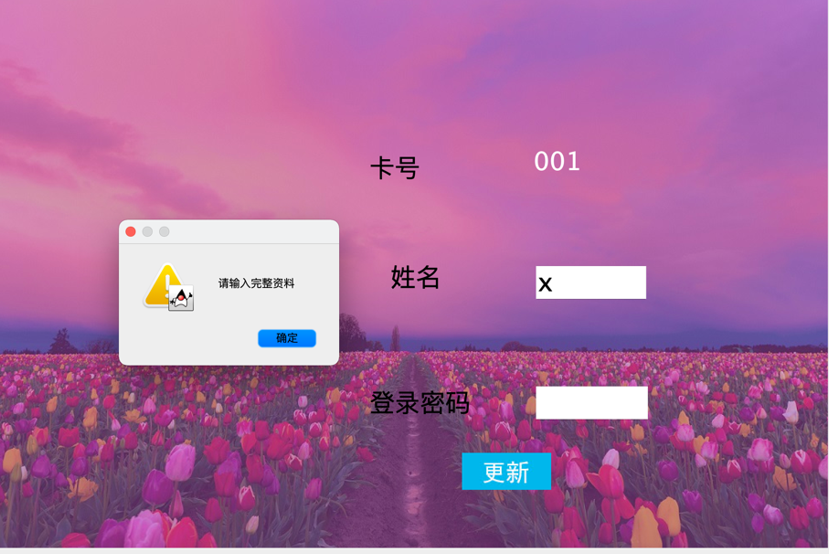

图4.32 客户更新资料失败

客户更新资料成功，如图4.33所示

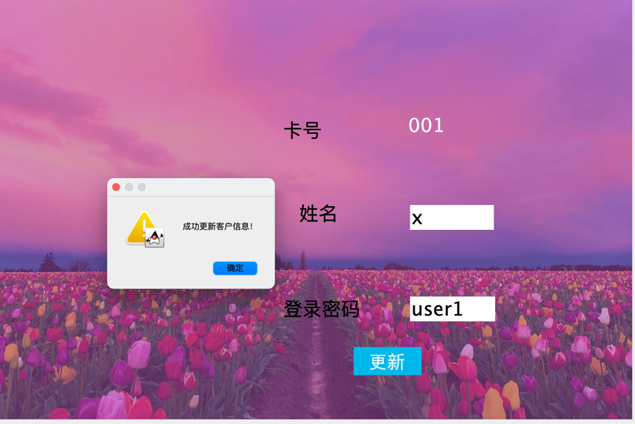

图4.33 客户更新资料成功

客户未选中就更新，如图4.34所示

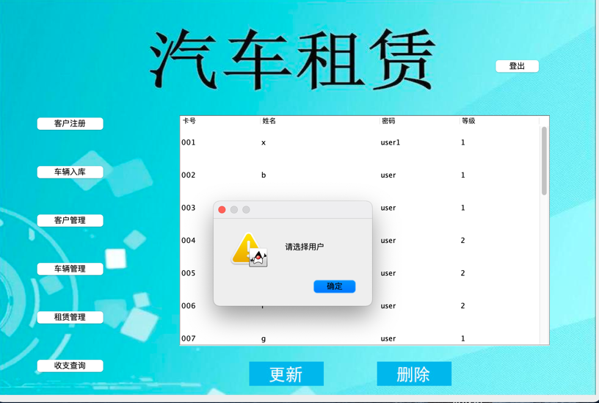

图4.34 客户未选中就更新

（6）车辆管理功能，如图4.35所示

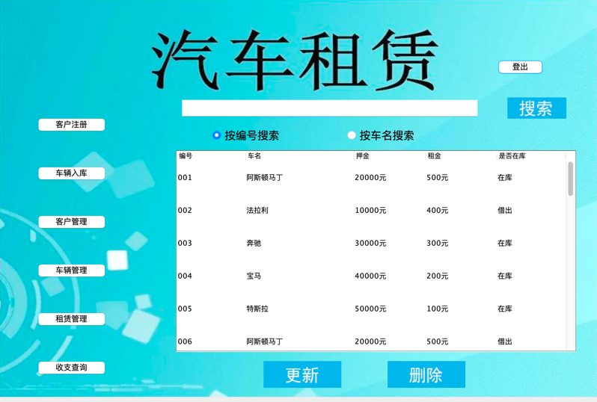

图4.35 车辆管理

按编号搜索，如图4.36所示

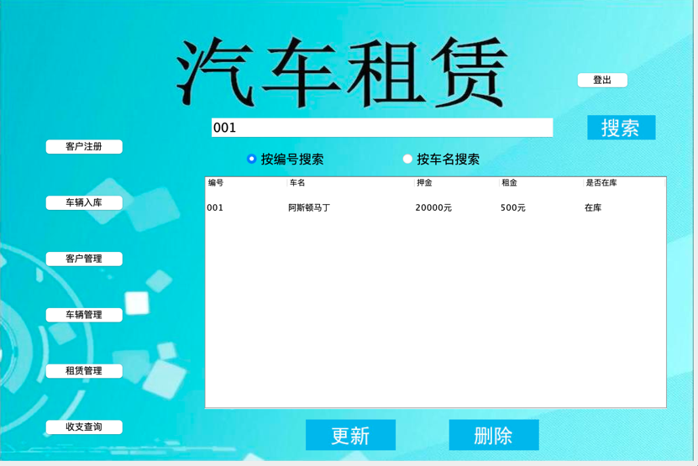

图4.36 按编号搜索

按车名搜索，如图4.37所示

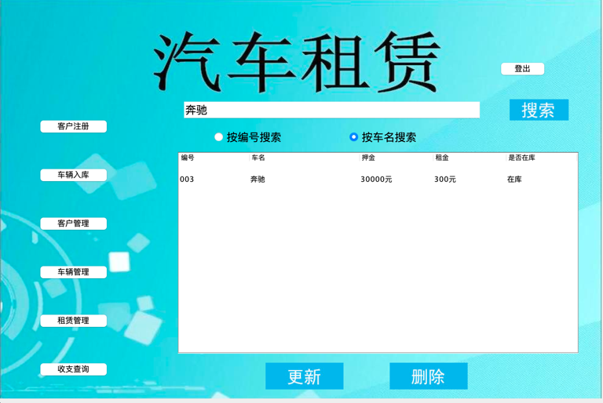

图4.37 按车名搜索

更新车辆信息，如图4.38所示

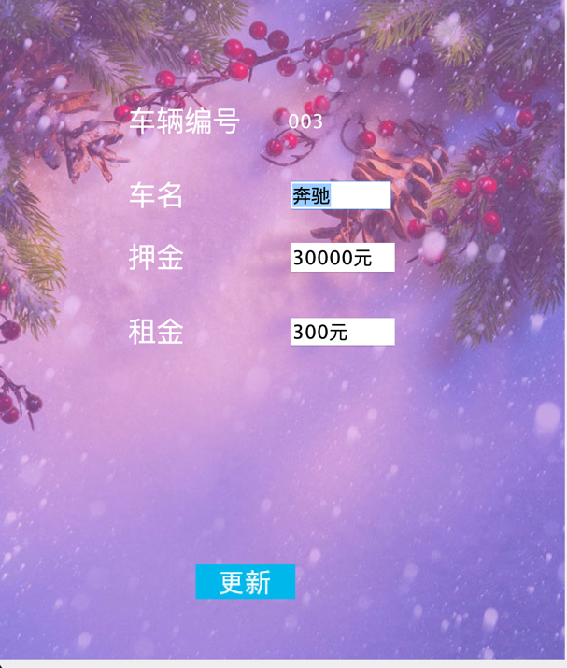

图4.38 更新车辆信息

更新车辆信息未输入完整资料，如图4.39所示

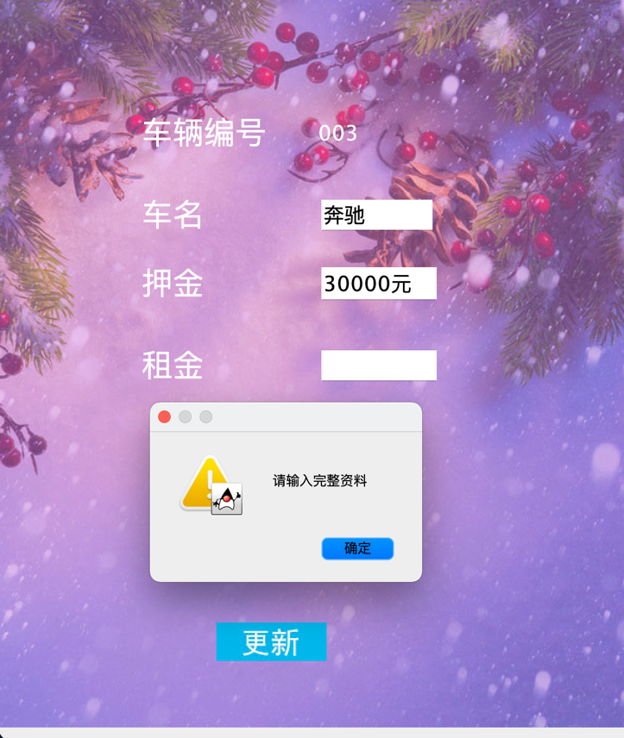

图4.39 车辆更新未输入完整资料

成功更新车辆信息，如图4.40所示

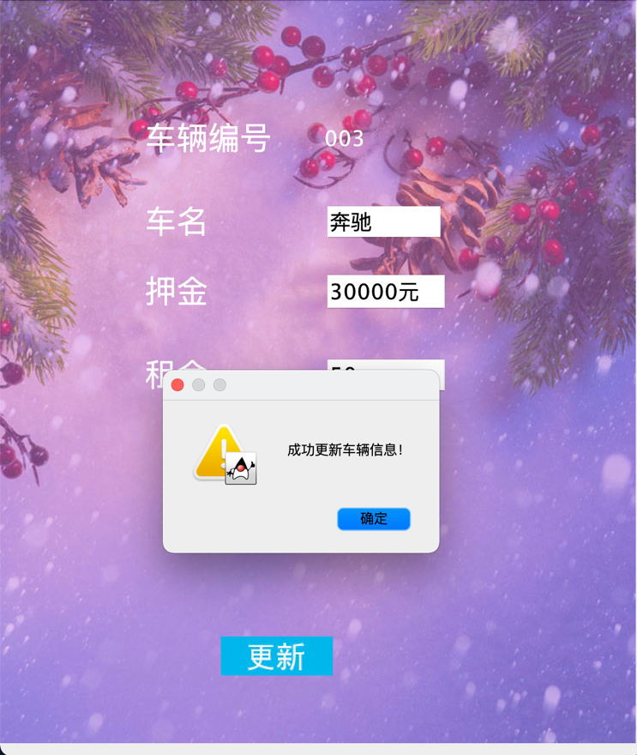

图4.40 成功更新车辆信息

（7）租赁管理功能，如图4.41所示

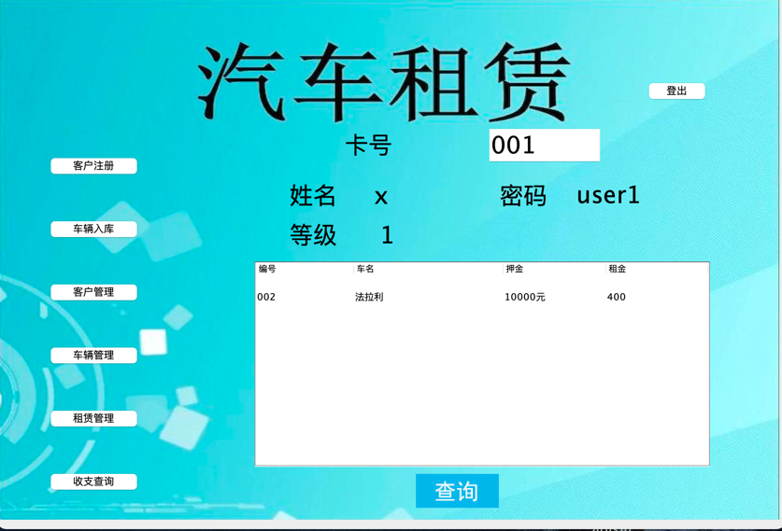

图4.41 租赁管理

搜索失败，如图4.42所示

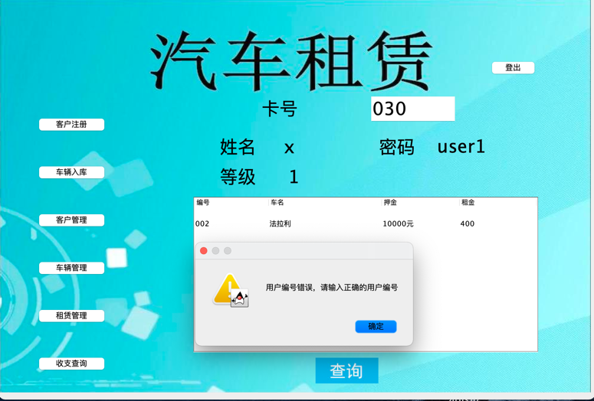

图4.42 搜索不存在的客户

（8）收支查询功能，如图4.43所示

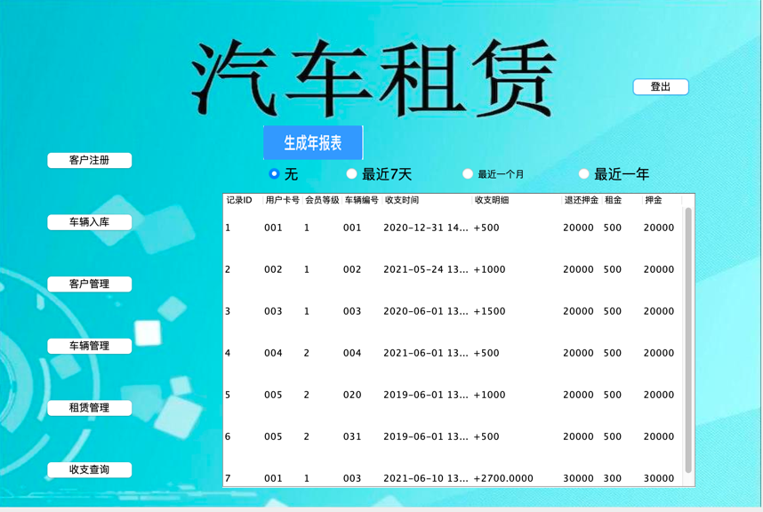

图4.43 收支查询

按最近7天查询，如图4.44所示

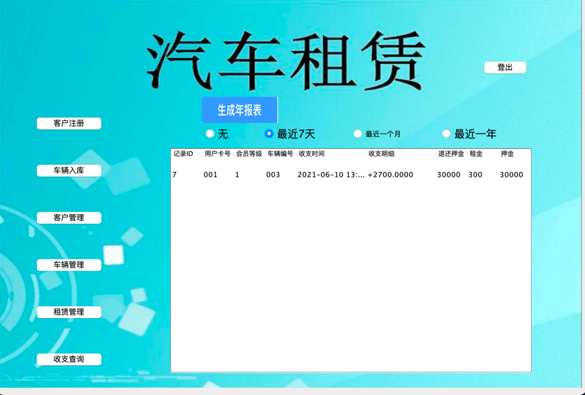

图4.44 最近7天

按最近一个月，如图4.45所示

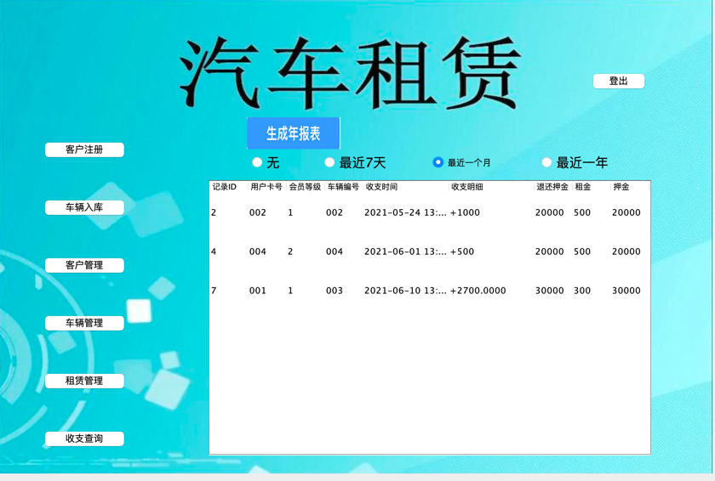

图4.45 最近一个月

按最近一年，如图4.46所示

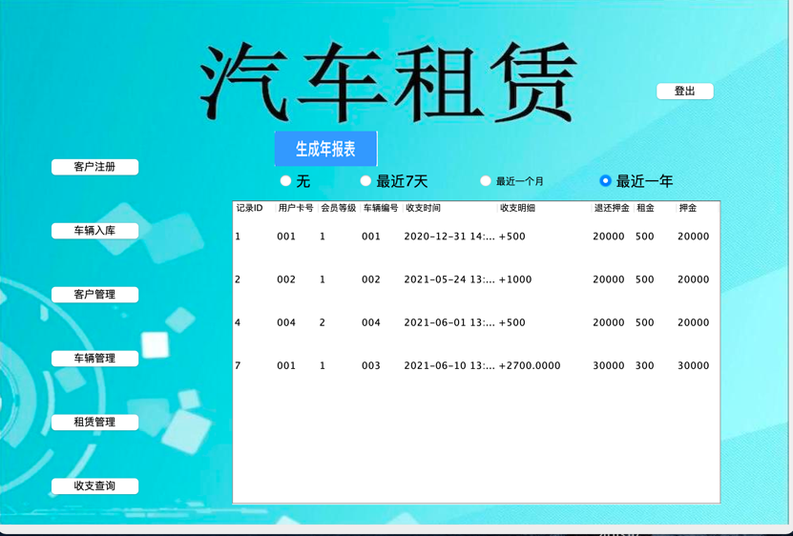

图4.46 最近一年

生成年份报表，如图4.47所示

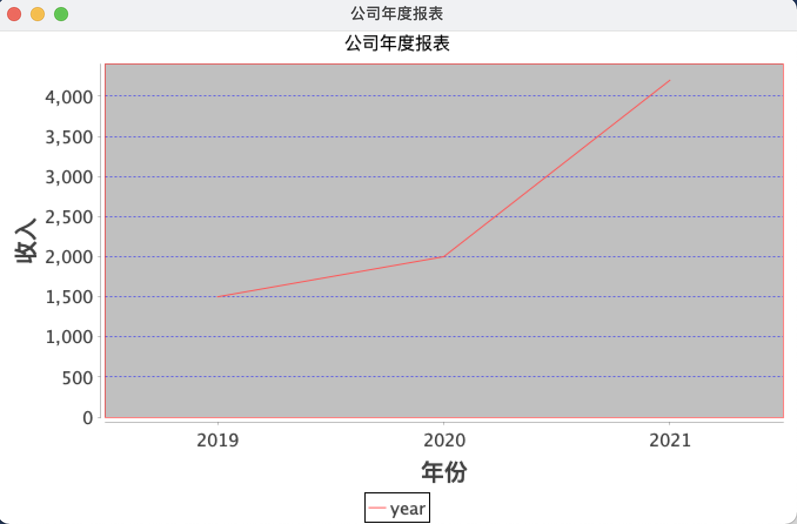

图4.47 公司年份报表生成

## 4.7 系统设计与实现总结

本系统最终可以完成以下功能：

1. 用户：

可以登陆，登出系统；

可以租车；

可以查看租车历史，包括已还和未还记录；

可以还车；

1. 租车公司：

可以登陆，登出系统；

可以注册用户；

可以新增车辆；

可以更新，删除用户资料；

可以更新，删除车辆资料；

可以通过用户卡号查询用户正在租借记录；

用户还车后可以生成对应的收支记录，公司可以进行收支查询并生成年度报表。

本系统具体实现历时7天，如图4.48所示

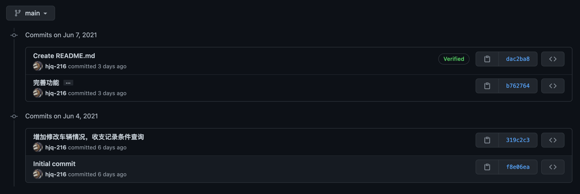

图4.48 git管理

本系统应用于汽车租借场景，用户界面为前台工作人员使用，设想为用户根据信息登陆后，前台工作人员可以帮助客户租，还车，是用户所能查看的界面。而公司界面应为前台工作人员管理车辆与用户的界面，不应给客户提供浏览。

# 5课程总结

本次实验实现了一个汽车租借功能，能简单模拟一个客户租，还车以及租车公司管理客户，车辆，收支等功能。

本次实验的难度不在于具体实现这个系统，而在于如何正确设计一个数据库系统。比如说E- R图，数据流图的设计，以及如何将E- R图转换为关系模式。问题就在于E- R图是表现实体之间的联系，而不需要体现功能。我最初更多在于把功能设计与E- R图混在了一起，导致关系模式有比较大的问题。还有数据流图应该表现数据的流动，也应与具体功能设计区分开。

此外，从头到尾设计一个规范的数据库让我收获良多，实习或者工作我可能更倾向于如何把一个功能实现出来而没有关注到如何正确的设计，本次实验虽然前期我没有做好设计，但顺序还是先做设计后做系统，可以发现这样做能思路清晰的完成一个应用的实现。

最后，希望该课程更加注重于数据库的设计，取消UI的设计，很多同学更多的精力都在于怎么使用高级语言做出一个页面，我觉得可以取消使用B/S或者C/S的要求，而利用别的方式考察数据库的使用。

# 附录：实验源代码

**建表**

-- 请在以下适当的空白位置填写SQL语句完成任务书的要求。空白位置不够的话，可以通过回车换行增加。

-- 表1 人员表(person)

DROP TABLE IF EXISTS person;

create table person(

id int,

fullname char(20) not null,

telephone char(11) not null,

constraint pk_person primary key (id)

);

-- 表2 地点表(location)

DROP TABLE IF EXISTS location;

create table location(

id int,

location_name char(20) not null,

constraint pk_location primary key (id)

);

-- 表3 行程表（itinerary）

DROP TABLE IF EXISTS itinerary;

create table itinerary(

id int,

p_id int,

loc_id int,

s_time datetime,

e_time datetime,

constraint fk_itinerary_pid foreign key (p_id) references person(id),

constraint fk_itinerary_lid foreign key (loc_id) references location(id),

constraint pk_itinerary primary key (id)

);

-- 表4 诊断表（diagnose_record）

DROP TABLE IF EXISTS diagnose_record;

create table diagnose_record (

id int,

p_id int,

diagnose_date datetime,

result int,

constraint fk_diagnose_pid foreign key (p_id) references person(id),

constraint pk_diagnose_record primary key (id)

);

-- 表5 密切接触者表（close_contact）

DROP TABLE IF EXISTS close_contact;

create table close_contact (

id int,

p_id int,

contact_date datetime,

loc_id int,

case_p_id int,

constraint fk_contact_pid foreign key (p_id) references person(id),

constraint fk_contact_lid foreign key (loc_id) references location(id),

constraint fk_contact_caseid foreign key (case_p_id) references person(id),

constraint pk_close_contact primary key (id)

);

-- 表6 隔离地点表（isolation_location）

DROP TABLE IF EXISTS isolation_location;

create table isolation_location (

id int,

location_name char(20),

capacity int,

constraint pk_isolation_loc primary key (id)

);

-- 表7 隔离表（isolation_record）

DROP TABLE IF EXISTS isolation_record;

create table isolation_record (

id int,

p_id int,

s_date datetime,

e_date datetime,

isol_loc_id int,

state int,

constraint fk_isolation_pid foreign key (p_id) references person(id),

constraint fk_isolation_lid foreign key (isol_loc_id) references isolation_location(id),

constraint pk_isolation primary key (id)

);

-- 代码结束

/* *********************************************************** */

**实验三代码：**

**sql语句：**

DROP TABLE IF EXISTS company CASCADE;

CREATE TABLE company(

cName VARCHAR(20) NOT NULL PRIMARY KEY,

cPassword VARCHAR(20) NOT NULL

);

INSERT INTO company VALUES('root','root');

INSERT INTO company VALUES('admin','root');

DROP TABLE IF EXISTS customer_level CASCADE;

DROP TABLE if EXISTS borrow;

DROP TABLE if EXISTS borrowed;

DROP TABLE IF EXISTS customer;

CREATE TABLE customer(

userID VARCHAR(20) NOT NULL PRIMARY KEY,

username VARCHAR(20) NOT NULL,

userPassword VARCHAR(20) NOT NULL

);

INSERT INTO customer VALUES('001','a','user');

INSERT INTO customer VALUES('002','b','user');

INSERT INTO customer VALUES('003','c','user');

INSERT INTO customer VALUES('004','d','user');

INSERT INTO customer VALUES('005','e','user');

INSERT INTO customer VALUES('006','f','user');

INSERT INTO customer VALUES('007','g','user');

INSERT INTO customer VALUES('008','h','user');

INSERT INTO customer VALUES('009','i','user');

INSERT INTO customer VALUES('010','j','user');

INSERT INTO customer VALUES('011','k','user');

INSERT INTO customer VALUES('012','l','user');

INSERT INTO customer VALUES('013','m','user');

INSERT INTO customer VALUES('014','n','user');

INSERT INTO customer VALUES('015','o','user');

INSERT INTO customer VALUES('016','p','user');

INSERT INTO customer VALUES('017','q','user');

INSERT INTO customer VALUES('018','r','user');

INSERT INTO customer VALUES('019','s','user');

INSERT INTO customer VALUES('020','t','user');

CREATE TABLE customer_level(

userID VARCHAR(20) NOT NULL,

borrowTimes INT NOT NULL DEFAULT 0,

overTimes INT NOT NULL DEFAULT 0,

userLevel INT NOT NULL DEFAULT 1,

FOREIGN KEY(userID) REFERENCES customer(userID)

);

INSERT INTO customer_level VALUES('001',DEFAULT,DEFAULT,DEFAULT);

INSERT INTO customer_level VALUES('002',DEFAULT,DEFAULT,DEFAULT);

INSERT INTO customer_level VALUES('003',DEFAULT,DEFAULT,DEFAULT);

INSERT INTO customer_level VALUES('004',DEFAULT,DEFAULT,2);

INSERT INTO customer_level VALUES('005',DEFAULT,DEFAULT,2);

INSERT INTO customer_level VALUES('006',DEFAULT,DEFAULT,2);

INSERT INTO customer_level VALUES('007',DEFAULT,DEFAULT,DEFAULT);

INSERT INTO customer_level VALUES('008',DEFAULT,DEFAULT,DEFAULT);

INSERT INTO customer_level VALUES('009',DEFAULT,DEFAULT,DEFAULT);

INSERT INTO customer_level VALUES('010',DEFAULT,DEFAULT,DEFAULT);

INSERT INTO customer_level VALUES('011',DEFAULT,DEFAULT,DEFAULT);

INSERT INTO customer_level VALUES('012',DEFAULT,DEFAULT,DEFAULT);

INSERT INTO customer_level VALUES('013',DEFAULT,DEFAULT,DEFAULT);

INSERT INTO customer_level VALUES('014',DEFAULT,DEFAULT,DEFAULT);

INSERT INTO customer_level VALUES('015',DEFAULT,DEFAULT,DEFAULT);

INSERT INTO customer_level VALUES('016',DEFAULT,DEFAULT,DEFAULT);

INSERT INTO customer_level VALUES('017',DEFAULT,DEFAULT,DEFAULT);

INSERT INTO customer_level VALUES('018',DEFAULT,DEFAULT,DEFAULT);

INSERT INTO customer_level VALUES('019',DEFAULT,DEFAULT,DEFAULT);

INSERT INTO customer_level VALUES('020',DEFAULT,DEFAULT,DEFAULT);

DROP TABLE IF EXISTS car;

CREATE TABLE car(

carID VARCHAR(20) NOT NULL PRIMARY KEY,

carName VARCHAR(20) NOT NULL,

carPrice VARCHAR(20) NOT NULL,

borrowPrice VARCHAR(20) NOT NULL

);

INSERT INTO car VALUES('001','阿斯顿马丁','20000','500');

INSERT INTO car VALUES('002','法拉利','10000','400');

INSERT INTO car VALUES('003','奔驰','30000','300');

INSERT INTO car VALUES('004','宝马','40000','200');

INSERT INTO car VALUES('005','特斯拉','50000','100');

INSERT INTO car VALUES('006','阿斯顿马丁','20000','500');

INSERT INTO car VALUES('007','阿斯顿马丁','20000','500');

INSERT INTO car VALUES('008','阿斯顿马丁','20000','500');

INSERT INTO car VALUES('009','阿斯顿马丁','20000','500');

INSERT INTO car VALUES('010','阿斯顿马丁','20000','500');

INSERT INTO car VALUES('011','阿斯顿马丁','20000','500');

INSERT INTO car VALUES('012','阿斯顿马丁','20000','500');

INSERT INTO car VALUES('013','阿斯顿马丁','20000','500');

INSERT INTO car VALUES('014','阿斯顿马丁','20000','500');

INSERT INTO car VALUES('015','阿斯顿马丁','20000','500');

INSERT INTO car VALUES('016','阿斯顿马丁','20000','500');

INSERT INTO car VALUES('017','阿斯顿马丁','20000','500');

INSERT INTO car VALUES('018','阿斯顿马丁','20000','500');

INSERT INTO car VALUES('019','阿斯顿马丁','20000','500');

INSERT INTO car VALUES('020','阿斯顿马丁','20000','500');

INSERT INTO car VALUES('021','阿斯顿马丁','20000','500');

INSERT INTO car VALUES('022','阿斯顿马丁','20000','500');

INSERT INTO car VALUES('023','阿斯顿马丁','20000','500');

INSERT INTO car VALUES('024','阿斯顿马丁','20000','500');

INSERT INTO car VALUES('025','阿斯顿马丁','20000','500');

INSERT INTO car VALUES('026','阿斯顿马丁','20000','500');

INSERT INTO car VALUES('027','阿斯顿马丁','20000','500');

INSERT INTO car VALUES('028','阿斯顿马丁','20000','500');

INSERT INTO car VALUES('029','阿斯顿马丁','20000','500');

INSERT INTO car VALUES('030','阿斯顿马丁','20000','500');

CREATE TABLE borrow(

userID VARCHAR(20) NOT NULL,

carID VARCHAR(20) NOT NULL,

carCondition VARCHAR(20) NOT NULL,

borrowTime DATE NOT NULL,

dueTime DATE NOT NULL,

overTime VARCHAR(20) NOT NULL DEFAULT '否',

FOREIGN KEY(userID) REFERENCES customer(userID),

FOREIGN KEY(carID) REFERENCES car(carID)

);

INSERT INTO borrow VALUES('001','002','良好','2021-06-01','2021-06-03',DEFAULT);

INSERT INTO borrow VALUES('002','006','交通违规','2021-06-01','2021-06-03',DEFAULT);

INSERT INTO borrow VALUES('003','020','未加满油','2021-06-01','2021-06-03',DEFAULT);

INSERT INTO borrow VALUES('004','010','良好','2021-04-01','2021-04-03',DEFAULT);

INSERT INTO borrow VALUES('005','011','未加满油','2021-05-01','2021-05-03',DEFAULT);

INSERT INTO borrow VALUES('005','012','交通违规','2021-03-29','2021-03-31',DEFAULT);

CREATE TABLE borrowed(

userID VARCHAR(20) NOT NULL,

carID VARCHAR(20) NOT NULL,

carCondition VARCHAR(20) NOT NULL,

borrowTime DATE NOT NULL,

dueTime DATE NOT NULL,

overTime VARCHAR(20) NOT NULL DEFAULT '否',

FOREIGN KEY(userID) REFERENCES customer(userID),

FOREIGN KEY(carID) REFERENCES car(carID)

);

INSERT INTO borrow VALUES('001','003','良好','2021-06-01','2021-06-03',DEFAULT);

INSERT INTO borrow VALUES('002','009','交通违规','2021-06-01','2021-06-03',DEFAULT);

DROP TABLE IF EXISTS money;

CREATE TABLE money(

moneyID INT NOT NULL PRIMARY KEY auto_increment,

userID VARCHAR(20) NOT NULL,

carID VARCHAR(20) NOT NULL,

moneyTime DATE,

moneyDetail VARCHAR(20),

moneyback VARCHAR(20),

price VARCHAR(20),

back VARCHAR(20)

)auto_increment=1;

INSERT INTO money(userID,carID,moneyTime,moneyDetail,moneyback,price,back) VALUES('001','001','2020-12-31','+500','20000','500','20000');

INSERT INTO money(userID,carID,moneyTime,moneyDetail,moneyback,price,back) VALUES('002','002','2021-05-24','+1000','20000','500','20000');

INSERT INTO money(userID,carID,moneyTime,moneyDetail,moneyback,price,back) VALUES('003','003','2020-06-01','+1500','20000','500','20000');

INSERT INTO money(userID,carID,moneyTime,moneyDetail,moneyback,price,back) VALUES('004','004','2021-06-01','+500','20000','500','20000');

INSERT INTO money(userID,carID,moneyTime,moneyDetail,moneyback,price,back) VALUES('005','020','2019-06-01','+1000','20000','500','20000');

INSERT INTO money(userID,carID,moneyTime,moneyDetail,moneyback,price,back) VALUES('005','031','2019-06-01','+500','20000','500','20000');

-- 在用户注册后自动产生等级表

DROP TRIGGER IF EXISTS customer_trigger;

delimiter ;;

CREATE TRIGGER customer_trigger

AFTER INSERT ON customer

FOR EACH ROW

BEGIN

INSERT INTO customer_level VALUES(new.userID,DEFAULT,DEFAULT,DEFAULT);

END;;

delimiter ;

-- 在还车后更新用户等级以及插入收支明细

DROP TRIGGER IF EXISTS borrow_trigger;

delimiter ;;

CREATE TRIGGER borrow_trigger

BEFORE DELETE ON borrow

FOR EACH ROW

BEGIN

UPDATE customer_level SET borrowTimes = borrowTimes + 1 WHERE userID = old.userID;

UPDATE customer_level SET overTimes = overTimes + 1 WHERE userID = old.userID AND CURRENT_DATE() > old.dueTime;

UPDATE customer_level SET userLevel = userLevel+((borrowTimes - overTimes)/100) WHERE userID = old.userID;

INSERT INTO borrowed VALUES(old.userID,old.carID,old.carCondition,old.borrowTime,old.dueTime,old.overTime);

IF(old.carCondition = '良好')

THEN

BEGIN

DECLARE price1 VARCHAR(20);

DECLARE back1 VARCHAR(20);

DECLARE level1 INT;

SET price1 = (SELECT borrowPrice FROM car WHERE carID = old.carID);

SET back1 = (SELECT carPrice FROM car WHERE carID = old.carID);

SET level1 = (SELECT userLevel FROM customer_level WHERE userID = old.userID);

INSERT INTO money(userID,carID,moneyTime,moneyDetail,moneyback,price,back) VALUES(old.userID,old.carID,CURRENT_DATE()

,CONCAT('+',CONVERT(CONVERT(TO_DAYS(CURRENT_DATE())-TO_DAYS(old.borrowTime),UNSIGNED)*CONVERT(price1,UNSIGNED)/level1,CHAR(20)))

,back1,price1,back1) ;

END;

END IF;

IF(old.carCondition = '未加满油')

THEN

BEGIN

DECLARE price1 VARCHAR(20);

DECLARE back1 VARCHAR(20);

DECLARE level1 INT;

SET price1 = (SELECT borrowPrice FROM car WHERE carID = old.carID);

SET back1 = (SELECT carPrice FROM car WHERE carID = old.carID);

SET level1 = (SELECT userLevel FROM customer_level WHERE userID = old.userID);

INSERT INTO money(userID,carID,moneyTime,moneyDetail,moneyback,price,back) VALUES(old.userID,old.carID,CURRENT_DATE()

,CONCAT('+',CONVERT(CONVERT(TO_DAYS(CURRENT_DATE())-TO_DAYS(old.borrowTime),UNSIGNED)*CONVERT(price1,UNSIGNED)/level1+100,CHAR(20)))

,CONVERT(CONVERT(back1,UNSIGNED)-100,char(20)),price1,back1) ;

END;

END IF;

IF(old.carCondition = '交通违规')

THEN

BEGIN

DECLARE price1 VARCHAR(20);

DECLARE back1 VARCHAR(20);

DECLARE level1 INT;

SET price1 = (SELECT borrowPrice FROM car WHERE carID = old.carID);

SET back1 = (SELECT carPrice FROM car WHERE carID = old.carID);

SET level1 = (SELECT userLevel FROM customer_level WHERE userID = old.userID);

INSERT INTO money(userID,carID,moneyTime,moneyDetail,moneyback,price,back) VALUES(old.userID,old.carID,CURRENT_DATE()

,CONCAT('+',CONVERT(CONVERT(TO_DAYS(CURRENT_DATE())-TO_DAYS(old.borrowTime),UNSIGNED)*CONVERT(price1,UNSIGNED)/level1+CONVERT(back1,UNSIGNED),CHAR(20)))

,'0',price1,back1) ;

END;

END IF;

END;;

**高级语言：**

package lab3.database.course.dao;

import java.util.Date;

import java.util.Objects;

public class Borrow {

private String userID;

private String carID;

private String carCondition;

private Date borrowTime;

private Date dueTime;

private String overTime;

public String getUserID() {

return userID;

}

public void setUserID(String userID) {

this.userID = userID;

}

public String getCarID() {

return carID;

}

public void setCarID(String carID) {

this.carID = carID;

}

public String getCarCondition() {

return carCondition;

}

public void setCarCondition(String carCondition) {

this.carCondition = carCondition;

}

public Date getBorrowTime() {

return borrowTime;

}

public void setBorrowTime(Date borrowTime) {

this.borrowTime = borrowTime;

}

public Date getDueTime() {

return dueTime;

}

public void setDueTime(Date dueTime) {

this.dueTime = dueTime;

}

public String getOverTime() {

return overTime;

}

public void setOverTime(String overTime) {

this.overTime = overTime;

}

@Override

public boolean equals(Object o) {

if (this == o) return true;

if (!(o instanceof Borrow)) return false;

Borrow borrow = (Borrow) o;

return getUserID().equals(borrow.getUserID()) && getCarID().equals(borrow.getCarID()) && getCarCondition().equals(borrow.getCarCondition()) && getBorrowTime().equals(borrow.getBorrowTime()) && getDueTime().equals(borrow.getDueTime()) && getOverTime().equals(borrow.getOverTime());

}

@Override

public int hashCode() {

return Objects.hash(getUserID(), getCarID(), getCarCondition(), getBorrowTime(), getDueTime(), getOverTime());

}

@Override

public String toString() {

return "Borrow{" +

"userID='" + userID + '\'' +

", carID='" + carID + '\'' +

", carCondition='" + carCondition + '\'' +

", borrowTime=" + borrowTime +

", dueTime=" + dueTime +

", overTime='" + overTime + '\'' +

'}';

}

}

package lab3.database.course.dao;

import java.util.Date;

import java.util.Objects;

public class Borrowed {

private String userID;

private String carID;

private String carCondition;

private Date borrowTime;

private Date dueTime;

private String overTime;

public String getUserID() {

return userID;

}

public void setUserID(String userID) {

this.userID = userID;

}

public String getCarID() {

return carID;

}

public void setCarID(String carID) {

this.carID = carID;

}

public String getCarCondition() {

return carCondition;

}

public void setCarCondition(String carCondition) {

this.carCondition = carCondition;

}

public Date getBorrowTime() {

return borrowTime;

}

public void setBorrowTime(Date borrowTime) {

this.borrowTime = borrowTime;

}

public Date getDueTime() {

return dueTime;

}

public void setDueTime(Date dueTime) {

this.dueTime = dueTime;

}

public String getOverTime() {

return overTime;

}

public void setOverTime(String overTime) {

this.overTime = overTime;

}

@Override

public boolean equals(Object o) {

if (this == o) return true;

if (!(o instanceof Borrowed)) return false;

Borrowed borrowed = (Borrowed) o;

return getUserID().equals(borrowed.getUserID()) && getCarID().equals(borrowed.getCarID()) && getCarCondition().equals(borrowed.getCarCondition()) && getBorrowTime().equals(borrowed.getBorrowTime()) && getDueTime().equals(borrowed.getDueTime()) && getOverTime().equals(borrowed.getOverTime());

}

@Override

public int hashCode() {

return Objects.hash(getUserID(), getCarID(), getCarCondition(), getBorrowTime(), getDueTime(), getOverTime());

}

@Override

public String toString() {

return "Borrowed{" +

"userID='" + userID + '\'' +

", carID='" + carID + '\'' +

", carCondition='" + carCondition + '\'' +

", borrowTime=" + borrowTime +

", dueTime=" + dueTime +

", overTime='" + overTime + '\'' +

'}';

}

}

package lab3.database.course.dao;

import java.util.Objects;

public class Car {

private String carID;

private String carName;

private String carPrice;

private String borrowPrice;

public String getCarID() {

return carID;

}

public void setCarID(String carID) {

this.carID = carID;

}

public String getCarName() {

return carName;

}

public void setCarName(String carName) {

this.carName = carName;

}

public String getCarPrice() {

return carPrice;

}

public void setCarPrice(String carPrice) {

this.carPrice = carPrice;

}

public String getBorrowPrice() {

return borrowPrice;

}

public void setBorrowPrice(String borrowPrice) {

this.borrowPrice = borrowPrice;

}

@Override

public boolean equals(Object o) {

if (this == o) return true;

if (!(o instanceof Car)) return false;

Car car = (Car) o;

return getCarID().equals(car.getCarID()) && getCarName().equals(car.getCarName()) && getCarPrice().equals(car.getCarPrice()) && getBorrowPrice().equals(car.getBorrowPrice());

}

@Override

public int hashCode() {

return Objects.hash(getCarID(), getCarName(), getCarPrice(), getBorrowPrice());

}

@Override

public String toString() {

return "Car{" +

"carID='" + carID + '\'' +

", carName='" + carName + '\'' +

", carPrice='" + carPrice + '\'' +

", borrowPrice='" + borrowPrice + '\'' +

'}';

}

}

package lab3.database.course.dao;

import java.util.Objects;

public class Company {

private String cName;

private String cPassword;

public String getcName() {

return cName;

}

public void setcName(String cName) {

this.cName = cName;

}

public String getcPassword() {

return cPassword;

}

public void setcPassword(String cPassword) {

this.cPassword = cPassword;

}

@Override

public boolean equals(Object o) {

if (this == o) return true;

if (!(o instanceof Company)) return false;

Company company = (Company) o;

return getcName().equals(company.getcName()) && getcPassword().equals(company.getcPassword());

}

@Override

public int hashCode() {

return Objects.hash(getcName(), getcPassword());

}

@Override

public String toString() {

return "Company{" +

"cName='" + cName + '\'' +

", cPassword='" + cPassword + '\'' +

'}';

}

}

package lab3.database.course.dao;

import java.util.Objects;

public class Customer {

private String userID;

private String username;

private String userPassword;

public String getUserID() {

return userID;

}

public void setUserID(String userID) {

this.userID = userID;

}

public String getUsername() {

return username;

}

public void setUsername(String username) {

this.username = username;

}

public String getUserPassword() {

return userPassword;

}

public void setUserPassword(String userPassword) {

this.userPassword = userPassword;

}

@Override

public boolean equals(Object o) {

if (this == o) return true;

if (!(o instanceof Customer)) return false;

Customer customer = (Customer) o;

return getUserID().equals(customer.getUserID()) && getUsername().equals(customer.getUsername()) && getUserPassword().equals(customer.getUserPassword());

}

@Override

public int hashCode() {

return Objects.hash(getUserID(), getUsername(), getUserPassword());

}

@Override

public String toString() {

return "Customer{" +

"userID='" + userID + '\'' +

", username='" + username + '\'' +

", userPassword='" + userPassword + '\'' +

'}';

}

}

package lab3.database.course.dao;

import java.util.Objects;

public class CustomerLevel {

private String userID;

private int borrowTimes;

private int overTimes;

private int userLevel;

public String getUserID() {

return userID;

}

public void setUserID(String userID) {

this.userID = userID;

}

public int getBorrowTimes() {

return borrowTimes;

}

public void setBorrowTimes(int borrowTimes) {

this.borrowTimes = borrowTimes;

}

public int getOverTimes() {

return overTimes;

}

public void setOverTimes(int overTimes) {

this.overTimes = overTimes;

}

public int getUserLevel() {

return userLevel;

}

public void setUserLevel(int userLevel) {

this.userLevel = userLevel;

}

@Override

public boolean equals(Object o) {

if (this == o) return true;

if (!(o instanceof CustomerLevel)) return false;

CustomerLevel that = (CustomerLevel) o;

return getBorrowTimes() == that.getBorrowTimes() && getOverTimes() == that.getOverTimes() && getUserLevel() == that.getUserLevel() && getUserID().equals(that.getUserID());

}

@Override

public int hashCode() {

return Objects.hash(getUserID(), getBorrowTimes(), getOverTimes(), getUserLevel());

}

@Override

public String toString() {

return "CustomerLevel{" +

"userID='" + userID + '\'' +

", borrowTimes=" + borrowTimes +

", overTimes=" + overTimes +

", userLevel=" + userLevel +

'}';

}

}

package lab3.database.course.dao;

import java.util.Date;

import java.util.Objects;

public class Money {

private String moneyID;

private String userID;

private String carID;

private Date moneyTime;

private String moneyDetail;

private String moneyback;

private String price;

private String back;

public String getMoneyID() {

return moneyID;

}

public void setMoneyID(String moneyID) {

this.moneyID = moneyID;

}

public String getUserID() {

return userID;

}

public void setUserID(String userID) {

this.userID = userID;

}

public String getCarID() {

return carID;

}

public void setCarID(String carID) {

this.carID = carID;

}

public Date getMoneyTime() {

return moneyTime;

}

public void setMoneyTime(Date moneyTime) {

this.moneyTime = moneyTime;

}

public String getMoneyDetail() {

return moneyDetail;

}

public void setMoneyDetail(String moneyDetail) {

this.moneyDetail = moneyDetail;

}

public String getMoneyback() {

return moneyback;

}

public void setMoneyback(String moneyback) {

this.moneyback = moneyback;

}

public String getPrice() {

return price;

}

public void setPrice(String price) {

this.price = price;

}

public String getBack() {

return back;

}

public void setBack(String back) {

this.back = back;

}

@Override

public boolean equals(Object o) {

if (this == o) return true;

if (!(o instanceof Money)) return false;

Money money = (Money) o;

return getMoneyID().equals(money.getMoneyID()) && getUserID().equals(money.getUserID()) && getCarID().equals(money.getCarID()) && getMoneyTime().equals(money.getMoneyTime()) && getMoneyDetail().equals(money.getMoneyDetail()) && getMoneyback().equals(money.getMoneyback()) && getPrice().equals(money.getPrice()) && getBack().equals(money.getBack());

}

@Override

public int hashCode() {

return Objects.hash(getMoneyID(), getUserID(), getCarID(), getMoneyTime(), getMoneyDetail(), getMoneyback(), getPrice(), getBack());

}

@Override

public String toString() {

return "Money{" +

"moneyID='" + moneyID + '\'' +

", userID='" + userID + '\'' +

", carID='" + carID + '\'' +

", moneyTime=" + moneyTime +

", moneyDetail='" + moneyDetail + '\'' +

", moneyback='" + moneyback + '\'' +

", price='" + price + '\'' +

", back='" + back + '\'' +

'}';

}

}

package lab3.database.course.database;

import java.sql.Connection;

import java.sql.DriverManager;

import java.sql.SQLException;

public class DatabaseTools {

public Connection conn=null;

public Connection getConn() {

try {

Class.forName("com.mysql.cj.jdbc.Driver"); //定义MySQL的数据库驱动程序

String DBURL= "jdbc:mysql://localhost:3306/carCompany?useUnicode=true&characterEncoding=utf-8&useSSL=false"; //定义MySQL的数据库连接地址

String DBUSER = "root"; //MySQL数据库的连接用户名

String DBPASS = "hjq216HJQ"; //MySQL数据库的连接密码

conn= DriverManager.getConnection(DBURL, DBUSER, DBPASS);

} catch (ClassNotFoundException e) {

e.printStackTrace();

} catch (SQLException e) {

e.printStackTrace();

}

return conn;

}

}

package lab3.database.course.frame;

import lab3.database.course.dao.Car;

import lab3.database.course.sqltools.BorrowTools;

import lab3.database.course.sqltools.CarTools;

import javax.swing.*;

import javax.swing.border.EmptyBorder;

import javax.swing.table.DefaultTableModel;

import java.awt.*;

import java.awt.event.ActionEvent;

import java.awt.event.ActionListener;

import java.awt.event.ItemEvent;

import java.awt.event.ItemListener;

import java.util.Iterator;

import java.util.List;

public class All_CarFrame extends JFrame implements ItemListener {

private static final long serialVersionUID = 1L;

private JPanel contentPane;

private JScrollPane carScrollPane;

public JTable carJtable;

private DefaultTableModel defaultModel;

public int row;

private JButton updateButton;

private JButton deleteButton;

private JButton searchButton;

private String searchType = "idCar";

private JRadioButton nameCarRadioButton;

private JRadioButton idCarRadioButton;

private ButtonGroup group;

private JTextField searchtextField;

public All_CarFrame()

{

setResizable(false);

setDefaultCloseOperation(JFrame.DISPOSE_ON_CLOSE);

setBounds(100, 100, 996, 699);

contentPane = new JPanel();

contentPane.setBorder(new EmptyBorder(5, 5, 5, 5));

setContentPane(contentPane);

contentPane.setLayout(null);

JButton reader_Registerbutton = new JButton("客户注册");

reader_Registerbutton.addActionListener(new ActionListener() {

public void actionPerformed(ActionEvent e) {

Customer_RegisterFrame customer_registerFrame = new Customer_RegisterFrame();

customer_registerFrame.setVisible(true);

CloseFrame();

}

});

reader_Registerbutton.setBounds(60, 197, 123, 29);

contentPane.add(reader_Registerbutton);

JButton book_Registerbutton = new JButton("车辆入库");

book_Registerbutton.addActionListener(new ActionListener() {

public void actionPerformed(ActionEvent e) {

Car_RegisterFrame car_registerFrame = new Car_RegisterFrame();

car_registerFrame.setVisible(true);

CloseFrame();

}

});

book_Registerbutton.setBounds(60, 277, 123, 29);

contentPane.add(book_Registerbutton);

JButton all_Readerbutton = new JButton("客户管理");

all_Readerbutton.addActionListener(new ActionListener() {

public void actionPerformed(ActionEvent e) {

All_CustomerFrame all_customerFrame = new All_CustomerFrame();

all_customerFrame.setVisible(true);

CloseFrame();

}

});

all_Readerbutton.setBounds(60, 357, 123, 29);

contentPane.add(all_Readerbutton);

JButton all_Bookbutton = new JButton("车辆管理");

all_Bookbutton.addActionListener(new ActionListener() {

public void actionPerformed(ActionEvent e) {

All_CarFrame all_carFrame = new All_CarFrame();

all_carFrame.setVisible(true);

CloseFrame();

}

});

all_Bookbutton.setBounds(60, 437, 123, 29);

contentPane.add(all_Bookbutton);

JButton checkReader_button = new JButton("租赁管理");

checkReader_button.addActionListener(new ActionListener() {

public void actionPerformed(ActionEvent e) {

CheckCustomerFrame checkCustomerFrame = new CheckCustomerFrame();

checkCustomerFrame.setVisible(true);

CloseFrame();

}

});

checkReader_button.setBounds(60, 517, 123, 29);

contentPane.add(checkReader_button);

JButton monetShow_button = new JButton("收支查询");

monetShow_button.addActionListener(new ActionListener() {

public void actionPerformed(ActionEvent e) {

Money_ShowFrame money_showFrame = new Money_ShowFrame();

money_showFrame.setVisible(true);

CloseFrame();

}

});

monetShow_button.setBounds(60, 597, 123, 29);

contentPane.add(monetShow_button);

JButton log_out_Button = new JButton("登出");

log_out_Button.addActionListener(new ActionListener() {

public void actionPerformed(ActionEvent e) {

LoginFrame loginframe = new LoginFrame();

loginframe.setVisible(true);

CloseFrame();

}

});

log_out_Button.setBounds(817, 102, 85, 29);

contentPane.add(log_out_Button);

carScrollPane = new JScrollPane();

carScrollPane.setBounds(293, 253, 658, 332);

contentPane.add(carScrollPane);

deleteButton = new JButton(new ImageIcon("image/delete.jpg"));

deleteButton.addActionListener(new ActionListener() {

public void actionPerformed(ActionEvent e) {

delete_Book();

}

});

deleteButton.setBounds(641, 600, 128, 44);

contentPane.add(deleteButton);

searchtextField = new JTextField();

searchtextField.setFont(new Font("宋体", Font.PLAIN, 18));

searchtextField.setBounds(300, 166, 492, 35);

contentPane.add(searchtextField);

searchtextField.setColumns(10);

searchButton = new JButton(new ImageIcon("image/search.jpg"));

searchButton.addActionListener(new ActionListener() {

public void actionPerformed(ActionEvent e) {

do_search_car();

}

});

searchButton.setBounds(838, 166, 97, 35);

contentPane.add(searchButton);

idCarRadioButton = new JRadioButton("按编号搜索");

idCarRadioButton.setFont(new Font("宋体", Font.PLAIN, 18));

idCarRadioButton.setBounds(346, 213, 177, 29);

contentPane.add(idCarRadioButton);

idCarRadioButton.setSelected(true);

idCarRadioButton.addItemListener(this);

idCarRadioButton.setContentAreaFilled(false);

nameCarRadioButton = new JRadioButton("按车名搜索");

nameCarRadioButton.setFont(new Font("宋体", Font.PLAIN, 18));

nameCarRadioButton.setBackground(UIManager.getColor("Button.disabledShadow"));

nameCarRadioButton.setBounds(568, 213, 177, 29);

contentPane.add(nameCarRadioButton);

nameCarRadioButton.addItemListener(this);

nameCarRadioButton.setContentAreaFilled(false);

// 将单选按钮加入到一个组里

group = new ButtonGroup();

group.add(this.idCarRadioButton);

group.add(this.nameCarRadioButton);

updateButton = new JButton(new ImageIcon("image/update.jpg"));

updateButton.addActionListener(new ActionListener() {

public void actionPerformed(ActionEvent e) {

update_car();

}

});

updateButton.setBounds(437, 600, 128, 44);

contentPane.add(updateButton);

// 显示全部图书信息

show_data();

JLabel background1 = new JLabel(new ImageIcon("image/background2.jpg"));

background1.setBounds(0, 0, 990, 659);

contentPane.add(background1);

}

private void delete_Book() {

row = carJtable.getSelectedRow();

if (row == -1) {

JOptionPane.showMessageDialog(this, "请选择车辆", "", JOptionPane.WARNING_MESSAGE);

return;

}

CarTools carTools = new CarTools();

int i = carTools.DeleteCar(carJtable.getValueAt(row, 0).toString());

if (i == 1) {

JOptionPane.showMessageDialog(getContentPane(), "成功删除车辆信息！", "", JOptionPane.WARNING_MESSAGE);

this.show_data();

return;

} else {

JOptionPane.showMessageDialog(getContentPane(), "删除车辆信息失败！", "", JOptionPane.WARNING_MESSAGE);

return;

}

}

private void do_search_car() {

// 这个超级大的if语句用于按“书名”进行搜索

if ("nameCar".equals(searchType)) {

carJtable = new JTable();

carJtable.setAutoResizeMode(JTable.AUTO_RESIZE_SUBSEQUENT_COLUMNS);

carJtable.setRowHeight(54);

defaultModel = (DefaultTableModel) carJtable.getModel();

defaultModel.setRowCount(0);

defaultModel.setColumnIdentifiers(new Object[] { "编号", "车名", "押金", "租金", "是否在库" });

carJtable.getTableHeader().setReorderingAllowed(false);

carJtable.setModel(defaultModel);

carJtable.getColumnModel().getColumn(0).setPreferredWidth(10);

carJtable.getColumnModel().getColumn(1).setPreferredWidth(80);

carJtable.getColumnModel().getColumn(2).setPreferredWidth(20);

carJtable.getColumnModel().getColumn(3).setPreferredWidth(20);

carJtable.getColumnModel().getColumn(4).setPreferredWidth(10);

CarTools carTools = new CarTools();

BorrowTools borrowtools = new BorrowTools();

String keyword = null;

if (searchtextField.getText() != null && !"".equals(searchtextField.getText())) {

keyword = searchtextField.getText();

} else {

JOptionPane.showMessageDialog(this, "请输入车名", "", JOptionPane.WARNING_MESSAGE);

return;

}

List<Car> carList = carTools.CarData(keyword);

if (carList.size() == 0) {

JOptionPane.showMessageDialog(this, "未找到有关车辆 ", "", JOptionPane.WARNING_MESSAGE);

return;

} else {

for (Iterator<Car> iterator = carList.iterator(); iterator.hasNext();) {

Car temp = (Car) iterator.next();

String whetherInStock = null;

if (borrowtools.whetherInStock(temp.getCarID()) == true) {

whetherInStock = "在库";

} else {

whetherInStock = "借出";

}

defaultModel.addRow(new Object[] { temp.getCarID(), temp.getCarName(), temp.getCarPrice() + "元",

temp.getBorrowPrice() + "元", whetherInStock });

}

carScrollPane.setViewportView(carJtable);

}

}

// 这个超级大的if语句用于按“书编号”进行搜索

if ("idCar".equals(searchType)) {

carJtable = new JTable();

carJtable.setAutoResizeMode(JTable.AUTO_RESIZE_SUBSEQUENT_COLUMNS);

carJtable.setRowHeight(54);

defaultModel = (DefaultTableModel) carJtable.getModel();

defaultModel.setRowCount(0);

defaultModel.setColumnIdentifiers(new Object[]{"编号", "车名", "押金", "租金", "是否在库"});

carJtable.getTableHeader().setReorderingAllowed(false);

carJtable.setModel(defaultModel);

carJtable.getColumnModel().getColumn(0).setPreferredWidth(10);

carJtable.getColumnModel().getColumn(1).setPreferredWidth(80);

carJtable.getColumnModel().getColumn(2).setPreferredWidth(20);

carJtable.getColumnModel().getColumn(3).setPreferredWidth(20);

carJtable.getColumnModel().getColumn(4).setPreferredWidth(10);

CarTools carTools = new CarTools();

BorrowTools borrowtools = new BorrowTools();

String keyword = null;

if (searchtextField.getText() != null && !"".equals(searchtextField.getText())) {

keyword = searchtextField.getText();

} else {

JOptionPane.showMessageDialog(this, "请输入车名", "", JOptionPane.WARNING_MESSAGE);

return;

}

List<Car> carList = borrowtools.CarData_Search_carID(keyword);

if (carList.size() == 0) {

JOptionPane.showMessageDialog(this, "未找到有关车辆 ", "", JOptionPane.WARNING_MESSAGE);

return;

} else {

for (Iterator<Car> iterator = carList.iterator(); iterator.hasNext(); ) {

Car temp = (Car) iterator.next();

String whetherInStock = null;

if (borrowtools.whetherInStock(temp.getCarID()) == true) {

whetherInStock = "在库";

} else {

whetherInStock = "借出";

}

defaultModel.addRow(new Object[]{temp.getCarID(), temp.getCarName(), temp.getCarPrice() + "元",

temp.getBorrowPrice() + "元", whetherInStock});

}

carScrollPane.setViewportView(carJtable);

}

}

}

private void update_car() {

row = carJtable.getSelectedRow();

if (row == -1) {

JOptionPane.showMessageDialog(this, "请选择车辆！", "", JOptionPane.WARNING_MESSAGE);

return;

}

Car_UpdateFrame book_UpdateFrame = new Car_UpdateFrame(All_CarFrame.this);

book_UpdateFrame.setVisible(true);

}

private void show_data() {

carJtable = new JTable();

carJtable.setAutoResizeMode(JTable.AUTO_RESIZE_SUBSEQUENT_COLUMNS);

carJtable.setRowHeight(54);

defaultModel = (DefaultTableModel) carJtable.getModel();

defaultModel.setRowCount(0);

defaultModel.setColumnIdentifiers(new Object[] { "编号", "车名", "押金", "租金", "是否在库" });

carJtable.getTableHeader().setReorderingAllowed(false);

carJtable.setModel(defaultModel);

carJtable.getColumnModel().getColumn(0).setPreferredWidth(10);

carJtable.getColumnModel().getColumn(1).setPreferredWidth(80);

carJtable.getColumnModel().getColumn(2).setPreferredWidth(20);

carJtable.getColumnModel().getColumn(3).setPreferredWidth(20);

carJtable.getColumnModel().getColumn(4).setPreferredWidth(10);

CarTools carTools = new CarTools();

BorrowTools borrowtools = new BorrowTools();

List<Car> carList = carTools.CarData();

for (Iterator<Car> iterator = carList.iterator(); iterator.hasNext();) {

Car temp = (Car) iterator.next();

String whetherInStock = null;

if (borrowtools.whetherInStock(temp.getCarID()) == true) {

whetherInStock = "在库";

} else {

whetherInStock = "借出";

}

defaultModel.addRow(new Object[] { temp.getCarID(), temp.getCarName(), temp.getCarPrice() + "元",

temp.getBorrowPrice() + "元", whetherInStock });

}

carScrollPane.setViewportView(carJtable);

}

public void CloseFrame() {

super.dispose();

}

@Override

public void itemStateChanged(ItemEvent e) {

if (idCarRadioButton.isSelected()) {

this.searchType = "idCar";

// System.out.println(this.searchType);

}

if (nameCarRadioButton.isSelected()) {

this.searchType = "nameCar";

// System.out.println(this.searchType);

}

}

}

package lab3.database.course.frame;

import lab3.database.course.dao.Customer;

import lab3.database.course.dao.CustomerLevel;

import lab3.database.course.sqltools.CustomerLevelTools;

import lab3.database.course.sqltools.CustomerTools;

import javax.swing.*;

import javax.swing.border.EmptyBorder;

import javax.swing.table.DefaultTableModel;

import java.awt.event.ActionEvent;

import java.awt.event.ActionListener;

import java.util.Iterator;

import java.util.List;

public class All_CustomerFrame extends JFrame {

private static final long serialVersionUID = 1L;

private JPanel contentPane;

private JScrollPane customerScrollPane;

public JTable customerJtable;

private DefaultTableModel defaultModel;

public int row;

private JButton updateButton;

private JButton deleteButton;

public All_CustomerFrame()

{

setResizable(false);

setDefaultCloseOperation(JFrame.DISPOSE_ON_CLOSE);

setBounds(100, 100, 996, 699);

contentPane = new JPanel();

contentPane.setBorder(new EmptyBorder(5, 5, 5, 5));

setContentPane(contentPane);

contentPane.setLayout(null);

JButton reader_Registerbutton = new JButton("客户注册");

reader_Registerbutton.addActionListener(new ActionListener() {

public void actionPerformed(ActionEvent e) {

Customer_RegisterFrame customer_registerFrame = new Customer_RegisterFrame();

customer_registerFrame.setVisible(true);

CloseFrame();

}

});

reader_Registerbutton.setBounds(60, 197, 123, 29);

contentPane.add(reader_Registerbutton);

JButton book_Registerbutton = new JButton("车辆入库");

book_Registerbutton.addActionListener(new ActionListener() {

public void actionPerformed(ActionEvent e) {

Car_RegisterFrame car_registerFrame = new Car_RegisterFrame();

car_registerFrame.setVisible(true);

CloseFrame();

}

});

book_Registerbutton.setBounds(60, 277, 123, 29);

contentPane.add(book_Registerbutton);

JButton all_Readerbutton = new JButton("客户管理");

all_Readerbutton.addActionListener(new ActionListener() {

public void actionPerformed(ActionEvent e) {

All_CustomerFrame all_customerFrame = new All_CustomerFrame();

all_customerFrame.setVisible(true);

CloseFrame();

}

});

all_Readerbutton.setBounds(60, 357, 123, 29);

contentPane.add(all_Readerbutton);

JButton all_Bookbutton = new JButton("车辆管理");

all_Bookbutton.addActionListener(new ActionListener() {

public void actionPerformed(ActionEvent e) {

All_CarFrame all_carFrame = new All_CarFrame();

all_carFrame.setVisible(true);

CloseFrame();

}

});

all_Bookbutton.setBounds(60, 437, 123, 29);

contentPane.add(all_Bookbutton);

JButton checkReader_button = new JButton("租赁管理");

checkReader_button.addActionListener(new ActionListener() {

public void actionPerformed(ActionEvent e) {

CheckCustomerFrame checkCustomerFrame = new CheckCustomerFrame();

checkCustomerFrame.setVisible(true);

CloseFrame();

}

});

checkReader_button.setBounds(60, 517, 123, 29);

contentPane.add(checkReader_button);

JButton monetShow_button = new JButton("收支查询");

monetShow_button.addActionListener(new ActionListener() {

public void actionPerformed(ActionEvent e) {

Money_ShowFrame money_showFrame = new Money_ShowFrame();

money_showFrame.setVisible(true);

CloseFrame();

}

});

monetShow_button.setBounds(60, 597, 123, 29);

contentPane.add(monetShow_button);

JButton log_out_Button = new JButton("登出");

log_out_Button.addActionListener(new ActionListener() {

public void actionPerformed(ActionEvent e) {

LoginFrame loginframe = new LoginFrame();

loginframe.setVisible(true);

CloseFrame();

}

});

log_out_Button.setBounds(817, 102, 85, 29);

contentPane.add(log_out_Button);

customerScrollPane = new JScrollPane();

customerScrollPane.setBounds(302, 197, 611, 381);

contentPane.add(customerScrollPane);

updateButton = new JButton(new ImageIcon("image/update.jpg"));

updateButton.addActionListener(new ActionListener() {

public void actionPerformed(ActionEvent e) {

update_Customer();

}

});

updateButton.setBounds(417, 604, 123, 40);

contentPane.add(updateButton);

deleteButton = new JButton(new ImageIcon("image/delete.jpg"));

deleteButton.addActionListener(new ActionListener() {

public void actionPerformed(ActionEvent e) {

delete_data();

}

});

deleteButton.setBounds(628, 604, 123, 40);

contentPane.add(deleteButton);

show_data();

JLabel background1 = new JLabel(new ImageIcon("image/background2.jpg"));

background1.setBounds(0, 0, 990, 659);

contentPane.add(background1);

}

private void update_Customer() {

row = customerJtable.getSelectedRow();

if (row == -1) {

JOptionPane.showMessageDialog(this, "请选择用户！", "", JOptionPane.WARNING_MESSAGE);

return;

}

Customer_UpdateFrame customer_updateFrame = new Customer_UpdateFrame(All_CustomerFrame.this);

customer_updateFrame.setVisible(true);

}

private void delete_data() {

int row = customerJtable.getSelectedRow();

if (row == -1) {

JOptionPane.showMessageDialog(this, "请选择用户", "", JOptionPane.WARNING_MESSAGE);

return;

}

CustomerTools customerTools = new CustomerTools();

CustomerLevelTools customerLevelTools = new CustomerLevelTools();

int j = customerLevelTools.DeleteCustomerLevel(customerJtable.getValueAt(row,0).toString());

int i = customerTools.DeleteCustomer(customerJtable.getValueAt(row, 0).toString());

if (i == 1 || j==1) {

JOptionPane.showMessageDialog(getContentPane(), "成功删除用户信息！", "", JOptionPane.WARNING_MESSAGE);

this.show_data();

return;

} else {

JOptionPane.showMessageDialog(getContentPane(), "删除用户信息失败！", "", JOptionPane.WARNING_MESSAGE);

return;

}

}

private void show_data() {

customerJtable = new JTable();

customerJtable.setAutoResizeMode(JTable.AUTO_RESIZE_SUBSEQUENT_COLUMNS);

customerJtable.setRowHeight(54);

defaultModel = (DefaultTableModel) customerJtable.getModel();

defaultModel.setRowCount(0);

defaultModel.setColumnIdentifiers(new Object[] { "卡号", "姓名","密码" ,"等级"});

customerJtable.getTableHeader().setReorderingAllowed(false);

customerJtable.setModel(defaultModel);

customerJtable.getColumnModel().getColumn(0).setPreferredWidth(10);

customerJtable.getColumnModel().getColumn(1).setPreferredWidth(80);

customerJtable.getColumnModel().getColumn(2).setPreferredWidth(10);

customerJtable.getColumnModel().getColumn(3).setPreferredWidth(10);

CustomerTools customerTools = new CustomerTools();

List<Customer> customerList = customerTools.customersData();

CustomerLevelTools customerLevelTools = new CustomerLevelTools();

for (Iterator<Customer> iterator = customerList.iterator(); iterator.hasNext();) {

Customer temp = (Customer) iterator.next();

CustomerLevel level = customerLevelTools.levelData(temp.getUserID());

defaultModel.addRow(new Object[] { temp.getUserID(), temp.getUsername(),

temp.getUserPassword(),level.getUserLevel() });

}

customerScrollPane.setViewportView(customerJtable);

}

public void CloseFrame() {

super.dispose();

}

}

package lab3.database.course.frame;

import lab3.database.course.dao.Car;

import lab3.database.course.sqltools.CarTools;

import javax.swing.*;

import javax.swing.border.EmptyBorder;

import java.awt.*;

import java.awt.event.ActionEvent;

import java.awt.event.ActionListener;

public class Car_RegisterFrame extends JFrame{

private static final long serialVersionUID = 1L;

private JPanel contentPane;

private JTextField idCartextField;

private JTextField nameCartextField;

private JTextField priceField;

private JTextField backtextField;

private JLabel idCarLabel;

private JLabel nameCarLabel;

private JLabel priceLabel;

private JLabel backLabel;

private JButton insertButton;

public Car_RegisterFrame()

{

setResizable(false);

setDefaultCloseOperation(JFrame.DISPOSE_ON_CLOSE);

setBounds(100, 100, 996, 699);

contentPane = new JPanel();

contentPane.setBorder(new EmptyBorder(5, 5, 5, 5));

setContentPane(contentPane);

contentPane.setLayout(null);

JButton reader_Registerbutton = new JButton("客户注册");

reader_Registerbutton.addActionListener(new ActionListener() {

public void actionPerformed(ActionEvent e) {

Customer_RegisterFrame customer_registerFrame = new Customer_RegisterFrame();

customer_registerFrame.setVisible(true);

CloseFrame();

}

});

reader_Registerbutton.setBounds(60, 197, 123, 29);

contentPane.add(reader_Registerbutton);

JButton book_Registerbutton = new JButton("车辆入库");

book_Registerbutton.addActionListener(new ActionListener() {

public void actionPerformed(ActionEvent e) {

Car_RegisterFrame car_registerFrame = new Car_RegisterFrame();

car_registerFrame.setVisible(true);

CloseFrame();

}

});

book_Registerbutton.setBounds(60, 277, 123, 29);

contentPane.add(book_Registerbutton);

JButton all_Readerbutton = new JButton("客户管理");

all_Readerbutton.addActionListener(new ActionListener() {

public void actionPerformed(ActionEvent e) {

All_CustomerFrame all_customerFrame = new All_CustomerFrame();

all_customerFrame.setVisible(true);

CloseFrame();

}

});

all_Readerbutton.setBounds(60, 357, 123, 29);

contentPane.add(all_Readerbutton);

JButton all_Bookbutton = new JButton("车辆管理");

all_Bookbutton.addActionListener(new ActionListener() {

public void actionPerformed(ActionEvent e) {

All_CarFrame all_carFrame = new All_CarFrame();

all_carFrame.setVisible(true);

CloseFrame();

}

});

all_Bookbutton.setBounds(60, 437, 123, 29);

contentPane.add(all_Bookbutton);

JButton checkReader_button = new JButton("租赁管理");

checkReader_button.addActionListener(new ActionListener() {

public void actionPerformed(ActionEvent e) {

CheckCustomerFrame checkCustomerFrame = new CheckCustomerFrame();

checkCustomerFrame.setVisible(true);

CloseFrame();

}

});

checkReader_button.setBounds(60, 517, 123, 29);

contentPane.add(checkReader_button);

JButton monetShow_button = new JButton("收支查询");

monetShow_button.addActionListener(new ActionListener() {

public void actionPerformed(ActionEvent e) {

Money_ShowFrame money_showFrame = new Money_ShowFrame();

money_showFrame.setVisible(true);

CloseFrame();

}

});

monetShow_button.setBounds(60, 597, 123, 29);

contentPane.add(monetShow_button);

JButton log_out_Button = new JButton("登出");

log_out_Button.addActionListener(new ActionListener() {

public void actionPerformed(ActionEvent e) {

LoginFrame loginframe = new LoginFrame();

loginframe.setVisible(true);

CloseFrame();

}

});

log_out_Button.setBounds(817, 102, 85, 29);

contentPane.add(log_out_Button);

idCarLabel = new JLabel("车辆编号");

idCarLabel.setFont(new Font("宋体", Font.PLAIN, 30));

idCarLabel.setBounds(448, 163, 131, 51);

contentPane.add(idCarLabel);

nameCarLabel = new JLabel("车名");

nameCarLabel.setFont(new Font("宋体", Font.PLAIN, 30));

nameCarLabel.setBounds(469, 229, 81, 51);

contentPane.add(nameCarLabel);

priceLabel = new JLabel("租金");

priceLabel.setFont(new Font("宋体", Font.PLAIN, 30));

priceLabel.setBounds(469, 292, 81, 51);

contentPane.add(priceLabel);

backLabel = new JLabel("押金");

backLabel.setFont(new Font("宋体", Font.PLAIN, 30));

backLabel.setBounds(469, 358, 81, 44);

contentPane.add(backLabel);

idCartextField = new JTextField();

idCartextField.setFont(new Font("宋体", Font.PLAIN, 30));

idCartextField.setBounds(594, 168, 131, 41);

contentPane.add(idCartextField);

idCartextField.setColumns(10);

nameCartextField = new JTextField();

nameCartextField.setFont(new Font("宋体", Font.PLAIN, 30));

nameCartextField.setBounds(594, 236, 131, 37);

contentPane.add(nameCartextField);

nameCartextField.setColumns(10);

priceField = new JTextField();

priceField.setFont(new Font("宋体", Font.PLAIN, 30));

priceField.setBounds(594, 299, 131, 37);

contentPane.add(priceField);

priceField.setColumns(10);

backtextField = new JTextField();

backtextField.setFont(new Font("宋体", Font.PLAIN, 30));

backtextField.setBounds(594, 367, 131, 37);

contentPane.add(backtextField);

backtextField.setColumns(10);

insertButton = new JButton(new ImageIcon("image/new.jpg"));

insertButton.addActionListener(new ActionListener() {

public void actionPerformed(ActionEvent e) {

do_insertButton_AddCar();

}

});

insertButton.setBounds(544, 582, 106, 44);

contentPane.add(insertButton);

JLabel background1 = new JLabel(new ImageIcon("image/background2.jpg"));

background1.setBounds(0, 0, 990, 659);

contentPane.add(background1);

}

protected void do_insertButton_AddCar() {

CarTools carTools = new CarTools();

Car car = new Car();

if (idCartextField.getText() != null && !"".equals(idCartextField.getText())

&& nameCartextField.getText() != null && !"".equals(nameCartextField.getText())

&& priceField.getText() != null && !"".equals(priceField.getText()) && backtextField.getText() != null

&& !"".equals(backtextField.getText()) ) {

car.setCarID(idCartextField.getText());

car.setCarName(nameCartextField.getText());

car.setCarPrice(priceField.getText());

car.setBorrowPrice(backtextField.getText());

int i = carTools.AddCar(car);

if (i == 1) {

JOptionPane.showMessageDialog(getContentPane(), "成功新增车辆信息！", "", JOptionPane.WARNING_MESSAGE);

return;

} else {

JOptionPane.showMessageDialog(getContentPane(), "新增车辆信息失败！", "", JOptionPane.WARNING_MESSAGE);

return;

}

} else {

JOptionPane.showMessageDialog(getContentPane(), "请输入完整资料", "", JOptionPane.WARNING_MESSAGE);

return;

}

}

public void CloseFrame() {

super.dispose();

}

}

package lab3.database.course.frame;

import lab3.database.course.dao.Car;

import lab3.database.course.sqltools.CarTools;

import javax.swing.*;

import javax.swing.border.EmptyBorder;

import java.awt.*;

import java.awt.event.ActionEvent;

import java.awt.event.ActionListener;

public class Car_UpdateFrame extends JFrame {

private static final long serialVersionUID = 1L;

private JPanel contentPane;

private JTextField nameCartextField;

private JTextField priceField;

private JTextField backtextField;

private JLabel idCar_showLabel;

private JLabel nameCarLabel;

private JLabel priceLabel;

private JLabel backLabel;

private JButton updateButton;

public Car_UpdateFrame(All_CarFrame all_carFrame)

{

setResizable(false);

this.setDefaultCloseOperation(JFrame.DISPOSE_ON_CLOSE);

setBounds(100, 100, 608, 743);

contentPane = new JPanel();

contentPane.setBorder(new EmptyBorder(5, 5, 5, 5));

setContentPane(contentPane);

contentPane.setLayout(null);

idCar_showLabel = new JLabel("车辆编号");

idCar_showLabel.setForeground(Color.WHITE);

idCar_showLabel.setFont(new Font("宋体", Font.PLAIN, 30));

idCar_showLabel.setBounds(137, 111, 137, 39);

contentPane.add(idCar_showLabel);

nameCarLabel = new JLabel("车名");

nameCarLabel.setForeground(Color.WHITE);

nameCarLabel.setFont(new Font("宋体", Font.PLAIN, 30));

nameCarLabel.setBounds(137, 190, 103, 39);

contentPane.add(nameCarLabel);

priceLabel = new JLabel("押金");

priceLabel.setForeground(Color.WHITE);

priceLabel.setFont(new Font("宋体", Font.PLAIN, 30));

priceLabel.setBounds(137, 256, 81, 39);

contentPane.add(priceLabel);

backLabel = new JLabel("租金");

backLabel.setForeground(Color.WHITE);

backLabel.setFont(new Font("宋体", Font.PLAIN, 30));

backLabel.setBounds(137, 335, 81, 39);

contentPane.add(backLabel);

idCar_showLabel = new JLabel();

idCar_showLabel.setFont(new Font("宋体", Font.PLAIN, 20));

idCar_showLabel.setForeground(Color.WHITE);

idCar_showLabel.setBounds(307, 112, 117, 37);

contentPane.add(idCar_showLabel);

idCar_showLabel.setText(all_carFrame.carJtable.getValueAt(all_carFrame.row, 0).toString());

nameCartextField = new JTextField();

nameCartextField.setFont(new Font("宋体", Font.PLAIN, 20));

nameCartextField.setBounds(307, 191, 113, 37);

contentPane.add(nameCartextField);

nameCartextField.setColumns(10);

nameCartextField.setText(all_carFrame.carJtable.getValueAt(all_carFrame.row, 1).toString());

priceField = new JTextField();

priceField.setFont(new Font("宋体", Font.PLAIN, 20));

priceField.setBounds(307, 256, 117, 39);

contentPane.add(priceField);

priceField.setColumns(10);

priceField.setText(all_carFrame.carJtable.getValueAt(all_carFrame.row, 2).toString());

backtextField = new JTextField();

backtextField.setFont(new Font("宋体", Font.PLAIN, 20));

backtextField.setBounds(307, 336, 117, 37);

contentPane.add(backtextField);

backtextField.setColumns(10);

backtextField.setText(all_carFrame.carJtable.getValueAt(all_carFrame.row, 3).toString());

updateButton = new JButton(new ImageIcon("image/update.jpg"));

updateButton.addActionListener(new ActionListener() {

public void actionPerformed(ActionEvent e) {

do_updateButton_UpdateCar();

}

});

updateButton.setBounds(209, 602, 106, 37);

contentPane.add(updateButton);

JLabel background = new JLabel(new ImageIcon("image/updatebackground.jpg"));

background.setBounds(0, 0, 602, 703);

contentPane.add(background);

}

protected void do_updateButton_UpdateCar() {

CarTools carTools = new CarTools();

Car car = new Car();

if (idCar_showLabel.getText() != null && !"".equals(idCar_showLabel.getText())

&& nameCartextField.getText() != null && !"".equals(nameCartextField.getText())

&& priceField.getText() != null && !"".equals(priceField.getText()) && backtextField.getText() != null

&& !"".equals(backtextField.getText()) ) {

car.setCarID(idCar_showLabel.getText());

car.setCarName(nameCartextField.getText());

car.setCarPrice(priceField.getText());

car.setBorrowPrice(backtextField.getText());

int i = carTools.UpdateCar(car);

if (i == 1) {

JOptionPane.showMessageDialog(getContentPane(), "成功更新车辆信息！", "", JOptionPane.WARNING_MESSAGE);

return;

} else {

JOptionPane.showMessageDialog(getContentPane(), "更新车辆信息失败！", "", JOptionPane.WARNING_MESSAGE);

return;

}

} else {

JOptionPane.showMessageDialog(getContentPane(), "请输入完整资料", "", JOptionPane.WARNING_MESSAGE);

return;

}

}

public void CloseFrame(){

super.dispose();

}

}

package lab3.database.course.frame;

import lab3.database.course.dao.Car;

import lab3.database.course.dao.Customer;

import lab3.database.course.dao.CustomerLevel;

import lab3.database.course.sqltools.BorrowTools;

import lab3.database.course.sqltools.CustomerLevelTools;

import lab3.database.course.sqltools.CustomerTools;

import javax.swing.*;

import javax.swing.border.EmptyBorder;

import javax.swing.table.DefaultTableModel;

import java.awt.*;

import java.awt.event.ActionEvent;

import java.awt.event.ActionListener;

import java.util.Iterator;

import java.util.List;

public class CheckCustomerFrame extends JFrame {

private static final long serialVersionUID = 1L;

private JPanel contentPane;

private JLayeredPane layeredPane;

private JScrollPane carScrollPane;

private JTable carJtable;

private DefaultTableModel defaultModel;

private JLabel idCustomerLabel;

private JLabel nameCustomerLabel;

private JLabel passwordLabel;

private JLabel levelLabel;

private JTextField idCustomertextField;

private JLabel showNameCustomerLabel;

private JLabel showPasswordLabel;

private JLabel showLevelLabel;

public CheckCustomerFrame()

{

setResizable(false);

setDefaultCloseOperation(JFrame.DISPOSE_ON_CLOSE);

setBounds(100, 100, 996, 699);

contentPane = new JPanel();

contentPane.setBorder(new EmptyBorder(5, 5, 5, 5));

setContentPane(contentPane);

contentPane.setLayout(null);

JButton reader_Registerbutton = new JButton("客户注册");

reader_Registerbutton.addActionListener(new ActionListener() {

public void actionPerformed(ActionEvent e) {

Customer_RegisterFrame customer_registerFrame = new Customer_RegisterFrame();

customer_registerFrame.setVisible(true);

CloseFrame();

}

});

reader_Registerbutton.setBounds(60, 197, 123, 29);

contentPane.add(reader_Registerbutton);

JButton book_Registerbutton = new JButton("车辆入库");

book_Registerbutton.addActionListener(new ActionListener() {

public void actionPerformed(ActionEvent e) {

Car_RegisterFrame car_registerFrame = new Car_RegisterFrame();

car_registerFrame.setVisible(true);

CloseFrame();

}

});

book_Registerbutton.setBounds(60, 277, 123, 29);

contentPane.add(book_Registerbutton);

JButton all_Readerbutton = new JButton("客户管理");

all_Readerbutton.addActionListener(new ActionListener() {

public void actionPerformed(ActionEvent e) {

All_CustomerFrame all_customerFrame = new All_CustomerFrame();

all_customerFrame.setVisible(true);

CloseFrame();

}

});

all_Readerbutton.setBounds(60, 357, 123, 29);

contentPane.add(all_Readerbutton);

JButton all_Bookbutton = new JButton("车辆管理");

all_Bookbutton.addActionListener(new ActionListener() {

public void actionPerformed(ActionEvent e) {

All_CarFrame all_carFrame = new All_CarFrame();

all_carFrame.setVisible(true);

CloseFrame();

}

});

all_Bookbutton.setBounds(60, 437, 123, 29);

contentPane.add(all_Bookbutton);

JButton checkReader_button = new JButton("租赁管理");

checkReader_button.addActionListener(new ActionListener() {

public void actionPerformed(ActionEvent e) {

CheckCustomerFrame checkCustomerFrame = new CheckCustomerFrame();

checkCustomerFrame.setVisible(true);

CloseFrame();

}

});

checkReader_button.setBounds(60, 517, 123, 29);

contentPane.add(checkReader_button);

JButton monetShow_button = new JButton("收支查询");

monetShow_button.addActionListener(new ActionListener() {

public void actionPerformed(ActionEvent e) {

Money_ShowFrame money_showFrame = new Money_ShowFrame();

money_showFrame.setVisible(true);

CloseFrame();

}

});

monetShow_button.setBounds(60, 597, 123, 29);

contentPane.add(monetShow_button);

JButton log_out_Button = new JButton("登出");

log_out_Button.addActionListener(new ActionListener() {

public void actionPerformed(ActionEvent e) {

LoginFrame loginframe = new LoginFrame();

loginframe.setVisible(true);

CloseFrame();

}

});

log_out_Button.setBounds(817, 102, 85, 29);

contentPane.add(log_out_Button);

layeredPane = new JLayeredPane();

layeredPane.setBounds(128, 61, 862, 598);

contentPane.add(layeredPane);

idCustomerLabel = new JLabel("卡号");

idCustomerLabel.setFont(new Font("宋体", Font.PLAIN, 30));

idCustomerLabel.setBounds(311, 102, 158, 43);

layeredPane.add(idCustomerLabel);

nameCustomerLabel = new JLabel("姓名");

nameCustomerLabel.setFont(new Font("宋体", Font.PLAIN, 30));

nameCustomerLabel.setBounds(241, 171, 81, 32);

layeredPane.add(nameCustomerLabel);

passwordLabel = new JLabel("密码");

passwordLabel.setFont(new Font("宋体", Font.PLAIN, 30));

passwordLabel.setBounds(507, 171, 93, 32);

layeredPane.add(passwordLabel);

levelLabel = new JLabel("等级");

levelLabel.setFont(new Font("宋体", Font.PLAIN, 30));

levelLabel.setBounds(241, 218, 81, 38);

layeredPane.add(levelLabel);

idCustomertextField = new JTextField();

idCustomertextField.setFont(new Font("宋体", Font.PLAIN, 30));

idCustomertextField.setBounds(491, 102, 146, 43);

idCustomertextField.setColumns(10);

layeredPane.add(idCustomertextField);

showNameCustomerLabel = new JLabel("");

showNameCustomerLabel.setFont(new Font("宋体", Font.PLAIN, 30));

showNameCustomerLabel.setBounds(348, 171, 144, 32);

layeredPane.add(showNameCustomerLabel);

showPasswordLabel = new JLabel("");

showPasswordLabel.setFont(new Font("宋体", Font.PLAIN, 30));

showPasswordLabel.setBounds(604, 170, 137, 33);

layeredPane.add(showPasswordLabel);

showLevelLabel = new JLabel("");

showLevelLabel.setFont(new Font("宋体", Font.PLAIN, 30));

showLevelLabel.setBounds(355, 218, 137, 38);

layeredPane.add(showLevelLabel);

JButton btnNewButton = new JButton(new ImageIcon("image/query.jpg"));

btnNewButton.addActionListener(new ActionListener() {

public void actionPerformed(ActionEvent e) {

show_data();

}

});

btnNewButton.setBounds(401, 540, 105, 43);

layeredPane.add(btnNewButton);

carScrollPane = new JScrollPane(carJtable);

carScrollPane.setBounds(197, 271, 576, 260);

layeredPane.add(carScrollPane);

JLabel background1 = new JLabel(new ImageIcon("image/background2.jpg"));

background1.setBounds(0, 0, 990, 659);

contentPane.add(background1);

}

private void show_data() {

carJtable = new JTable();

carJtable.setAutoResizeMode(JTable.AUTO_RESIZE_SUBSEQUENT_COLUMNS);

carJtable.setRowHeight(54);

defaultModel = (DefaultTableModel) carJtable.getModel();

defaultModel.setRowCount(0);

defaultModel.setColumnIdentifiers(new Object[] { "编号", "车名", "押金", "租金" });

carJtable.getTableHeader().setReorderingAllowed(false);

carJtable.setModel(defaultModel);

carJtable.getColumnModel().getColumn(0).setPreferredWidth(10);

carJtable.getColumnModel().getColumn(1).setPreferredWidth(80);

carJtable.getColumnModel().getColumn(2).setPreferredWidth(20);

carJtable.getColumnModel().getColumn(3).setPreferredWidth(20);

CustomerTools customerTools = new CustomerTools();

Customer customer = new Customer();

BorrowTools borrowtools = new BorrowTools();

if (idCustomertextField.getText() != null && !"".equals(idCustomertextField.getText())) {

customer.setUserID(idCustomertextField.getText());

} else {

JOptionPane.showMessageDialog(this, "请输入用户编号", "", JOptionPane.WARNING_MESSAGE);

return;

}

java.util.List<Customer> customerList = customerTools.customersData(customer.getUserID());

List<Car> carList = borrowtools.CarData(customer.getUserID());

CustomerLevelTools customerLevelTools = new CustomerLevelTools();

// Check the idReader

if (customerList.size() == 0) {

JOptionPane.showMessageDialog(this, "用户编号错误，请输入正确的用户编号 ", "", JOptionPane.WARNING_MESSAGE);

return;

} else {

for (Iterator<Customer> iterator = customerList.iterator(); iterator.hasNext();) {

Customer temp = (Customer) iterator.next();

CustomerLevel customerLevel = customerLevelTools.levelData(temp.getUserID());

showNameCustomerLabel.setText(temp.getUsername());

showPasswordLabel.setText(temp.getUserPassword());

showLevelLabel.setText(String.valueOf(customerLevel.getUserLevel()));

}

for (Iterator<Car> iterator = carList.iterator(); iterator.hasNext();) {

Car temp = (Car) iterator.next();

defaultModel.addRow(new Object[] { temp.getCarID(), temp.getCarName(), temp.getCarPrice() + "元",

temp.getBorrowPrice() });

}

}

carScrollPane.setViewportView(carJtable);

}

public void CloseFrame() {

super.dispose();

}

}

package lab3.database.course.frame;

import lab3.database.course.dao.Customer;

import lab3.database.course.sqltools.CustomerTools;

import javax.swing.*;

import javax.swing.border.EmptyBorder;

import java.awt.*;

import java.awt.event.ActionEvent;

import java.awt.event.ActionListener;

public class Customer_RegisterFrame extends JFrame {

private static final long serialVersionUID = 1L;

private JPanel contentPane;

private JTextField idCustomertextField;

private JTextField nameCustomertextField;

private JTextField passwordtextField;

private JLabel idCustomerLabel;

private JLabel nameCustomerLabel;

private JLabel passwordLabel;

private JButton insertButton;

public Customer_RegisterFrame()

{

setResizable(false);

setDefaultCloseOperation(JFrame.DISPOSE_ON_CLOSE);

setBounds(100, 100, 996, 699);

contentPane = new JPanel();

contentPane.setBorder(new EmptyBorder(5, 5, 5, 5));

setContentPane(contentPane);

contentPane.setLayout(null);

JButton reader_Registerbutton = new JButton("客户注册");

reader_Registerbutton.addActionListener(new ActionListener() {

public void actionPerformed(ActionEvent e) {

Customer_RegisterFrame customer_registerFrame = new Customer_RegisterFrame();

customer_registerFrame.setVisible(true);

CloseFrame();

}

});

reader_Registerbutton.setBounds(60, 197, 123, 29);

contentPane.add(reader_Registerbutton);

JButton book_Registerbutton = new JButton("车辆入库");

book_Registerbutton.addActionListener(new ActionListener() {

public void actionPerformed(ActionEvent e) {

Car_RegisterFrame car_registerFrame = new Car_RegisterFrame();

car_registerFrame.setVisible(true);

CloseFrame();

}

});

book_Registerbutton.setBounds(60, 277, 123, 29);

contentPane.add(book_Registerbutton);

JButton all_Readerbutton = new JButton("客户管理");

all_Readerbutton.addActionListener(new ActionListener() {

public void actionPerformed(ActionEvent e) {

All_CustomerFrame all_customerFrame = new All_CustomerFrame();

all_customerFrame.setVisible(true);

CloseFrame();

}

});

all_Readerbutton.setBounds(60, 357, 123, 29);

contentPane.add(all_Readerbutton);

JButton all_Bookbutton = new JButton("车辆管理");

all_Bookbutton.addActionListener(new ActionListener() {

public void actionPerformed(ActionEvent e) {

All_CarFrame all_carFrame = new All_CarFrame();

all_carFrame.setVisible(true);

CloseFrame();

}

});

all_Bookbutton.setBounds(60, 437, 123, 29);

contentPane.add(all_Bookbutton);

JButton checkReader_button = new JButton("租赁管理");

checkReader_button.addActionListener(new ActionListener() {

public void actionPerformed(ActionEvent e) {

CheckCustomerFrame checkCustomerFrame = new CheckCustomerFrame();

checkCustomerFrame.setVisible(true);

CloseFrame();

}

});

checkReader_button.setBounds(60, 517, 123, 29);

contentPane.add(checkReader_button);

JButton monetShow_button = new JButton("收支查询");

monetShow_button.addActionListener(new ActionListener() {

public void actionPerformed(ActionEvent e) {

Money_ShowFrame money_showFrame = new Money_ShowFrame();

money_showFrame.setVisible(true);

CloseFrame();

}

});

monetShow_button.setBounds(60, 597, 123, 29);

contentPane.add(monetShow_button);

JButton log_out_Button = new JButton("登出");

log_out_Button.addActionListener(new ActionListener() {

public void actionPerformed(ActionEvent e) {

LoginFrame loginframe = new LoginFrame();

loginframe.setVisible(true);

CloseFrame();

}

});

log_out_Button.setBounds(817, 102, 85, 29);

contentPane.add(log_out_Button);

idCustomerLabel = new JLabel("卡号");

idCustomerLabel.setFont(new Font("宋体", Font.PLAIN, 30));

idCustomerLabel.setBounds(445, 180, 149, 55);

contentPane.add(idCustomerLabel);

nameCustomerLabel = new JLabel("姓名");

nameCustomerLabel.setFont(new Font("宋体", Font.PLAIN, 30));

nameCustomerLabel.setBounds(470, 320, 113, 34);

contentPane.add(nameCustomerLabel);

passwordLabel = new JLabel("登录密码");

passwordLabel.setFont(new Font("宋体", Font.PLAIN, 30));

passwordLabel.setBounds(445, 459, 120, 55);

contentPane.add(passwordLabel);

idCustomertextField = new JTextField();

idCustomertextField.setFont(new Font("宋体", Font.PLAIN, 30));

idCustomertextField.setBounds(640, 184, 139, 47);

contentPane.add(idCustomertextField);

idCustomertextField.setColumns(10);

nameCustomertextField = new JTextField();

nameCustomertextField.setFont(new Font("宋体", Font.PLAIN, 30));

nameCustomertextField.setBounds(640, 320, 137, 47);

contentPane.add(nameCustomertextField);

nameCustomertextField.setColumns(10);

passwordtextField = new JTextField();

passwordtextField.setFont(new Font("宋体", Font.PLAIN, 30));

passwordtextField.setBounds(640, 463, 139, 47);

contentPane.add(passwordtextField);

passwordtextField.setColumns(10);

insertButton = new JButton(new ImageIcon("image/register.jpg"));

insertButton.addActionListener(new ActionListener() {

public void actionPerformed(ActionEvent e) {

do_insertButton_AddCustomer();

}

});

insertButton.setBounds(555, 545, 106, 47);

contentPane.add(insertButton);

JLabel background1 = new JLabel(new ImageIcon("image/background2.jpg"));

background1.setBounds(0, 0, 990, 659);

contentPane.add(background1);

}

protected void do_insertButton_AddCustomer() {

CustomerTools customerTools = new CustomerTools();

Customer customer = new Customer();

if (idCustomertextField.getText() != null && !"".equals(idCustomertextField.getText())

&& nameCustomertextField.getText() != null && !"".equals(nameCustomertextField.getText())

&& passwordtextField.getText() != null && !"".equals(passwordtextField.getText())) {

customer.setUserID(idCustomertextField.getText());

customer.setUsername(nameCustomertextField.getText());

customer.setUserPassword(passwordtextField.getText());

int i = customerTools.AddCustomer(customer);

if (i == 1) {

JOptionPane.showMessageDialog(getContentPane(), "成功新增客户信息！", "", JOptionPane.WARNING_MESSAGE);

return;

} else {

JOptionPane.showMessageDialog(getContentPane(), "新增客户信息失败！", "", JOptionPane.WARNING_MESSAGE);

return;

}

} else {

JOptionPane.showMessageDialog(getContentPane(), "请输入完整资料", "", JOptionPane.WARNING_MESSAGE);

return;

}

}

public void CloseFrame() {

super.dispose();

}

}

package lab3.database.course.frame;

import lab3.database.course.dao.Customer;

import lab3.database.course.sqltools.CustomerTools;

import javax.swing.*;

import javax.swing.border.EmptyBorder;

import java.awt.*;

import java.awt.event.ActionEvent;

import java.awt.event.ActionListener;

public class Customer_UpdateFrame extends JFrame {

private static final long serialVersionUID = 1L;

private JPanel contentPane;

private JTextField nameCustomertextField;

private JTextField passwordtextField;

private JLabel idCustomer_showLable;

private JLabel idCustomerLabel;

private JLabel nameCustomerLabel;

private JLabel passwordLabel;

private JButton updateButton;

public Customer_UpdateFrame(All_CustomerFrame all_customerFrame)

{

setResizable(false);

setDefaultCloseOperation(JFrame.DISPOSE_ON_CLOSE);

setBounds(100, 100, 996, 699);

contentPane = new JPanel();

contentPane.setBorder(new EmptyBorder(5, 5, 5, 5));

setContentPane(contentPane);

contentPane.setLayout(null);

idCustomerLabel = new JLabel("卡号");

idCustomerLabel.setFont(new Font("宋体", Font.PLAIN, 30));

idCustomerLabel.setBounds(445, 180, 149, 55);

contentPane.add(idCustomerLabel);

nameCustomerLabel = new JLabel("姓名");

nameCustomerLabel.setFont(new Font("宋体", Font.PLAIN, 30));

nameCustomerLabel.setBounds(470, 320, 113, 34);

contentPane.add(nameCustomerLabel);

passwordLabel = new JLabel("登录密码");

passwordLabel.setFont(new Font("宋体", Font.PLAIN, 30));

passwordLabel.setBounds(445, 459, 120, 55);

contentPane.add(passwordLabel);

idCustomer_showLable = new JLabel();

idCustomer_showLable.setFont(new Font("宋体", Font.PLAIN, 30));

idCustomer_showLable.setForeground(Color.WHITE);

idCustomer_showLable.setBounds(640, 180, 156, 38);

contentPane.add(idCustomer_showLable);

idCustomer_showLable.setText(all_customerFrame.customerJtable.getValueAt(all_customerFrame.row,0).toString());

nameCustomertextField = new JTextField();

nameCustomertextField.setFont(new Font("宋体", Font.PLAIN, 30));

nameCustomertextField.setBounds(640, 320, 137, 47);

contentPane.add(nameCustomertextField);

nameCustomertextField.setColumns(10);

nameCustomertextField.setText(all_customerFrame.customerJtable.getValueAt(all_customerFrame.row, 1).toString());

passwordtextField = new JTextField();

passwordtextField.setFont(new Font("宋体", Font.PLAIN, 30));

passwordtextField.setBounds(640, 463, 139, 47);

contentPane.add(passwordtextField);

passwordtextField.setColumns(10);

passwordtextField.setText(all_customerFrame.customerJtable.getValueAt(all_customerFrame.row,2).toString());

updateButton = new JButton(new ImageIcon("image/update.jpg"));

updateButton.addActionListener(new ActionListener() {

public void actionPerformed(ActionEvent e) {

do_UpdateButton_UpdateCustomer();

}

});

updateButton.setBounds(555, 545, 106, 47);

contentPane.add(updateButton);

JLabel background1 = new JLabel(new ImageIcon("image/updateReaderbackground.jpg"));

background1.setBounds(0, 0, 990, 659);

contentPane.add(background1);

}

protected void do_UpdateButton_UpdateCustomer() {

CustomerTools customerTools = new CustomerTools();

Customer customer = new Customer();

if (idCustomer_showLable.getText() != null && !"".equals(idCustomer_showLable.getText())

&& nameCustomertextField.getText() != null && !"".equals(nameCustomertextField.getText())

&& passwordtextField.getText() != null && !"".equals(passwordtextField.getText())) {

customer.setUserID(idCustomer_showLable.getText());

customer.setUsername(nameCustomertextField.getText());

customer.setUserPassword(passwordtextField.getText());

int i = customerTools.UpdateCustomer(customer);

if (i == 1) {

JOptionPane.showMessageDialog(getContentPane(), "成功更新客户信息！", "", JOptionPane.WARNING_MESSAGE);

return;

} else {

JOptionPane.showMessageDialog(getContentPane(), "更新客户信息失败！", "", JOptionPane.WARNING_MESSAGE);

return;

}

} else {

JOptionPane.showMessageDialog(getContentPane(), "请输入完整资料", "", JOptionPane.WARNING_MESSAGE);

return;

}

}

public void CloseFrame() {

super.dispose();

}

}

package lab3.database.course.frame;

import javax.swing.*;

import java.awt.*;

public class Gif_CompanyFrame extends JFrame implements Runnable {

public Gif_CompanyFrame() {

setUndecorated(true);

setResizable(false);

setSize(520, 402);

JLabel gif_Label = new JLabel(new ImageIcon("image/FINAL FANTASY.gif"));

// JLabel gif_Label = new JLabel(new ImageIcon("image/GoodLibrarian.gif"));

getContentPane().add(gif_Label, BorderLayout.CENTER);

}

public void run() {

Gif_CompanyFrame frame = new Gif_CompanyFrame();

frame.setVisible(true);

try {

Thread.sleep(4200);

} catch (InterruptedException e) {

e.printStackTrace();

} // 睡4200 (即4.2秒)

frame.setVisible(false);// 隐藏了.

// 以下那句是响应关闭的,如果在期间不用到关窗口,不用这句也行的.

frame.setDefaultCloseOperation(JFrame.EXIT_ON_CLOSE);

frame.dispose();

Login_CompanyFrame login_companyFrame = new Login_CompanyFrame();

login_companyFrame.setVisible(true);

}

}

package lab3.database.course.frame;

import javax.swing.*;

import java.awt.*;

public class Gif_CustomerFrame extends JFrame implements Runnable {

private static final long serialVersionUID = 1L;

public Gif_CustomerFrame() {

setUndecorated(true);

setResizable(false);

setSize(529, 527);

// JLabel gif_Label = new JLabel(new ImageIcon("image/Reader.gif"));

JLabel gif_Label = new JLabel(new ImageIcon("image/goodReader.gif"));

getContentPane().add(gif_Label, BorderLayout.CENTER);

}

public void run() {

Gif_CustomerFrame frame = new Gif_CustomerFrame();

frame.setVisible(true);

try {

Thread.sleep(1800);

} catch (InterruptedException e) {

e.printStackTrace();

}// 睡1800 (即1.8秒)

frame.setVisible(false);// 隐藏了.

// 以下那句是响应关闭的,如果在期间不用到关窗口,不用这句也行的.

frame.setDefaultCloseOperation(JFrame.EXIT_ON_CLOSE);

frame.dispose();

Login_CustomerFrame login_customerFrame = new Login_CustomerFrame();

login_customerFrame.setVisible(true);

}

}

package lab3.database.course.frame;

import lab3.database.course.dao.Borrow;

import lab3.database.course.dao.Borrowed;

import lab3.database.course.dao.Money;

import lab3.database.course.sqltools.BorrowTools;

import lab3.database.course.sqltools.BorrowedTools;

import javax.swing.*;

import javax.swing.border.EmptyBorder;

import javax.swing.table.DefaultTableModel;

import java.awt.*;

import java.awt.event.ActionEvent;

import java.awt.event.ActionListener;

import java.util.Iterator;

import java.util.List;

public class History_CustomerFrame extends JFrame {

private static final long serialVersionUID = 1L;

private JPanel contentPane;

private JScrollPane borrowScrollPane;

public JTable borrowJtable;

private DefaultTableModel defaultModel;

public History_CustomerFrame(){

setResizable(false);

setDefaultCloseOperation(JFrame.DISPOSE_ON_CLOSE);

setBounds(100, 100, 996, 699);

contentPane = new JPanel();

contentPane.setBorder(new EmptyBorder(5, 5, 5, 5));

setContentPane(contentPane);

contentPane.setLayout(null);

JButton borrow_Button = new JButton("借车");

borrow_Button.addActionListener(new ActionListener() {

public void actionPerformed(ActionEvent e) {

Search_CarFrame search_carFrame = new Search_CarFrame();

search_carFrame.setVisible(true);

CloseFrame();

}

});

borrow_Button.setBounds(77, 288, 123, 29);

contentPane.add(borrow_Button);

JButton history_Button = new JButton("租借历史");

history_Button.addActionListener(new ActionListener() {

@Override

public void actionPerformed(ActionEvent e) {

History_CustomerFrame history_customerFrame = new History_CustomerFrame();

history_customerFrame.setVisible(true);

CloseFrame();

}

});

history_Button.setBounds(77,380,123,29);

contentPane.add(history_Button);

JButton self_info_Button = new JButton("还车");

self_info_Button.addActionListener(new ActionListener() {

public void actionPerformed(ActionEvent e) {

Return_CarFrame return_carFrame = new Return_CarFrame();

return_carFrame.setVisible(true);

CloseFrame();

}

});

self_info_Button.setBounds(77, 474, 123, 29);

contentPane.add(self_info_Button);

JButton log_out_Button = new JButton("登出");

log_out_Button.addActionListener(new ActionListener() {

public void actionPerformed(ActionEvent e) {

LoginFrame loginframe = new LoginFrame();

loginframe.setVisible(true);

CloseFrame();

}

});

log_out_Button.setBounds(817, 102, 85, 29);

contentPane.add(log_out_Button);

borrowScrollPane = new JScrollPane();

borrowScrollPane.setBounds(293, 253, 658, 332);

contentPane.add(borrowScrollPane);

show_data();

JLabel background1 = new JLabel(new ImageIcon("image/background2.jpg"));

background1.setBounds(0, 0, 990, 659);

contentPane.add(background1);

}

private void show_data(){

borrowJtable = new JTable();

borrowJtable.setAutoResizeMode(JTable.AUTO_RESIZE_SUBSEQUENT_COLUMNS);

borrowJtable.setRowHeight(54);

defaultModel = (DefaultTableModel) borrowJtable.getModel();

defaultModel.setRowCount(0);

defaultModel.setColumnIdentifiers(new Object[] {"用户ID","车辆ID"," 车辆使用情况","借车时间","截止时间","是否超时","是否已还"});

borrowJtable.getTableHeader().setReorderingAllowed(false);

borrowJtable.setModel(defaultModel);

borrowJtable.getColumnModel().getColumn(0).setPreferredWidth(5);

borrowJtable.getColumnModel().getColumn(1).setPreferredWidth(10);

borrowJtable.getColumnModel().getColumn(2).setPreferredWidth(20);

borrowJtable.getColumnModel().getColumn(3).setPreferredWidth(80);

borrowJtable.getColumnModel().getColumn(4).setPreferredWidth(80);

borrowJtable.getColumnModel().getColumn(5).setPreferredWidth(10);

borrowJtable.getColumnModel().getColumn(6).setPreferredWidth(15);

BorrowTools borrowTools = new BorrowTools();

List<Borrow> borrowList = borrowTools.getUsingCar(LoginFrame.userID);

BorrowedTools borrowedTools = new BorrowedTools();

List<Borrowed> borrowedList = borrowedTools.getUsedCar(LoginFrame.userID);

for (Iterator<Borrow> iterator = borrowList.iterator(); iterator.hasNext();){

Borrow temp = (Borrow) iterator.next();

defaultModel.addRow(new Object[]{temp.getUserID(),temp.getCarID(),temp.getCarCondition(),

temp.getBorrowTime(),temp.getDueTime(),temp.getOverTime(),"未还"});

}

for (Iterator<Borrowed> iterator = borrowedList.iterator(); iterator.hasNext();){

Borrowed temp = (Borrowed) iterator.next();

defaultModel.addRow(new Object[]{temp.getUserID(),temp.getCarID(),temp.getCarCondition(),

temp.getBorrowTime(),temp.getDueTime(),temp.getOverTime(),"已还"});

}

borrowScrollPane.setViewportView(borrowJtable);

}

public void CloseFrame() {

super.dispose();

}

}

package lab3.database.course.frame;

import javax.swing.*;

import javax.swing.border.EmptyBorder;

import java.awt.event.ActionEvent;

import java.awt.event.ActionListener;

public class Login_CompanyFrame extends JFrame {

private static final long serialVersionUID = 1L;

private JPanel contentPane;

/* *//**

* Launch the application.

*/

/* public static void main(String[] args) {

try {

Login_LibrarianFrame frame = new Login_LibrarianFrame();

frame.setVisible(true);

} catch (Exception e) {

e.printStackTrace();

}

}

*/

/**

* Create the frame.

*/

public Login_CompanyFrame() {

setResizable(false);

setDefaultCloseOperation(JFrame.DISPOSE_ON_CLOSE);

setBounds(100, 100, 996, 699);

contentPane = new JPanel();

contentPane.setBorder(new EmptyBorder(5, 5, 5, 5));

setContentPane(contentPane);

contentPane.setLayout(null);

JButton reader_Registerbutton = new JButton("客户注册");

reader_Registerbutton.addActionListener(new ActionListener() {

public void actionPerformed(ActionEvent e) {

Customer_RegisterFrame customer_registerFrame = new Customer_RegisterFrame();

customer_registerFrame.setVisible(true);

CloseFrame();

}

});

reader_Registerbutton.setBounds(60, 197, 123, 29);

contentPane.add(reader_Registerbutton);

JButton book_Registerbutton = new JButton("车辆入库");

book_Registerbutton.addActionListener(new ActionListener() {

public void actionPerformed(ActionEvent e) {

Car_RegisterFrame car_registerFrame = new Car_RegisterFrame();

car_registerFrame.setVisible(true);

CloseFrame();

}

});

book_Registerbutton.setBounds(60, 277, 123, 29);

contentPane.add(book_Registerbutton);

JButton all_Readerbutton = new JButton("客户管理");

all_Readerbutton.addActionListener(new ActionListener() {

public void actionPerformed(ActionEvent e) {

All_CustomerFrame all_customerFrame = new All_CustomerFrame();

all_customerFrame.setVisible(true);

CloseFrame();

}

});

all_Readerbutton.setBounds(60, 357, 123, 29);

contentPane.add(all_Readerbutton);

JButton all_Bookbutton = new JButton("车辆管理");

all_Bookbutton.addActionListener(new ActionListener() {

public void actionPerformed(ActionEvent e) {

All_CarFrame all_carFrame = new All_CarFrame();

all_carFrame.setVisible(true);

CloseFrame();

}

});

all_Bookbutton.setBounds(60, 437, 123, 29);

contentPane.add(all_Bookbutton);

JButton checkReader_button = new JButton("租赁管理");

checkReader_button.addActionListener(new ActionListener() {

public void actionPerformed(ActionEvent e) {

CheckCustomerFrame checkCustomerFrame = new CheckCustomerFrame();

checkCustomerFrame.setVisible(true);

CloseFrame();

}

});

checkReader_button.setBounds(60, 517, 123, 29);

contentPane.add(checkReader_button);

JButton monetShow_button = new JButton("收支查询");

monetShow_button.addActionListener(new ActionListener() {

public void actionPerformed(ActionEvent e) {

Money_ShowFrame money_showFrame = new Money_ShowFrame();

money_showFrame.setVisible(true);

CloseFrame();

}

});

monetShow_button.setBounds(60, 597, 123, 29);

contentPane.add(monetShow_button);

JButton log_out_Button = new JButton("登出");

log_out_Button.addActionListener(new ActionListener() {

public void actionPerformed(ActionEvent e) {

LoginFrame loginframe = new LoginFrame();

loginframe.setVisible(true);

CloseFrame();

}

});

log_out_Button.setBounds(817, 102, 85, 29);

contentPane.add(log_out_Button);

JLabel background1 = new JLabel(new ImageIcon("image/background2.jpg"));

background1.setBounds(0, 0, 990, 659);

contentPane.add(background1);

}

/**

* 关闭当前窗体

*/

private void CloseFrame() {

super.dispose();

}

}

package lab3.database.course.frame;

import javax.swing.*;

import javax.swing.border.EmptyBorder;

import java.awt.event.ActionEvent;

import java.awt.event.ActionListener;

public class Login_CustomerFrame extends JFrame {

private static final long serialVersionUID = 1L;

private JPanel contentPane;

/* *//**

* Launch the application.

*/

/* public static void main(String[] args) {

try {

Login_ReaderFrame frame = new Login_ReaderFrame();

frame.setVisible(true);

} catch (Exception e) {

e.printStackTrace();

}

}*/

/**

* Create the frame.

*/

public Login_CustomerFrame() {

setResizable(false);

setDefaultCloseOperation(JFrame.DISPOSE_ON_CLOSE);

setBounds(100, 100, 996, 699);

contentPane = new JPanel();

contentPane.setBorder(new EmptyBorder(5, 5, 5, 5));

setContentPane(contentPane);

contentPane.setLayout(null);

JButton borrow_Button = new JButton("借车");

borrow_Button.addActionListener(new ActionListener() {

public void actionPerformed(ActionEvent e) {

Search_CarFrame search_carFrame = new Search_CarFrame();

search_carFrame.setVisible(true);

CloseFrame();

}

});

borrow_Button.setBounds(77, 288, 123, 29);

contentPane.add(borrow_Button);

JButton history_Button = new JButton("租借历史");

history_Button.addActionListener(new ActionListener() {

@Override

public void actionPerformed(ActionEvent e) {

History_CustomerFrame history_customerFrame = new History_CustomerFrame();

history_customerFrame.setVisible(true);

CloseFrame();

}

});

history_Button.setBounds(77,380,123,29);

contentPane.add(history_Button);

JButton self_info_Button = new JButton("还车");

self_info_Button.addActionListener(new ActionListener() {

public void actionPerformed(ActionEvent e) {

Return_CarFrame return_carFrame = new Return_CarFrame();

return_carFrame.setVisible(true);

CloseFrame();

}

});

self_info_Button.setBounds(77, 474, 123, 29);

contentPane.add(self_info_Button);

JButton log_out_Button = new JButton("登出");

log_out_Button.addActionListener(new ActionListener() {

public void actionPerformed(ActionEvent e) {

LoginFrame loginframe = new LoginFrame();

loginframe.setVisible(true);

CloseFrame();

}

});

log_out_Button.setBounds(817, 102, 85, 29);

contentPane.add(log_out_Button);

JLabel background1 = new JLabel(new ImageIcon("image/background2.jpg"));

background1.setBounds(0, 0, 990, 659);

contentPane.add(background1);

}

public void CloseFrame() {

super.dispose();

}

}

package lab3.database.course.frame;

import lab3.database.course.dao.Company;

import lab3.database.course.dao.Customer;

import lab3.database.course.sqltools.CompanyTools;

import lab3.database.course.sqltools.CustomerTools;

import javax.swing.*;

import javax.swing.border.EmptyBorder;

import java.awt.*;

import java.awt.event.*;

public class LoginFrame extends JFrame implements ItemListener {

private static final long serialVersionUID = 1L;

private JPanel contentPane;

private boolean customerLogin = true;

private boolean companyLogin = false;

private Company company;

private Customer customer;

private JTextField nameUserTextField;

private JPasswordField passwordField;

private JButton loginButton;

private JButton view_Password_Button;

private JRadioButton customerRadioButton;

private JRadioButton companyRadioButton;

private ButtonGroup group;

private JLabel userNameLabel;

private JLabel passwordLabel;

public static String userID;

public static String username;

public static String cName;

public LoginFrame()

{

setResizable(false);

setDefaultCloseOperation(JFrame.DISPOSE_ON_CLOSE);

setBounds(100, 100, 389, 560);

contentPane = new JPanel();

contentPane.setBorder(new EmptyBorder(5, 5, 5, 5));

setContentPane(contentPane);

contentPane.setLayout(null);

userNameLabel = new JLabel("用户名");

userNameLabel.setForeground(Color.BLACK);

userNameLabel.setFont(new Font("Dialog", Font.BOLD, 15));

userNameLabel.setBounds(64, 188, 55, 20);

contentPane.add(userNameLabel);

passwordLabel = new JLabel("密码");

passwordLabel.setForeground(Color.BLACK);

passwordLabel.setFont(new Font("Dialog", Font.BOLD, 15));

passwordLabel.setBounds(64, 267, 55, 18);

contentPane.add(passwordLabel);

nameUserTextField = new JTextField();

nameUserTextField.setFont(new Font("Dialog", Font.PLAIN, 15));

nameUserTextField.setBounds(128, 188, 167, 22);

contentPane.add(nameUserTextField);

nameUserTextField.setColumns(10);

passwordField = new JPasswordField();

passwordField.setFont(new Font("Dialog", Font.PLAIN, 15));

passwordField.setBounds(128, 265, 167, 22);

contentPane.add(passwordField);

loginButton = new JButton(new ImageIcon("image/loginbutton.jpg"));

loginButton.setFont(new Font("Dialog", Font.BOLD, 17));

loginButton.addActionListener(new ActionListener() {

public void actionPerformed(ActionEvent e) {

check_login();

}

});

loginButton.setBounds(129, 386, 98, 36);

contentPane.add(loginButton);

// 为单选按钮JRadioButton加上事件监听，默认选中readerRadioButton

customerRadioButton = new JRadioButton("客户");

customerRadioButton.setForeground(Color.BLACK);

customerRadioButton.setBounds(57, 323, 121, 26);

contentPane.add(customerRadioButton);

customerRadioButton.addItemListener(this);

customerRadioButton.setSelected(true);

customerRadioButton.setContentAreaFilled(false);

companyRadioButton = new JRadioButton("管理员");

companyRadioButton.setForeground(Color.BLACK);

companyRadioButton.setBounds(198, 323, 121, 26);

contentPane.add(companyRadioButton);

companyRadioButton.addItemListener(this);

companyRadioButton.setContentAreaFilled(false);

// 将单选按钮加入到一个组里

group = new ButtonGroup();

group.add(this.customerRadioButton);

group.add(this.companyRadioButton);

view_Password_Button = new JButton(new ImageIcon("image/review.jpg"));

view_Password_Button.setBounds(302, 267, 31, 20);

view_Password_Button.addMouseListener(new MouseAdapter(){

char echoChar=passwordField.getEchoChar();

public void mousePressed(MouseEvent e){

passwordField.setEchoChar((char)0);

}

public void mouseReleased(MouseEvent e){

passwordField.setEchoChar(echoChar);

passwordField.requestFocus();

}

});

contentPane.add(view_Password_Button);

JLabel background1 = new JLabel(new ImageIcon("image/login3.jpg"));

background1.setBounds(0, 0, 383, 520);

contentPane.add(background1);

}

private void check_login()

{

if (this.customerLogin == true) {

CustomerTools rTools = new CustomerTools();

customer = new Customer();

customer.setUserID(nameUserTextField.getText());

customer.setUserPassword(new String(passwordField.getPassword()));

if (nameUserTextField.getText() != null && !"".equals(nameUserTextField.getText())

&& passwordField.getPassword() != null && !("".equals(new String(passwordField.getPassword())))) {

boolean whether_login = rTools.customerLogin(customer.getUserID(), customer.getUserPassword());

username = rTools.customersData(customer.getUserID()).get(0).getUsername();

if (whether_login == true) {

userID = customer.getUserID();

Gif_CustomerFrame frame = new Gif_CustomerFrame();

new Thread(frame,"Reader线程").start();

CloseFrame();

return;

} else {

JOptionPane.showMessageDialog(this, "用户名或密码错误", "", JOptionPane.WARNING_MESSAGE);

return;

}

} else {

JOptionPane.showMessageDialog(this, "请填写用户名和密码", "", JOptionPane.WARNING_MESSAGE);

return;

}

}

if (this.companyLogin == true) {

CompanyTools companyTools = new CompanyTools();

company = new Company();

company.setcName(nameUserTextField.getText());

company.setcPassword(new String(passwordField.getPassword()));

if (nameUserTextField.getText() != null && !"".equals(nameUserTextField.getText())

&& passwordField.getPassword() != null && !("".equals(new String(passwordField.getPassword())))) {

boolean whether_login = companyTools.CompanyLogin(company.getcName(), company.getcPassword());

if (whether_login == true) {

cName = company.getcName();

Gif_CompanyFrame frame = new Gif_CompanyFrame();

new Thread(frame,"Reader线程").start();

CloseFrame();

return;

} else {

JOptionPane.showMessageDialog(this, "用户名或密码错误", "", JOptionPane.WARNING_MESSAGE);

return;

}

} else {

JOptionPane.showMessageDialog(this, "请填写用户名和密码", "", JOptionPane.WARNING_MESSAGE);

return;

}

}

}

@Override

public void itemStateChanged(ItemEvent e) {

if (e.getSource() == customerRadioButton) {

this.customerLogin = true;

this.companyLogin = false;

} else {

this.customerLogin = false;

this.companyLogin = true;

}

}

public void CloseFrame() {

super.dispose();

}

}

package lab3.database.course.frame;

import java.awt.*;

public class MainFrame {

public static void main(String[] args) {

EventQueue.invokeLater(new Runnable() {

public void run() {

try {

LoginFrame frame = new LoginFrame();

frame.setVisible(true);

} catch (Exception e) {

e.printStackTrace();

}

}

});

}

}

package lab3.database.course.frame;

import lab3.database.course.dao.CustomerLevel;

import lab3.database.course.dao.Money;

import lab3.database.course.sqltools.CustomerLevelTools;

import lab3.database.course.sqltools.MoneyTools;

import org.jfree.chart.ChartFactory;

import org.jfree.chart.ChartFrame;

import org.jfree.chart.JFreeChart;

import org.jfree.chart.StandardChartTheme;

import org.jfree.chart.plot.CategoryPlot;

import org.jfree.chart.plot.PlotOrientation;

import org.jfree.data.category.CategoryDataset;

import org.jfree.data.category.DefaultCategoryDataset;

import javax.swing.*;

import javax.swing.border.EmptyBorder;

import javax.swing.table.DefaultTableModel;

import java.awt.*;

import java.awt.event.ActionEvent;

import java.awt.event.ActionListener;

import java.awt.event.ItemEvent;

import java.awt.event.ItemListener;

import java.util.*;

import java.util.List;

public class Money_ShowFrame extends JFrame implements ItemListener {

private static final long serialVersionUID = 1L;

private JPanel contentPane;

private JScrollPane moneyScrollPane;

public JTable customerJtable;

private DefaultTableModel defaultModel;

public int row;

private JTextField searchtextField;

private JButton generateYearButton;

private String searchType = "none";

private JRadioButton noneButton;

private JRadioButton dayButton;

private JRadioButton monthButton;

private JRadioButton yearButton;

private ButtonGroup group;

public Money_ShowFrame()

{

setResizable(false);

setDefaultCloseOperation(JFrame.DISPOSE_ON_CLOSE);

setBounds(100, 100, 996, 699);

contentPane = new JPanel();

contentPane.setBorder(new EmptyBorder(5, 5, 5, 5));

setContentPane(contentPane);

contentPane.setLayout(null);

JButton reader_Registerbutton = new JButton("客户注册");

reader_Registerbutton.addActionListener(new ActionListener() {

public void actionPerformed(ActionEvent e) {

Customer_RegisterFrame customer_registerFrame = new Customer_RegisterFrame();

customer_registerFrame.setVisible(true);

CloseFrame();

}

});

reader_Registerbutton.setBounds(60, 197, 123, 29);

contentPane.add(reader_Registerbutton);

JButton book_Registerbutton = new JButton("车辆入库");

book_Registerbutton.addActionListener(new ActionListener() {

public void actionPerformed(ActionEvent e) {

Car_RegisterFrame car_registerFrame = new Car_RegisterFrame();

car_registerFrame.setVisible(true);

CloseFrame();

}

});

book_Registerbutton.setBounds(60, 277, 123, 29);

contentPane.add(book_Registerbutton);

JButton all_Readerbutton = new JButton("客户管理");

all_Readerbutton.addActionListener(new ActionListener() {

public void actionPerformed(ActionEvent e) {

All_CustomerFrame all_customerFrame = new All_CustomerFrame();

all_customerFrame.setVisible(true);

CloseFrame();

}

});

all_Readerbutton.setBounds(60, 357, 123, 29);

contentPane.add(all_Readerbutton);

JButton all_Bookbutton = new JButton("车辆管理");

all_Bookbutton.addActionListener(new ActionListener() {

public void actionPerformed(ActionEvent e) {

All_CarFrame all_carFrame = new All_CarFrame();

all_carFrame.setVisible(true);

CloseFrame();

}

});

all_Bookbutton.setBounds(60, 437, 123, 29);

contentPane.add(all_Bookbutton);

JButton checkReader_button = new JButton("租赁管理");

checkReader_button.addActionListener(new ActionListener() {

public void actionPerformed(ActionEvent e) {

CheckCustomerFrame checkCustomerFrame = new CheckCustomerFrame();

checkCustomerFrame.setVisible(true);

CloseFrame();

}

});

checkReader_button.setBounds(60, 517, 123, 29);

contentPane.add(checkReader_button);

JButton monetShow_button = new JButton("收支查询");

monetShow_button.addActionListener(new ActionListener() {

public void actionPerformed(ActionEvent e) {

Money_ShowFrame money_showFrame = new Money_ShowFrame();

money_showFrame.setVisible(true);

CloseFrame();

}

});

monetShow_button.setBounds(60, 597, 123, 29);

contentPane.add(monetShow_button);

JButton log_out_Button = new JButton("登出");

log_out_Button.addActionListener(new ActionListener() {

public void actionPerformed(ActionEvent e) {

LoginFrame loginframe = new LoginFrame();

loginframe.setVisible(true);

CloseFrame();

}

});

log_out_Button.setBounds(817, 102, 85, 29);

contentPane.add(log_out_Button);

moneyScrollPane = new JScrollPane();

moneyScrollPane.setBounds(293, 253, 611, 381);

contentPane.add(moneyScrollPane);

// searchtextField = new JTextField();

// searchtextField.setFont(new Font("宋体", Font.PLAIN, 18));

// searchtextField.setBounds(300, 166, 492, 35);

// contentPane.add(searchtextField);

// searchtextField.setColumns(10);

//

generateYearButton = new JButton(new ImageIcon("image/generate.png"));

generateYearButton.addActionListener(new ActionListener() {

public void actionPerformed(ActionEvent e) {

do_generate_year();

}

});

generateYearButton.setBounds(346, 166, 129, 44);

contentPane.add(generateYearButton);

noneButton = new JRadioButton("无");

noneButton.setFont(new Font("宋体", Font.PLAIN, 18));

noneButton.setBounds(346, 213, 100, 29);

contentPane.add(noneButton);

noneButton.setSelected(true);

noneButton.addItemListener(this);

noneButton.setContentAreaFilled(false);

noneButton.addActionListener(new ActionListener() {

@Override

public void actionPerformed(ActionEvent e) {

show_data();

}

});

dayButton = new JRadioButton("最近7天");

dayButton.setFont(new Font("宋体", Font.PLAIN, 18));

dayButton.setBackground(UIManager.getColor("Button.disabledShadow"));

dayButton.setBounds(446, 213, 150, 29);

contentPane.add(dayButton);

dayButton.addItemListener(this);

dayButton.setContentAreaFilled(false);

dayButton.addActionListener(new ActionListener() {

@Override

public void actionPerformed(ActionEvent e) {

show_data();

}

});

monthButton = new JRadioButton("最近一个月");

monthButton.setFont(new Font("宋体", Font.PLAIN, 12));

monthButton.setBackground(UIManager.getColor("Button.disabledShadow"));

monthButton.setBounds(596, 213, 120, 29);

contentPane.add(monthButton);

monthButton.addItemListener(this);

monthButton.setContentAreaFilled(false);

monthButton.addActionListener(new ActionListener() {

@Override

public void actionPerformed(ActionEvent e) {

show_data();

}

});

yearButton = new JRadioButton("最近一年");

yearButton.setFont(new Font("宋体", Font.PLAIN, 18));

yearButton.setBackground(UIManager.getColor("Button.disabledShadow"));

yearButton.setBounds(746, 213, 177, 29);

contentPane.add(yearButton);

yearButton.addItemListener(this);

yearButton.setContentAreaFilled(false);

yearButton.addActionListener(new ActionListener() {

@Override

public void actionPerformed(ActionEvent e) {

show_data();

}

});

group = new ButtonGroup();

group.add(noneButton);

group.add(dayButton);

group.add(monthButton);

group.add(yearButton);

show_data();

JLabel background1 = new JLabel(new ImageIcon("image/background2.jpg"));

background1.setBounds(0, 0, 990, 659);

contentPane.add(background1);

}

private void show_data()

{

if ("none".equals(searchType)){

customerJtable = new JTable();

customerJtable.setAutoResizeMode(JTable.AUTO_RESIZE_SUBSEQUENT_COLUMNS);

customerJtable.setRowHeight(54);

defaultModel = (DefaultTableModel) customerJtable.getModel();

defaultModel.setRowCount(0);

defaultModel.setColumnIdentifiers(new Object[] { "记录ID","用户卡号","会员等级","车辆编号","收支时间","收支明细","退还押金","租金","押金"});

customerJtable.getTableHeader().setReorderingAllowed(false);

customerJtable.setModel(defaultModel);

customerJtable.getColumnModel().getColumn(0).setPreferredWidth(5);

customerJtable.getColumnModel().getColumn(1).setPreferredWidth(10);

customerJtable.getColumnModel().getColumn(2).setPreferredWidth(5);

customerJtable.getColumnModel().getColumn(3).setPreferredWidth(10);

customerJtable.getColumnModel().getColumn(4).setPreferredWidth(80);

customerJtable.getColumnModel().getColumn(5).setPreferredWidth(80);

customerJtable.getColumnModel().getColumn(6).setPreferredWidth(15);

customerJtable.getColumnModel().getColumn(7).setPreferredWidth(15);

customerJtable.getColumnModel().getColumn(8).setPreferredWidth(15);

MoneyTools moneyTools = new MoneyTools();

CustomerLevelTools customerLevelTools = new CustomerLevelTools();

List<Money> moneyList = moneyTools.moneyData();

for (Iterator<Money> iterator = moneyList.iterator(); iterator.hasNext();) {

Money temp = (Money) iterator.next();

CustomerLevel level = customerLevelTools.levelData(temp.getUserID());

defaultModel.addRow(new Object[] {temp.getMoneyID(), temp.getUserID(),level.getUserLevel(),temp.getCarID(),

temp.getMoneyTime(),temp.getMoneyDetail(),temp.getMoneyback(),temp.getPrice(),temp.getBack()});

}

moneyScrollPane.setViewportView(customerJtable);

}

if ("day".equals(searchType)){

customerJtable = new JTable();

customerJtable.setAutoResizeMode(JTable.AUTO_RESIZE_SUBSEQUENT_COLUMNS);

customerJtable.setRowHeight(54);

defaultModel = (DefaultTableModel) customerJtable.getModel();

defaultModel.setRowCount(0);

defaultModel.setColumnIdentifiers(new Object[] { "记录ID","用户卡号","会员等级","车辆编号","收支时间","收支明细","退还押金","租金","押金"});

customerJtable.getTableHeader().setReorderingAllowed(false);

customerJtable.setModel(defaultModel);

customerJtable.getColumnModel().getColumn(0).setPreferredWidth(5);

customerJtable.getColumnModel().getColumn(1).setPreferredWidth(10);

customerJtable.getColumnModel().getColumn(2).setPreferredWidth(5);

customerJtable.getColumnModel().getColumn(3).setPreferredWidth(10);

customerJtable.getColumnModel().getColumn(4).setPreferredWidth(80);

customerJtable.getColumnModel().getColumn(5).setPreferredWidth(80);

customerJtable.getColumnModel().getColumn(6).setPreferredWidth(15);

customerJtable.getColumnModel().getColumn(7).setPreferredWidth(15);

customerJtable.getColumnModel().getColumn(8).setPreferredWidth(15);

MoneyTools moneyTools = new MoneyTools();

CustomerLevelTools customerLevelTools = new CustomerLevelTools();

List<Money> moneyList = moneyTools.money7Day();

for (Iterator<Money> iterator = moneyList.iterator(); iterator.hasNext();) {

Money temp = (Money) iterator.next();

CustomerLevel level = customerLevelTools.levelData(temp.getUserID());

defaultModel.addRow(new Object[] {temp.getMoneyID(), temp.getUserID(),level.getUserLevel(),temp.getCarID(),

temp.getMoneyTime(),temp.getMoneyDetail(),temp.getMoneyback(),temp.getPrice(),temp.getBack()});

}

moneyScrollPane.setViewportView(customerJtable);

}

if ("month".equals(searchType)){

customerJtable = new JTable();

customerJtable.setAutoResizeMode(JTable.AUTO_RESIZE_SUBSEQUENT_COLUMNS);

customerJtable.setRowHeight(54);

defaultModel = (DefaultTableModel) customerJtable.getModel();

defaultModel.setRowCount(0);

defaultModel.setColumnIdentifiers(new Object[] { "记录ID","用户卡号","会员等级","车辆编号","收支时间","收支明细","退还押金","租金","押金"});

customerJtable.getTableHeader().setReorderingAllowed(false);

customerJtable.setModel(defaultModel);

customerJtable.getColumnModel().getColumn(0).setPreferredWidth(5);

customerJtable.getColumnModel().getColumn(1).setPreferredWidth(10);

customerJtable.getColumnModel().getColumn(2).setPreferredWidth(5);

customerJtable.getColumnModel().getColumn(3).setPreferredWidth(10);

customerJtable.getColumnModel().getColumn(4).setPreferredWidth(80);

customerJtable.getColumnModel().getColumn(5).setPreferredWidth(80);

customerJtable.getColumnModel().getColumn(6).setPreferredWidth(15);

customerJtable.getColumnModel().getColumn(7).setPreferredWidth(15);

customerJtable.getColumnModel().getColumn(8).setPreferredWidth(15);

MoneyTools moneyTools = new MoneyTools();

CustomerLevelTools customerLevelTools = new CustomerLevelTools();

List<Money> moneyList = moneyTools.moneyMonth();

for (Iterator<Money> iterator = moneyList.iterator(); iterator.hasNext();) {

Money temp = (Money) iterator.next();

CustomerLevel level = customerLevelTools.levelData(temp.getUserID());

defaultModel.addRow(new Object[] {temp.getMoneyID(), temp.getUserID(),level.getUserLevel(),temp.getCarID(),

temp.getMoneyTime(),temp.getMoneyDetail(),temp.getMoneyback(),temp.getPrice(),temp.getBack()});

}

moneyScrollPane.setViewportView(customerJtable);

}

if ("year".equals(searchType)){

customerJtable = new JTable();

customerJtable.setAutoResizeMode(JTable.AUTO_RESIZE_SUBSEQUENT_COLUMNS);

customerJtable.setRowHeight(54);

defaultModel = (DefaultTableModel) customerJtable.getModel();

defaultModel.setRowCount(0);

defaultModel.setColumnIdentifiers(new Object[] { "记录ID","用户卡号","会员等级","车辆编号","收支时间","收支明细","退还押金","租金","押金"});

customerJtable.getTableHeader().setReorderingAllowed(false);

customerJtable.setModel(defaultModel);

customerJtable.getColumnModel().getColumn(0).setPreferredWidth(5);

customerJtable.getColumnModel().getColumn(1).setPreferredWidth(10);

customerJtable.getColumnModel().getColumn(2).setPreferredWidth(5);

customerJtable.getColumnModel().getColumn(3).setPreferredWidth(10);

customerJtable.getColumnModel().getColumn(4).setPreferredWidth(80);

customerJtable.getColumnModel().getColumn(5).setPreferredWidth(80);

customerJtable.getColumnModel().getColumn(6).setPreferredWidth(15);

customerJtable.getColumnModel().getColumn(7).setPreferredWidth(15);

customerJtable.getColumnModel().getColumn(8).setPreferredWidth(15);

MoneyTools moneyTools = new MoneyTools();

CustomerLevelTools customerLevelTools = new CustomerLevelTools();

List<Money> moneyList = moneyTools.moneyYear();

for (Iterator<Money> iterator = moneyList.iterator(); iterator.hasNext();) {

Money temp = (Money) iterator.next();

CustomerLevel level = customerLevelTools.levelData(temp.getUserID());

defaultModel.addRow(new Object[] {temp.getMoneyID(), temp.getUserID(),level.getUserLevel(),temp.getCarID(),

temp.getMoneyTime(),temp.getMoneyDetail(),temp.getMoneyback(),temp.getPrice(),temp.getBack()});

}

moneyScrollPane.setViewportView(customerJtable);

}

}

private void do_generate_year(){

StandardChartTheme mChartTheme = new StandardChartTheme("CN");

mChartTheme.setLargeFont(new Font("黑体", Font.BOLD, 20));

mChartTheme.setExtraLargeFont(new Font("宋体", Font.PLAIN, 15));

mChartTheme.setRegularFont(new Font("宋体", Font.PLAIN, 15));

ChartFactory.setChartTheme(mChartTheme);

CategoryDataset mDataset = GetDatasetYear();

JFreeChart mChart = ChartFactory.createLineChart(

"公司年度报表",//图名字

"年份",//横坐标

"收入",//纵坐标

mDataset,//数据集

PlotOrientation.VERTICAL,

true, // 显示图例

true, // 采用标准生成器

false);// 是否生成超链接

CategoryPlot mPlot = (CategoryPlot)mChart.getPlot();

mPlot.setBackgroundPaint(Color.LIGHT_GRAY);

mPlot.setRangeGridlinePaint(Color.BLUE);//背景底部横虚线

mPlot.setOutlinePaint(Color.RED);//边界线

ChartFrame mChartFrame = new ChartFrame("公司年度报表", mChart);

mChartFrame.pack();

mChartFrame.setVisible(true);

}

private CategoryDataset GetDatasetYear() {

HashMap<String,String> yearMap = new HashMap<>();

MoneyTools moneyTools = new MoneyTools();

List<Money> moneyList = moneyTools.moneyData();

for(Money money:moneyList){

Calendar calendar = Calendar.getInstance();

calendar.setTime(money.getMoneyTime());

double moneyDetail = Double.parseDouble(money.getMoneyDetail().replace("+",""));

yearMap.put(String.valueOf(calendar.get(Calendar.YEAR)),

String.valueOf(Double.parseDouble(yearMap.getOrDefault(String.valueOf(calendar.get(Calendar.YEAR)),"0"))+moneyDetail));

}

DefaultCategoryDataset mDataset = new DefaultCategoryDataset();

var yearArray = yearMap.keySet().toArray();

Arrays.sort(yearArray);

for (Object key:yearArray){

mDataset.addValue(Double.parseDouble(yearMap.get((String) key)),"year", (String) key);

}

return mDataset;

}

public void CloseFrame() {

super.dispose();

}

@Override

public void itemStateChanged(ItemEvent e) {

if (noneButton.isSelected())

searchType = "none";

if (dayButton.isSelected())

searchType = "day";

if (monthButton.isSelected())

searchType = "month";

if (yearButton.isSelected())

searchType = "year";

}

}

package lab3.database.course.frame;

import lab3.database.course.dao.Car;

import lab3.database.course.dao.Customer;

import lab3.database.course.sqltools.BorrowTools;

import lab3.database.course.sqltools.CustomerTools;

import javax.swing.*;

import javax.swing.border.EmptyBorder;

import javax.swing.table.DefaultTableModel;

import java.awt.*;

import java.awt.event.ActionEvent;

import java.awt.event.ActionListener;

import java.util.Iterator;

import java.util.List;

public class Return_CarFrame extends JFrame{

private static final long serialVersionUID = 1L;

private JPanel contentPane;

private JLayeredPane layeredPane;

private JScrollPane carScrollPane;

private JTable carJtable;

private DefaultTableModel defaultModel;

public static int row;

private JLabel idCustomerLabel;

private JLabel nameCustomerLabel;

private JLabel passwordLabel;

private JLabel showidCustomerLabel;

private JLabel showNameCustomerLabel;

private JLabel showPasswordLabel;

private JButton return_BookButton;

private JTextField updatetextField;

private JButton updateButton;

public Return_CarFrame() {

setResizable(false);

setDefaultCloseOperation(JFrame.DISPOSE_ON_CLOSE);

setBounds(100, 100, 996, 699);

contentPane = new JPanel();

contentPane.setBorder(new EmptyBorder(5, 5, 5, 5));

setContentPane(contentPane);

contentPane.setLayout(null);

JButton borrow_Button = new JButton("借车");

borrow_Button.addActionListener(new ActionListener() {

public void actionPerformed(ActionEvent e) {

Search_CarFrame search_carFrame = new Search_CarFrame();

search_carFrame.setVisible(true);

CloseFrame();

}

});

borrow_Button.setBounds(77, 288, 123, 29);

contentPane.add(borrow_Button);

JButton history_Button = new JButton("租借历史");

history_Button.addActionListener(new ActionListener() {

@Override

public void actionPerformed(ActionEvent e) {

History_CustomerFrame history_customerFrame = new History_CustomerFrame();

history_customerFrame.setVisible(true);

CloseFrame();

}

});

history_Button.setBounds(77,380,123,29);

contentPane.add(history_Button);

JButton self_info_Button = new JButton("还车");

self_info_Button.addActionListener(new ActionListener() {

public void actionPerformed(ActionEvent e) {

Return_CarFrame return_carFrame = new Return_CarFrame();

return_carFrame.setVisible(true);

CloseFrame();

}

});

self_info_Button.setBounds(77, 474, 123, 29);

contentPane.add(self_info_Button);

JButton log_out_Button = new JButton("登出");

log_out_Button.addActionListener(new ActionListener() {

public void actionPerformed(ActionEvent e) {

LoginFrame loginframe = new LoginFrame();

loginframe.setVisible(true);

CloseFrame();

}

});

log_out_Button.setBounds(817, 102, 85, 29);

contentPane.add(log_out_Button);

layeredPane = new JLayeredPane();

layeredPane.setBounds(128, 61, 862, 598);

contentPane.add(layeredPane);

idCustomerLabel = new JLabel("卡号");

idCustomerLabel.setFont(new Font("宋体", Font.PLAIN, 25));

idCustomerLabel.setBounds(241, 102, 158, 30);

layeredPane.add(idCustomerLabel);

nameCustomerLabel = new JLabel("姓名");

nameCustomerLabel.setFont(new Font("宋体", Font.PLAIN, 25));

nameCustomerLabel.setBounds(241, 142, 81, 32);

layeredPane.add(nameCustomerLabel);

passwordLabel = new JLabel("密码");

passwordLabel.setFont(new Font("宋体", Font.PLAIN, 25));

passwordLabel.setBounds(241, 172, 81, 38);

layeredPane.add(passwordLabel);

showidCustomerLabel = new JLabel();

showidCustomerLabel.setFont(new Font("宋体", Font.PLAIN, 25));

showidCustomerLabel.setBounds(348, 102, 146, 43);

layeredPane.add(showidCustomerLabel);

showidCustomerLabel.setText(LoginFrame.userID);

showNameCustomerLabel = new JLabel("");

showNameCustomerLabel.setFont(new Font("宋体", Font.PLAIN, 25));

showNameCustomerLabel.setBounds(348, 142, 144, 32);

layeredPane.add(showNameCustomerLabel);

showPasswordLabel = new JLabel("");

showPasswordLabel.setFont(new Font("宋体", Font.PLAIN, 25));

showPasswordLabel.setBounds(348, 172, 144, 32);

layeredPane.add(showPasswordLabel);

updatetextField = new JTextField();

updatetextField.setFont(new Font("宋体", Font.PLAIN, 18));

updatetextField.setBounds(300, 280, 492, 35);

contentPane.add(updatetextField);

updatetextField.setColumns(10);

updateButton = new JButton(new ImageIcon("image/update.jpg"));

updateButton.addActionListener(new ActionListener() {

public void actionPerformed(ActionEvent e) {

do_update_car();

}

});

updateButton.setBounds(838, 280, 97, 35);

contentPane.add(updateButton);

carScrollPane = new JScrollPane(carJtable);

carScrollPane.setBounds(197, 271, 576, 249);

layeredPane.add(carScrollPane);

return_BookButton = new JButton(new ImageIcon("image/return.jpg"));

return_BookButton.setBounds(401, 540, 123, 43);

return_BookButton.setFont(new Font("宋体", Font.PLAIN, 30));

return_BookButton.addActionListener(new ActionListener() {

public void actionPerformed(ActionEvent e) {

do_return_car();

}

});

layeredPane.add(return_BookButton);

show_data();

JLabel background1 = new JLabel(new ImageIcon("image/background2.jpg"));

background1.setBounds(0, 0, 990, 659);

contentPane.add(background1);

}

private void do_update_car(){

row = carJtable.getSelectedRow();

row = carJtable.getSelectedRow();

if (row == -1) {

JOptionPane.showMessageDialog(this, "请选择车辆", "", JOptionPane.WARNING_MESSAGE);

return;

}

String carID = carJtable.getValueAt(row, 0).toString();

BorrowTools borrowtools = new BorrowTools();

int i = borrowtools.UpdateCar(carID,updatetextField.getText());

if (i == 1) {

JOptionPane.showMessageDialog(this, "更新成功", "", JOptionPane.WARNING_MESSAGE);

show_data();

return;

} else {

JOptionPane.showMessageDialog(this, "更新失败", "", JOptionPane.WARNING_MESSAGE);

show_data();

return;

}

}

private void do_return_car() {

row = carJtable.getSelectedRow();

if (row == -1) {

JOptionPane.showMessageDialog(this, "请选择车辆", "", JOptionPane.WARNING_MESSAGE);

return;

}

BorrowTools borrowtools = new BorrowTools();

String idcar = carJtable.getValueAt(row, 0).toString();

int i = borrowtools.ReturnCar(idcar);

if (i == 1) {

JOptionPane.showMessageDialog(this, "还车成功", "", JOptionPane.WARNING_MESSAGE);

show_data();

return;

} else {

JOptionPane.showMessageDialog(this, "还车失败", "", JOptionPane.WARNING_MESSAGE);

show_data();

return;

}

}

private void show_data() {

carJtable = new JTable();

carJtable.setAutoResizeMode(JTable.AUTO_RESIZE_SUBSEQUENT_COLUMNS);

carJtable.setRowHeight(54);

defaultModel = (DefaultTableModel) carJtable.getModel();

defaultModel.setRowCount(0);

defaultModel.setColumnIdentifiers(new Object[] { "编号", "车名", "押金", "租金","车辆使用情况"});

carJtable.getTableHeader().setReorderingAllowed(false);

carJtable.setModel(defaultModel);

carJtable.getColumnModel().getColumn(0).setPreferredWidth(10);

carJtable.getColumnModel().getColumn(1).setPreferredWidth(80);

carJtable.getColumnModel().getColumn(2).setPreferredWidth(20);

carJtable.getColumnModel().getColumn(3).setPreferredWidth(20);

carJtable.getColumnModel().getColumn(4).setPreferredWidth(80);

CustomerTools customerTools = new CustomerTools();

Customer customer = new Customer();

BorrowTools borrowtools = new BorrowTools();

if (showidCustomerLabel.getText() != null && !"".equals(showidCustomerLabel.getText())) {

customer.setUserID(showidCustomerLabel.getText());

} else {

JOptionPane.showMessageDialog(this, "请输入客户编号", "", JOptionPane.WARNING_MESSAGE);

return;

}

java.util.List<Customer> customerList = customerTools.customersData(customer.getUserID());

List<Car> carList = borrowtools.CarData(customer.getUserID());

// Check the idReader

if (customerList.size() == 0) {

JOptionPane.showMessageDialog(this, "客户编号错误，请输入正确的客户编号 ", "", JOptionPane.WARNING_MESSAGE);

return;

} else {

for (Iterator<Customer> iterator = customerList.iterator(); iterator.hasNext();) {

Customer temp = (Customer) iterator.next();

showNameCustomerLabel.setText(temp.getUsername());

showPasswordLabel.setText(temp.getUserPassword());

}

for (Iterator<Car> iterator = carList.iterator(); iterator.hasNext();) {

Car temp = (Car) iterator.next();

String condition = borrowtools.getCondition(temp.getCarID());

defaultModel.addRow(new Object[] { temp.getCarID(), temp.getCarName(), temp.getCarPrice() + "元",

temp.getBorrowPrice() + "元",condition });

}

}

carScrollPane.setViewportView(carJtable);

}

public void CloseFrame() {

super.dispose();

}

}

package lab3.database.course.frame;

import lab3.database.course.dao.Car;

import lab3.database.course.sqltools.BorrowTools;

import lab3.database.course.sqltools.CarTools;

import javax.swing.*;

import javax.swing.border.EmptyBorder;

import javax.swing.table.DefaultTableModel;

import java.awt.*;

import java.awt.event.ActionEvent;

import java.awt.event.ActionListener;

import java.util.Iterator;

import java.util.List;

public class Search_CarFrame extends JFrame {

private static final long serialVersionUID = 1L;

private JPanel contentPane;

private JScrollPane carScrollPane;

public JTable carJtable;

private DefaultTableModel defaultModel;

public static int row;

private JLabel messageLabel;

private JTextField nameCarField;

private JButton searchButton;

private JButton borrowButton;

public Search_CarFrame(){

setResizable(false);

setDefaultCloseOperation(JFrame.DISPOSE_ON_CLOSE);

setBounds(100, 100, 996, 699);

contentPane = new JPanel();

contentPane.setBorder(new EmptyBorder(5, 5, 5, 5));

setContentPane(contentPane);

contentPane.setLayout(null);

JButton borrow_Button = new JButton("借车");

borrow_Button.addActionListener(new ActionListener() {

public void actionPerformed(ActionEvent e) {

Search_CarFrame search_carFrame = new Search_CarFrame();

search_carFrame.setVisible(true);

CloseFrame();

}

});

borrow_Button.setBounds(77, 288, 123, 29);

contentPane.add(borrow_Button);

JButton history_Button = new JButton("租借历史");

history_Button.addActionListener(new ActionListener() {

@Override

public void actionPerformed(ActionEvent e) {

History_CustomerFrame history_customerFrame = new History_CustomerFrame();

history_customerFrame.setVisible(true);

CloseFrame();

}

});

history_Button.setBounds(77,380,123,29);

contentPane.add(history_Button);

JButton self_info_Button = new JButton("还车");

self_info_Button.addActionListener(new ActionListener() {

public void actionPerformed(ActionEvent e) {

Return_CarFrame return_carFrame = new Return_CarFrame();

return_carFrame.setVisible(true);

CloseFrame();

}

});

self_info_Button.setBounds(77, 474, 123, 29);

contentPane.add(self_info_Button);

JButton log_out_Button = new JButton("登出");

log_out_Button.addActionListener(new ActionListener() {

public void actionPerformed(ActionEvent e) {

LoginFrame loginframe = new LoginFrame();

loginframe.setVisible(true);

CloseFrame();

}

});

log_out_Button.setBounds(817, 102, 85, 29);

contentPane.add(log_out_Button);

messageLabel = new JLabel("车名搜索");

messageLabel.setFont(new Font("宋体", Font.PLAIN, 30));

messageLabel.setBounds(539, 155, 123, 41);

contentPane.add(messageLabel);

nameCarField = new JTextField();

nameCarField.setFont(new Font("宋体", Font.PLAIN, 30));

nameCarField.setBounds(370, 209, 292, 37);

contentPane.add(nameCarField);

nameCarField.setColumns(10);

searchButton = new JButton(new ImageIcon("image/search.jpg"));

searchButton.setFont(new Font("宋体", Font.PLAIN, 30));

searchButton.addActionListener(new ActionListener() {

public void actionPerformed(ActionEvent e) {

do_search_car();

}

});

searchButton.setBounds(712, 209, 123, 41);

contentPane.add(searchButton);

carScrollPane = new JScrollPane(carJtable);

carScrollPane.setBounds(283, 261, 692, 323);

contentPane.add(carScrollPane);

borrowButton = new JButton(new ImageIcon("image/borrow.jpg"));

borrowButton.setFont(new Font("宋体", Font.PLAIN, 30));

borrowButton.addActionListener(new ActionListener() {

public void actionPerformed(ActionEvent e) {

do_borrow_car();

}

});

borrowButton.setBounds(539, 603, 123, 41);

contentPane.add(borrowButton);

// 显示全部图书信息

show_data();

JLabel background1 = new JLabel(new ImageIcon("image/background2.jpg"));

background1.setBounds(0, 0, 990, 659);

contentPane.add(background1);

}

private void do_search_car() {

carJtable = new JTable();

carJtable.setAutoResizeMode(JTable.AUTO_RESIZE_SUBSEQUENT_COLUMNS);

carJtable.setRowHeight(54);

defaultModel = (DefaultTableModel) carJtable.getModel();

defaultModel.setRowCount(0);

defaultModel.setColumnIdentifiers(new Object[] { "编号", "车名", "押金", "租金", "是否在库" });

carJtable.getTableHeader().setReorderingAllowed(false);

carJtable.setModel(defaultModel);

carJtable.getColumnModel().getColumn(0).setPreferredWidth(10);

carJtable.getColumnModel().getColumn(1).setPreferredWidth(80);

carJtable.getColumnModel().getColumn(2).setPreferredWidth(20);

carJtable.getColumnModel().getColumn(3).setPreferredWidth(20);

carJtable.getColumnModel().getColumn(4).setPreferredWidth(10);

CarTools carTools = new CarTools();

BorrowTools borrowtools = new BorrowTools();

String keyword = null;

if (nameCarField.getText() != null && !"".equals(nameCarField.getText())) {

keyword = nameCarField.getText();

} else {

JOptionPane.showMessageDialog(this, "请输入车名", "", JOptionPane.WARNING_MESSAGE);

return;

}

List<Car> carList = carTools.CarData(keyword);

if (carList.size() == 0) {

JOptionPane.showMessageDialog(this, "未找到有关车辆 ", "", JOptionPane.WARNING_MESSAGE);

return;

} else {

for (Iterator<Car> iterator = carList.iterator(); iterator.hasNext();) {

Car temp = (Car) iterator.next();

String whetherInStock = null;

if (borrowtools.whetherInStock(temp.getCarID()) == true) {

whetherInStock = "在库";

} else {

whetherInStock = "借出";

}

defaultModel.addRow(new Object[] { temp.getCarID(), temp.getCarName(), temp.getCarPrice() + "元",

temp.getBorrowPrice() + "元", whetherInStock });

}

carScrollPane.setViewportView(carJtable);

}

}

private void do_borrow_car() {

row = carJtable.getSelectedRow();

if (row == -1) {

JOptionPane.showMessageDialog(this, "请选择车辆", "", JOptionPane.WARNING_MESSAGE);

return;

}

if ("借出".equals(carJtable.getValueAt(row, 4).toString())) {

JOptionPane.showMessageDialog(this, "车辆已被借出", "", JOptionPane.WARNING_MESSAGE);

return;

} else {

BorrowTools borrowtools = new BorrowTools();

String userID = LoginFrame.userID;

String carID = carJtable.getValueAt(row, 0).toString();

int i = borrowtools.BorrowCar(userID, carID);

if (i == 1) {

JOptionPane.showMessageDialog(this, "借车成功", "", JOptionPane.WARNING_MESSAGE);

return;

} else {

JOptionPane.showMessageDialog(this, "借车失败", "", JOptionPane.WARNING_MESSAGE);

return;

}

}

}

private void show_data() {

carJtable = new JTable();

carJtable.setAutoResizeMode(JTable.AUTO_RESIZE_SUBSEQUENT_COLUMNS);

carJtable.setRowHeight(54);

defaultModel = (DefaultTableModel) carJtable.getModel();

defaultModel.setRowCount(0);

defaultModel.setColumnIdentifiers(new Object[] { "编号", "车名", "押金", "租金", "是否在库" });

carJtable.getTableHeader().setReorderingAllowed(false);

carJtable.setModel(defaultModel);

carJtable.getColumnModel().getColumn(0).setPreferredWidth(10);

carJtable.getColumnModel().getColumn(1).setPreferredWidth(80);

carJtable.getColumnModel().getColumn(2).setPreferredWidth(20);

carJtable.getColumnModel().getColumn(3).setPreferredWidth(20);

carJtable.getColumnModel().getColumn(4).setPreferredWidth(10);

CarTools carTools = new CarTools();

List<Car> carList = carTools.CarData();

BorrowTools borrowtools = new BorrowTools();

for (Iterator<Car> iterator = carList.iterator(); iterator.hasNext();) {

Car temp = (Car) iterator.next();

// Check the idReader

String whetherInStock = null;

if (borrowtools.whetherInStock(temp.getCarID()) == true) {

whetherInStock = "在库";

} else {

whetherInStock = "借出";

}

defaultModel.addRow(new Object[] { temp.getCarID(), temp.getCarName(), temp.getCarPrice() + "元",

temp.getBorrowPrice() + "元", whetherInStock });

}

carScrollPane.setViewportView(carJtable);

}

public void CloseFrame() {

super.dispose();

}

}

package lab3.database.course.sqltools;

import lab3.database.course.dao.Borrow;

import lab3.database.course.dao.Borrowed;

import lab3.database.course.database.DatabaseTools;

import java.sql.Connection;

import java.sql.PreparedStatement;

import java.sql.ResultSet;

import java.sql.SQLException;

import java.util.ArrayList;

import java.util.List;

public class BorrowedTools {

public List<Borrowed> getUsedCar(String userID){

String sql="select * from borrowed where userID='" + userID + "'";

DatabaseTools db = new DatabaseTools();

Connection conn = db.getConn();

ResultSet rs=null;

List<Borrowed> ls=new ArrayList<Borrowed>();

try {

PreparedStatement st =conn.prepareStatement(sql);

rs=st.executeQuery(sql);

while(rs.next()){

Borrowed borrowed=new Borrowed();

borrowed.setUserID(rs.getString("userID"));

borrowed.setCarID(rs.getString("carID"));

borrowed.setCarCondition(rs.getString("carCondition"));

borrowed.setBorrowTime(rs.getTimestamp("borrowTime"));

borrowed.setDueTime(rs.getTimestamp("dueTime"));

borrowed.setOverTime(rs.getString("overTime"));

ls.add(borrowed);

}

rs.close();

st.close();

conn.close();

} catch (SQLException e) {

e.printStackTrace();

}

return ls;

}

}

package lab3.database.course.sqltools;

import lab3.database.course.dao.Borrow;

import lab3.database.course.dao.Car;

import lab3.database.course.database.DatabaseTools;

import java.sql.Connection;

import java.sql.PreparedStatement;

import java.sql.ResultSet;

import java.sql.SQLException;

import java.util.ArrayList;

import java.util.List;

public class BorrowTools {

public List<Car> CarData(String userID) {

String sql="select car.carID,car.carName,car.carPrice,car.borrowPrice from customer,borrow,car "

+ "where car.carID = borrow.carID and customer.userID = borrow.userID "

+ "and customer.userID= '" + userID + "'";

DatabaseTools db = new DatabaseTools();

Connection conn = db.getConn();

ResultSet rs=null;

List<Car> ls=new ArrayList<Car>();

try {

PreparedStatement st =conn.prepareStatement(sql);

rs=st.executeQuery(sql);

while(rs.next()){

Car car=new Car();

car.setCarID(rs.getString("carID"));

car.setCarName(rs.getString("carName"));

car.setCarPrice(rs.getString("carPrice"));

car.setBorrowPrice(rs.getString("borrowPrice"));

ls.add(car);

}

rs.close();

st.close();

conn.close();

} catch (SQLException e) {

e.printStackTrace();

}

return ls;

}

public List<Car> CarData_Search_carID(String carID) {

String sql="select * from car where carID = '" + carID + "'";

DatabaseTools db = new DatabaseTools();

Connection conn = db.getConn();

ResultSet rs=null;

List<Car> ls=new ArrayList<Car>();

try {

PreparedStatement st =conn.prepareStatement(sql);

rs=st.executeQuery(sql);

while(rs.next()){

Car car=new Car();

car.setCarID(rs.getString("carID"));

car.setCarName(rs.getString("carName"));

car.setCarPrice(rs.getString("carPrice"));

car.setBorrowPrice(rs.getString("borrowPrice"));

ls.add(car);

}

rs.close();

st.close();

conn.close();

} catch (SQLException e) {

e.printStackTrace();

}

return ls;

}

public boolean whetherInStock(String carID) {

DatabaseTools db = new DatabaseTools();

Connection conn = db.getConn();

String sql = "select * from borrow ";

try {

PreparedStatement st =conn.prepareStatement(sql);

ResultSet rs = st.executeQuery(sql);

while (rs.next()) {

if(rs.getString("carID")!=null){

if(rs.getString("carID").equals(carID)){

return false;

}

}

}

st.close();

conn.close();

} catch (SQLException e) {

e.printStackTrace();

}

return true;

}

public int BorrowCar(String userID,String carID) {

int i=0;

String sql="insert into borrow (userID,carID,carCondition,borrowTime,dueTime,overtime)values(?,?,'良好',"

+ "CURRENT_DATE(),DATE_ADD(CURRENT_DATE(),INTERVAL 2 DAY),'否')";

DatabaseTools db = new DatabaseTools();

Connection conn = db.getConn();

try {

PreparedStatement st = conn.prepareStatement(sql);

st.setString(1, userID);

st.setString(2, carID);

i=st.executeUpdate();

st.close();

conn.close();

}catch (SQLException e) {

e.printStackTrace();

}

return i;

}

public int ReturnCar(String carID) {

int i=0;

String sql="delete from borrow where carID=?";

DatabaseTools db = new DatabaseTools();

Connection conn = db.getConn();

try {

PreparedStatement st = conn.prepareStatement(sql);

st.setString(1, carID);

i=st.executeUpdate();

st.close();

conn.close();

}catch (SQLException e) {

e.printStackTrace();

}

return i;

}

public String getCondition(String carID){

String sql="select carCondition from borrow where carID='" + carID + "'";

DatabaseTools db = new DatabaseTools();

Connection conn = db.getConn();

ResultSet rs=null;

String condition="";

try {

PreparedStatement st =conn.prepareStatement(sql);

rs=st.executeQuery(sql);

while(rs.next()){

condition = rs.getString("carCondition");

}

rs.close();

st.close();

conn.close();

} catch (SQLException e) {

e.printStackTrace();

}

return condition;

}

public int UpdateCar(String carID,String carCondition){

int i=0;

String sql="update borrow set carCondition =? where carID=?";

DatabaseTools db = new DatabaseTools();

Connection conn = db.getConn();

try {

PreparedStatement st = conn.prepareStatement(sql);

st.setString(1,carCondition);

st.setString(2,carID);

i=st.executeUpdate();

st.close();

conn.close();

}catch (SQLException e) {

e.printStackTrace();

}

return i;

}

public List<Borrow> getUsingCar(String userID){

String sql="select * from borrow where userID='" + userID + "'";

DatabaseTools db = new DatabaseTools();

Connection conn = db.getConn();

ResultSet rs=null;

List<Borrow> ls=new ArrayList<Borrow>();

try {

PreparedStatement st =conn.prepareStatement(sql);

rs=st.executeQuery(sql);

while(rs.next()){

Borrow borrow=new Borrow();

borrow.setUserID(rs.getString("userID"));

borrow.setCarID(rs.getString("carID"));

borrow.setCarCondition(rs.getString("carCondition"));

borrow.setBorrowTime(rs.getTimestamp("borrowTime"));

borrow.setDueTime(rs.getTimestamp("dueTime"));

borrow.setOverTime(rs.getString("overTime"));

ls.add(borrow);

}

rs.close();

st.close();

conn.close();

} catch (SQLException e) {

e.printStackTrace();

}

return ls;

}

}

package lab3.database.course.sqltools;

import lab3.database.course.dao.Car;

import lab3.database.course.database.DatabaseTools;

import java.sql.Connection;

import java.sql.PreparedStatement;

import java.sql.ResultSet;

import java.sql.SQLException;

import java.util.ArrayList;

import java.util.List;

public class CarTools {

public List<Car> CarData() {

String sql="select * from car";

DatabaseTools db = new DatabaseTools();

Connection conn = db.getConn();

ResultSet rs=null;

List<Car> ls=new ArrayList<Car>();

try {

PreparedStatement st =conn.prepareStatement(sql);

rs=st.executeQuery(sql);

while(rs.next()){

Car car=new Car();

car.setCarID(rs.getString("carID"));

car.setCarName(rs.getString("carName"));

car.setCarPrice(rs.getString("carPrice"));

car.setBorrowPrice(rs.getString("borrowPrice"));

ls.add(car);

}

rs.close();

st.close();

conn.close();

} catch (SQLException e) {

e.printStackTrace();

}

return ls;

}

public List<Car> CarData(String carName) {

String sql="select * from car where carName like'%" + carName + "%'";

DatabaseTools db = new DatabaseTools();

Connection conn = db.getConn();

ResultSet rs=null;

List<Car> ls=new ArrayList<Car>();

try {

PreparedStatement st =conn.prepareStatement(sql);

rs=st.executeQuery(sql);

while(rs.next()){

Car car=new Car();

car.setCarID(rs.getString("carID"));

car.setCarName(rs.getString("carName"));

car.setCarPrice(rs.getString("carPrice"));

car.setBorrowPrice(rs.getString("borrowPrice"));

ls.add(car);

}

rs.close();

st.close();

conn.close();

} catch (SQLException e) {

e.printStackTrace();

}

return ls;

}

public Car Search_Car(String carID) {

String sql="select * from car where carID='" + carID + "'";

DatabaseTools db = new DatabaseTools();

Connection conn = db.getConn();

ResultSet rs=null;

Car car = null;

try {

PreparedStatement st =conn.prepareStatement(sql);

rs=st.executeQuery(sql);

while(rs.next()){

car=new Car();

car.setCarID(rs.getString("carID"));

car.setCarName(rs.getString("carName"));

car.setCarPrice(rs.getString("carPrice"));

car.setBorrowPrice(rs.getString("borrowPrice"));

}

rs.close();

st.close();

conn.close();

} catch (SQLException e) {

e.printStackTrace();

}

return car;

}

public int AddCar(Car car) {

int i=0;

String sql="insert into car (carID,carName,carPrice,borrowPrice)values(?,?,?,?)";

DatabaseTools db = new DatabaseTools();

Connection conn = db.getConn();

try {

PreparedStatement st = conn.prepareStatement(sql);

st.setString(1, car.getCarID());

st.setString(2, car.getCarName());

st.setString(3, car.getCarPrice());

st.setString(4, car.getBorrowPrice());

i=st.executeUpdate();

st.close();

conn.close();

}catch (SQLException e) {

e.printStackTrace();

}

return i;

}

public int UpdateCar(Car car) {

int i=0;

String sql="update car set carID=?,carName=?,carPrice=?,borrowPrice=? where carID=?";

DatabaseTools db = new DatabaseTools();

Connection conn = db.getConn();

try {

PreparedStatement st = conn.prepareStatement(sql);

st.setString(1, car.getCarID());

st.setString(2, car.getCarName());

st.setString(3, car.getCarPrice());

st.setString(4, car.getBorrowPrice());

st.setString(5, car.getCarID());

i=st.executeUpdate();

st.close();

conn.close();

}catch (SQLException e) {

e.printStackTrace();

}

return i;

}

public int DeleteCar(String carID) {

int i=0;

String sql="delete from car where carID=?";

DatabaseTools db = new DatabaseTools();

Connection conn = db.getConn();

try {

PreparedStatement st = conn.prepareStatement(sql);

st.setString(1, carID);

i=st.executeUpdate();

st.close();

conn.close();

}catch (SQLException e) {

e.printStackTrace();

}

return i;

}

}

package lab3.database.course.sqltools;

import lab3.database.course.database.DatabaseTools;

import java.sql.Connection;

import java.sql.PreparedStatement;

import java.sql.ResultSet;

import java.sql.SQLException;

public class CompanyTools {

public boolean CompanyLogin(String cName, String cPassword) {

DatabaseTools db = new DatabaseTools();

Connection conn = db.getConn();

try {

String sql = "select cName,cPassword from company where cName='" + cName + "' and cPassword='" + cPassword+"'";

PreparedStatement st =conn.prepareStatement(sql);

ResultSet rs = st.executeQuery(sql);

if (rs.next()) {

return true;

}

st.close();

conn.close();

} catch (SQLException e) {

e.printStackTrace();

}

return false;

}

}

package lab3.database.course.sqltools;

import lab3.database.course.dao.Customer;

import lab3.database.course.dao.CustomerLevel;

import lab3.database.course.database.DatabaseTools;

import java.sql.Connection;

import java.sql.PreparedStatement;

import java.sql.ResultSet;

import java.sql.SQLException;

import java.util.ArrayList;

import java.util.List;

public class CustomerLevelTools {

public CustomerLevel levelData(String userID) {

String sql="select userLevel from customer_level where userID ='" + userID + "'";

DatabaseTools db = new DatabaseTools();

Connection conn = db.getConn();

ResultSet rs=null;

CustomerLevel customerLevel = new CustomerLevel();

try {

PreparedStatement st =conn.prepareStatement(sql);

rs=st.executeQuery(sql);

while (rs.next())

{

customerLevel.setUserLevel(Integer.parseInt(rs.getString("userLevel")));

}

rs.close();

st.close();

conn.close();

} catch (SQLException e) {

e.printStackTrace();

}

return customerLevel;

}

public int DeleteCustomerLevel(String userID) {

int i=0;

String sql="delete from customer_level where userID=?";

DatabaseTools db = new DatabaseTools();

Connection conn = db.getConn();

try {

PreparedStatement st = conn.prepareStatement(sql);

st.setString(1, userID);

i=st.executeUpdate();

st.close();

conn.close();

}catch (SQLException e) {

e.printStackTrace();

}

return i;

}

}

package lab3.database.course.sqltools;

import lab3.database.course.dao.Customer;

import lab3.database.course.database.DatabaseTools;

import java.sql.Connection;

import java.sql.PreparedStatement;

import java.sql.ResultSet;

import java.sql.SQLException;

import java.util.ArrayList;

import java.util.List;

public class CustomerTools {

public List<Customer> customersData(String userID) {

String sql="select * from customer where userID ='" + userID + "'";

DatabaseTools db = new DatabaseTools();

Connection conn = db.getConn();

ResultSet rs=null;

List<Customer> ls=new ArrayList<Customer>();

try {

PreparedStatement st =conn.prepareStatement(sql);

rs=st.executeQuery(sql);

while(rs.next()){

Customer customer=new Customer();

customer.setUserID(rs.getString("userID"));

customer.setUsername(rs.getString("username"));

customer.setUserPassword(rs.getString("userPassword"));

ls.add(customer);

}

rs.close();

st.close();

conn.close();

} catch (SQLException e) {

e.printStackTrace();

}

return ls;

}

public List<Customer> customersData() {

String sql="select * from customer";

DatabaseTools db = new DatabaseTools();

Connection conn = db.getConn();

ResultSet rs=null;

List<Customer> ls=new ArrayList<Customer>();

try {

PreparedStatement st =conn.prepareStatement(sql);

rs=st.executeQuery(sql);

while(rs.next()){

Customer customer=new Customer();

customer.setUserID(rs.getString("userID"));

customer.setUsername(rs.getString("username"));

customer.setUserPassword(rs.getString("userPassword"));

ls.add(customer);

}

rs.close();

st.close();

conn.close();

} catch (SQLException e) {

e.printStackTrace();

}

return ls;

}

public boolean customerLogin(String userID, String userPassword) {

DatabaseTools db = new DatabaseTools();

Connection conn = db.getConn();

try {

String sql = "select userID,userPassword from customer where userID='" + userID + "' and userPassword='" + userPassword+"'";

PreparedStatement st =conn.prepareStatement(sql);

ResultSet rs = st.executeQuery(sql);

if (rs.next()) {

return true;

}

st.close();

conn.close();

} catch (SQLException e) {

e.printStackTrace();

}

return false;

}

public int AddCustomer(Customer c) {

int i=0;

String sql="insert into customer (userID,username,userPassword)values(?,?,?)";

DatabaseTools db = new DatabaseTools();

Connection conn = db.getConn();

try {

PreparedStatement st = conn.prepareStatement(sql);

st.setString(1, c.getUserID());

st.setString(2, c.getUsername());

st.setString(3, c.getUserPassword());

i=st.executeUpdate();

st.close();

conn.close();

}catch (SQLException e) {

e.printStackTrace();

}

return i;

}

public int UpdateCustomer(Customer customer) {

int i=0;

String sql="update customer set userID=?,username=?,userPassword=? where userID=?";

DatabaseTools db = new DatabaseTools();

Connection conn = db.getConn();

try {

PreparedStatement st = conn.prepareStatement(sql);

st.setString(1, customer.getUserID());

st.setString(2, customer.getUsername());

st.setString(3, customer.getUserPassword());

st.setString(4, customer.getUserID());

i=st.executeUpdate();

st.close();

conn.close();

}catch (SQLException e) {

e.printStackTrace();

}

return i;

}

public int DeleteCustomer(String userID) {

int i=0;

String sql="delete from customer where userID=?";

DatabaseTools db = new DatabaseTools();

Connection conn = db.getConn();

try {

PreparedStatement st = conn.prepareStatement(sql);

st.setString(1, userID);

i=st.executeUpdate();

st.close();

conn.close();

}catch (SQLException e) {

e.printStackTrace();

}

return i;

}

}

package lab3.database.course.sqltools;

import lab3.database.course.dao.Customer;

import lab3.database.course.dao.Money;

import lab3.database.course.database.DatabaseTools;

import java.sql.Connection;

import java.sql.PreparedStatement;

import java.sql.ResultSet;

import java.sql.SQLException;

import java.util.ArrayList;

import java.util.List;

public class MoneyTools {

public List<Money> moneyData(){

String sql="select * from money";

DatabaseTools db = new DatabaseTools();

Connection conn = db.getConn();

ResultSet rs=null;

List<Money> ls=new ArrayList<Money>();

try {

PreparedStatement st =conn.prepareStatement(sql);

rs=st.executeQuery(sql);

while(rs.next()){

Money money=new Money();

money.setMoneyID(rs.getString("moneyID"));

money.setUserID(rs.getString("userID"));

money.setCarID(rs.getString("carID"));

money.setMoneyTime(rs.getTimestamp("moneyTime"));

money.setMoneyDetail(rs.getString("moneyDetail"));

money.setMoneyback(rs.getString("moneyback"));

money.setPrice(rs.getString("price"));

money.setBack(rs.getString("back"));

ls.add(money);

}

rs.close();

st.close();

conn.close();

} catch (SQLException e) {

e.printStackTrace();

}

return ls;

}

public List<Money> money7Day(){

String sql="select * from money where date_sub(CURDATE(),INTERVAL 7 DAY) <= DATE(moneyTime)";

DatabaseTools db = new DatabaseTools();

Connection conn = db.getConn();

ResultSet rs=null;

List<Money> ls=new ArrayList<Money>();

try {

PreparedStatement st =conn.prepareStatement(sql);

rs=st.executeQuery(sql);

while(rs.next()){

Money money=new Money();

money.setMoneyID(rs.getString("moneyID"));

money.setUserID(rs.getString("userID"));

money.setCarID(rs.getString("carID"));

money.setMoneyTime(rs.getTimestamp("moneyTime"));

money.setMoneyDetail(rs.getString("moneyDetail"));

money.setMoneyback(rs.getString("moneyback"));

money.setPrice(rs.getString("price"));

money.setBack(rs.getString("back"));

ls.add(money);

}

rs.close();

st.close();

conn.close();

} catch (SQLException e) {

e.printStackTrace();

}

return ls;

}

public List<Money> moneyMonth(){

String sql="select * from money where date_sub(CURDATE(),INTERVAL 30 DAY) <= DATE(moneyTime)";

DatabaseTools db = new DatabaseTools();

Connection conn = db.getConn();

ResultSet rs=null;

List<Money> ls=new ArrayList<Money>();

try {

PreparedStatement st =conn.prepareStatement(sql);

rs=st.executeQuery(sql);

while(rs.next()){

Money money=new Money();

money.setMoneyID(rs.getString("moneyID"));

money.setUserID(rs.getString("userID"));

money.setCarID(rs.getString("carID"));

money.setMoneyTime(rs.getTimestamp("moneyTime"));

money.setMoneyDetail(rs.getString("moneyDetail"));

money.setMoneyback(rs.getString("moneyback"));

money.setPrice(rs.getString("price"));

money.setBack(rs.getString("back"));

ls.add(money);

}

rs.close();

st.close();

conn.close();

} catch (SQLException e) {

e.printStackTrace();

}

return ls;

}

public List<Money> moneyYear(){

String sql="select * from money where moneyTime between date_sub(now(),interval 12 month) and now()";

DatabaseTools db = new DatabaseTools();

Connection conn = db.getConn();

ResultSet rs=null;

List<Money> ls=new ArrayList<Money>();

try {

PreparedStatement st =conn.prepareStatement(sql);

rs=st.executeQuery(sql);

while(rs.next()){

Money money=new Money();

money.setMoneyID(rs.getString("moneyID"));

money.setUserID(rs.getString("userID"));

money.setCarID(rs.getString("carID"));

money.setMoneyTime(rs.getTimestamp("moneyTime"));

money.setMoneyDetail(rs.getString("moneyDetail"));

money.setMoneyback(rs.getString("moneyback"));

money.setPrice(rs.getString("price"));

money.setBack(rs.getString("back"));

ls.add(money);

}

rs.close();

st.close();

conn.close();

} catch (SQLException e) {

e.printStackTrace();

}

return ls;

}

}

# 参考文献

[1] 王珊 萨师煊. 数据库系统概论(第 5 版)高等教育出版社，2014.

[2] Abraham Silberschatz Henry F. Korth S.Sudarshan. 数据库系统概念(第 6 版) 杨冬青 李红燕 唐世渭，译. 机械工业出版社，2013.

[3] Lynn Beighley Michael Morrison. Head First PHP & MySQL 苏金国 徐阳，译. 中国电力出版社，2011

[4] Nicholas C. Zakas. JavaScript 高级程序设计(第 3 版) 李松峰 曹力，译. 人 民邮电出版社，2016.

[5] W3School 中文文档:http://www.w3school.com.cn/